Economic-based land ethics are about as old as the concept of currency and, more important, industry. Economics seeks to assign a numeric value of worth to almost everything. In land ethics, this means assigning an economic value to plants, animals, water, minerals, and even air. This, alongside Utilitarian-based land ethics, were the most common in the 19th and 20th century.
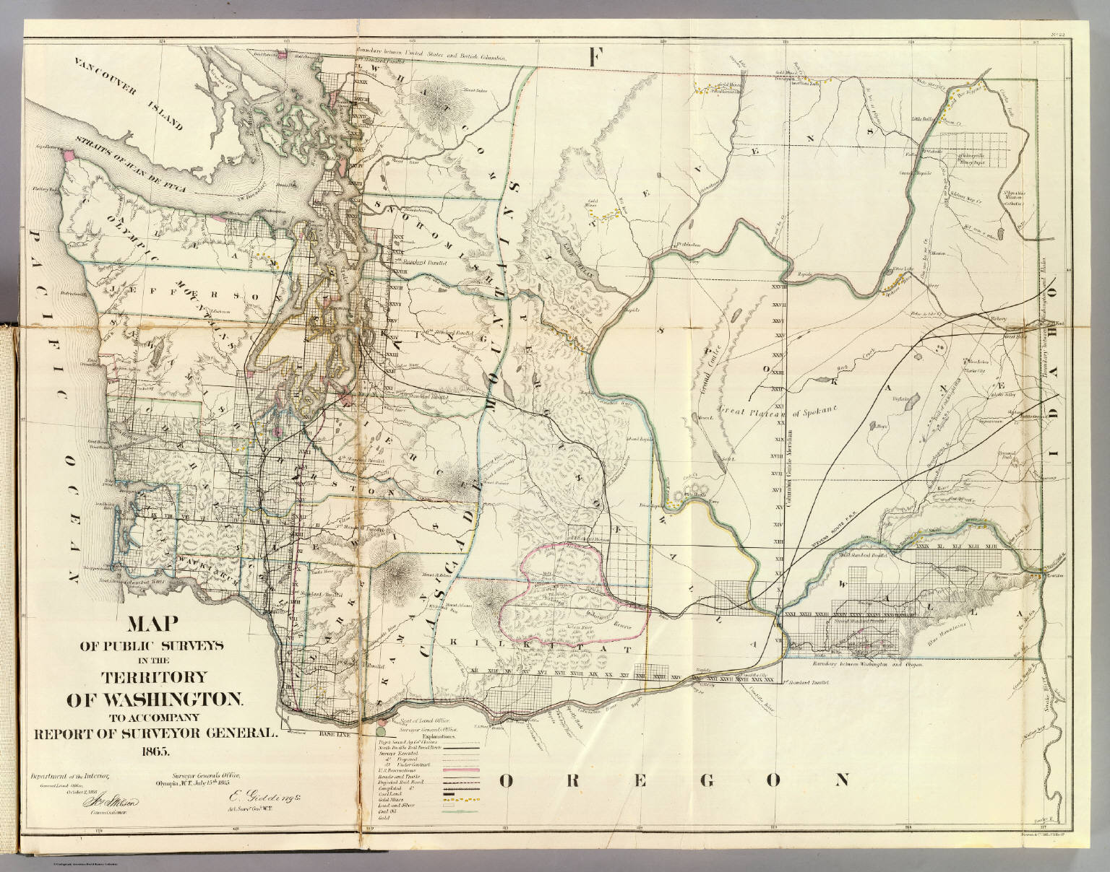

Example map of Washington from the General Land Office ca. 1866
Many companies already subscribed to this land ethic as their main goal was economic gain. A few government agencies existed that also subscribed to economic-based land ethics due to their missions. Those agencies included the Bureau or Division of Forestry - which would later become the United States Forest Service (USFS) - General Land Office, and the United States Grazing Office. The General Land Office and the United States Grazing Office would later be merged to form the Bureau of Land Management.
The General Land Office was the agency responsible for selling land under the Homestead Act. Once the land it had remaining was set aside for other public uses, their mission changed to leasing land for grazing and mineral extraction. Due to the overlapping mission with the Grazing Office, the Bureau of Land Management was formed to manage grazing and mineral extraction leases.
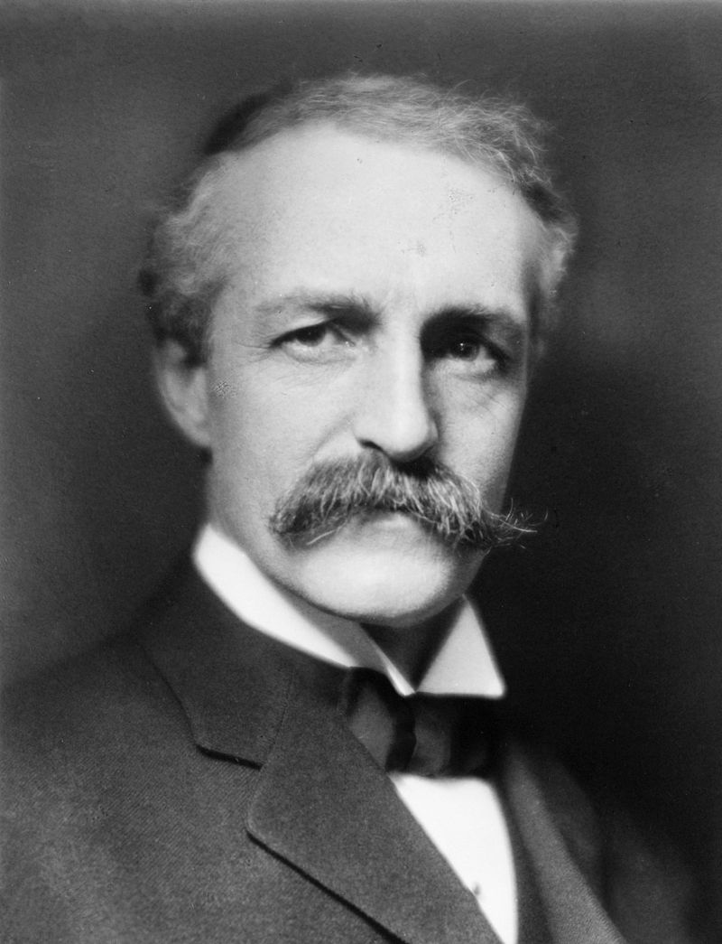

Gifford Pinchot ca. 1909, as first Chief of the USFS

Gifford Pinchot: Conservation
Gifford Pinchot is best known as the first chief of the US Forest Service, and was steeped in conservationism from a young age. His education furthered his interest and training in conservation forestry, attending programs at Yale University and the French National School of Forestry. Upon his return to the United States, Pinchot became involved with groups that aligned with his conservation mindset, such as the National Forest Commission and the Boone and Crockett Club. The National Forest Commission brought him in contact with President Grover Cleveland, who would ask him to help develop a management plan for the United States’ forests in the west, and further help catapult him to the office of Chief of the Division of Forestry, first under McKinley, then under Theodore Roosevelt.
Pinchot’s focus, as Chief Forester, was to maximize the life expectancy of the forests, so that harvest for timber could continue indefinitely. His methods focused on the commercialization of the resources under his management without depleting them. Despite initial support under Theodore Roosevelt, Pinchot found himself at odds with Taft, who pushed for quicker access and deforestation of the land.
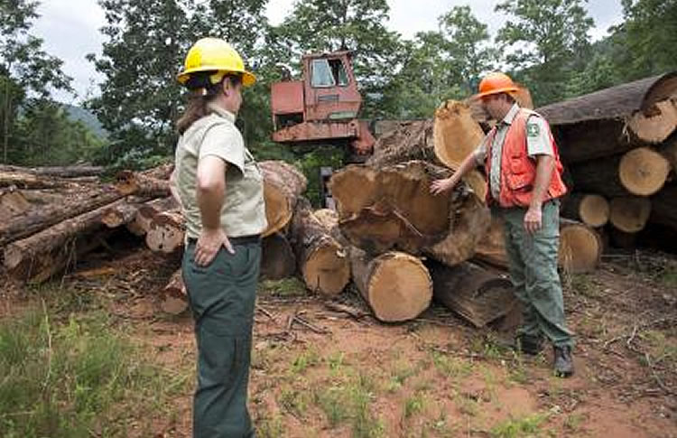

USFS Employees inspecting timber harvest

Benefits
When done properly, economic-based land ethics can be useful. Since the mission is to ensure sustainable and sustained harvest of resources, the private companies or government agencies will make sure not to harm their investment. Since their mission is to make money off the resources they manage, they require less outside money. With different rules and regulations, they open up areas that can withstand recreational use. In some cases, the land can be repurposed to scientific money-making endeavors.

The Sanford Underground Research Facility (SURF) was constructed in portions of the Homestake Mine in Lead, South Dakota. The Homestake Mine, was the deepest and largest shaft mining operation in North America, producing approximately 44 million ounces of gold. The National Science Foundation, along with multiple research universities, invested in the mine to start research endeavors. This research, in turn continues to bring grant money into the area. In other words, economic-based land ethics can also include scientific experimentation in an area.
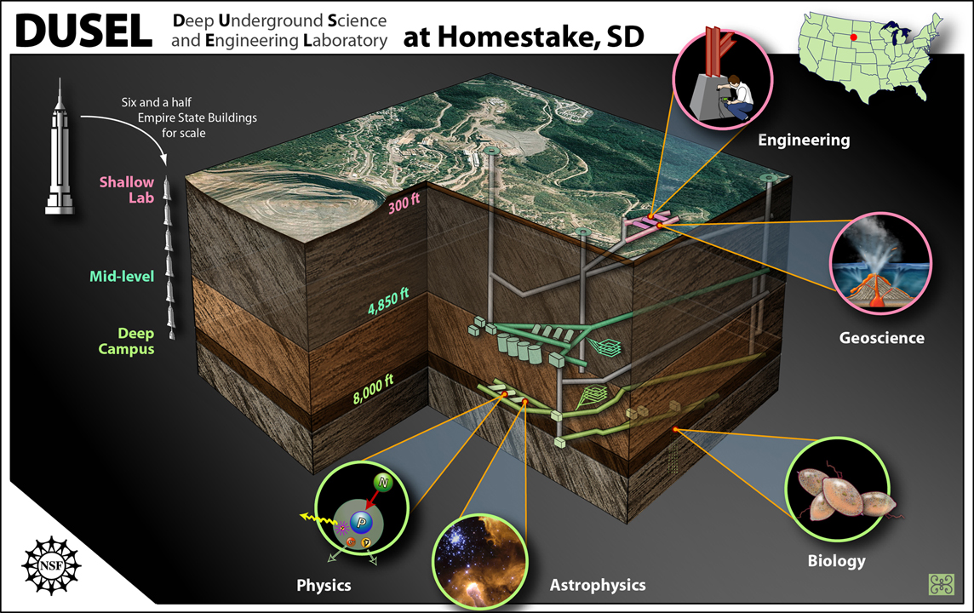

Proposed Layout of the DUSEL/SURF Lab, 2009

Risks
Most of the risks that come from economic-based land ethics stem from over-harvesting of resources. Completely clear-cutting a forest makes it so that new trees are less likely to grow, disrupts hunting by driving animals out, and can cause economic damage via landslides or flash floods. Introduction of poisonous chemicals from mining increase the costs of water treatment and medical treatment. Overhunting and fishing leads to the cost of getting new stock to continue providing revenue. This land ethic also forces humans to put a monetary value on everything, which can be next to impossible.

