Ecological-based land ethics is the youngest of the five, with the concept only truly being cemented and put into words by Aldo Leopold in his book, A Sand County Almanac in 1949. Unlike the other land ethics, ecological-based land ethics do not focus heavily on human-centered concerns. Rather, the focus is more on giving intrinsic, or natural, value to the land and organisms.
One of the missions of the National Park Service is supporting ecological-based land ethics. The United Nations Educational, Scientific, and Cultural Organization follows this ethic when it comes to the selection of World Heritage Sites. Additionally, there are many not-for-profit organizations that support ecologically-based land ethics, such as the World Wildlife Fund, the International Union for Conservation of Nature, and the International Society for Environmental Ethics.

Great Smoky Mountains National Park and World Heritage Site

Before Leopold
Humanity has always wondered about its place in the universe and on earth. One extreme of this is that humanity has complete and utter domain over nature. This side thought that nature was there for humans to do anything with. The other extreme is that humanity is like a virus, destroying the earth.
The person who drew the most attention to this discussion was Alexander von Humboldt. However, the conversation did not end with him. It continued as scientists, philosophers, and the general population continued to contribute observations about what they were seeing as effects on the land.
Ayers Brinser was one of the latest before Aldo Leopold to look at and describe an ecological-based land ethic. In his book, Our Use of the Land, he looked at how the natural systems have changed in the United States. According to his work, settlers and Western civilization treated the land like coal in their furnaces, using it for every bit they could before moving on.
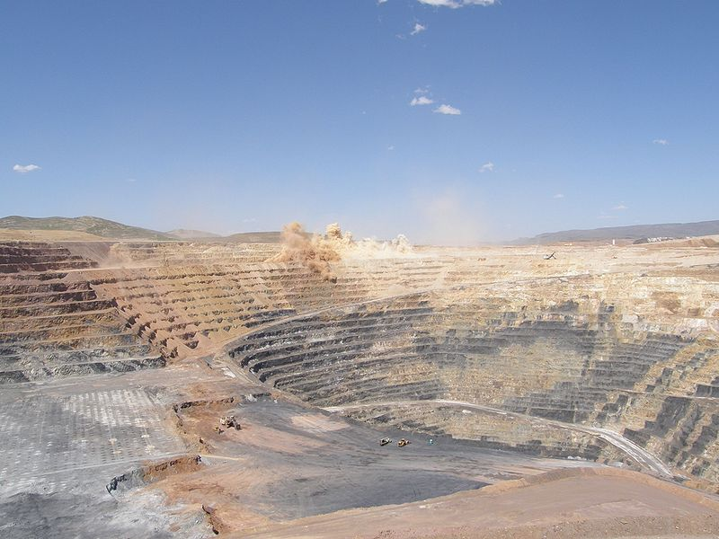

Twin Creeks Open Pit Gold Mine, Nevada

A Sand County Almanac
From an early age, Aldo Leopold showed an interest in observation and being outdoors. This interest was supported by his father, who would bring his children into the woods on excursions. In 1900, Pinchot, the chief forester for what would become the United States Forest Service, helped to develop a forestry program at Yale University. When Leopold heard of this development, his parents did everything they could to help him get in, and further encourage his love of the outdoors.
After completing his graduate degree at Yale, he was assigned to District 3 of the Forest Service, where his main task was the hunting and killing of big game predators such as bears, wolves, and mountain lions. From there, he was transferred within District 3, from Arizona to New Mexico. While in Arizona, he would further develop a respect for the animals he had to hunt, and the beginnings of his ecological-based land ethic. This culminated in projects such as a comprehensive management plan for the Grand Canyon, the first fish and game Handbook for the Forest Service, and helping to propose the Gila Wilderness Area.
Those years with the Forest Service would lead to Leopold changing his personal ethic from a human-dominated wilderness ethic to an ecological one. This would help to lead to his rethinking of how important predators are to the ecosystem. Further still, that lead to the return of bears and mountain lions in New Mexico wilderness areas.
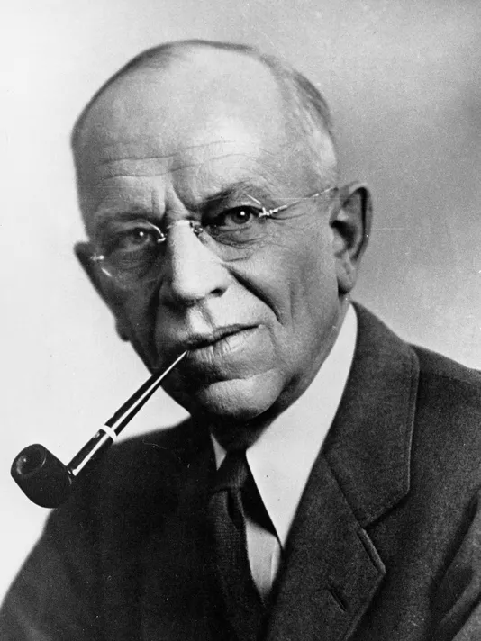

Aldo Leopold
In the 1930’s he had further developed his concept of wilderness and land ethics, to include healthy biotic communities or ecosystems. He gathered these thoughts, and more into his posthumous work, A Sand Creek County Almanac, where the concept of land ethics were finally put into words, and many of them were popularized.

Benefits
Unlike the other land ethics, ecological-based ones focus more exclusively on non-human interests, and puts non-monetary values on them. This promotes natural systems working as they should with minimal human intervention. This land ethic seeks to preserve wilderness areas for the enjoyment of all people. Preserving wilderness helps to protect species that are unique to a region, potentially bringing pride of being one of the few places to see that species.These range from tiny insects only found in specific underground lakes in a single cave up to massive aspen colonies.
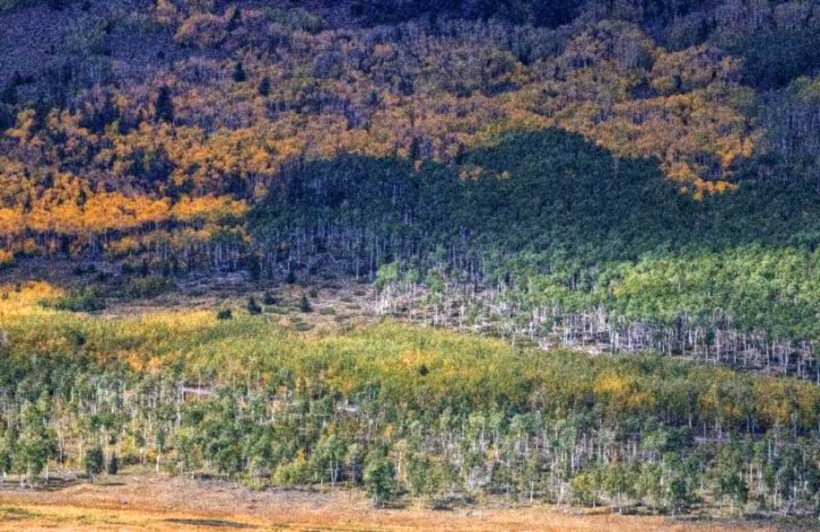

Pando, the largest aspen clonal colony known, Fishlake National Forest, Utah, 2018

Risks
One of the major risks associated with the ecological-based land ethic is that by managing it using scientific methods, humans are still interfering with the natural system. Another risk and issue is that there are few places that have been untouched by humans, so the concept of wilderness may no longer exist. Lastly, ecological-based land ethics restrict other uses of the land, to promote the natural systems.

