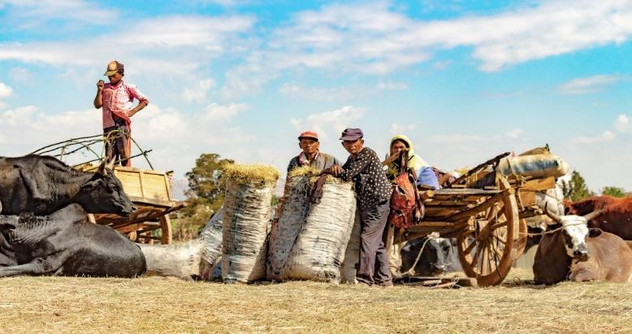

Understanding Tavy
Slash and burn farming, or tavy in Malagasy, leads to the permanent destruction of the rainforest. At the same time, the people of Madagascar respect the forests and can see that tavy greatly jeopardizes future generations. So why destroy what you love and need? The answer is very complex. In Madagascar, poverty is at an extreme high and there are few other options available for profitable farming. Rice is the food staple which can be grown both on flat ground in sustainable paddy fields, and/or on steep slopes of slashed and burned forests.
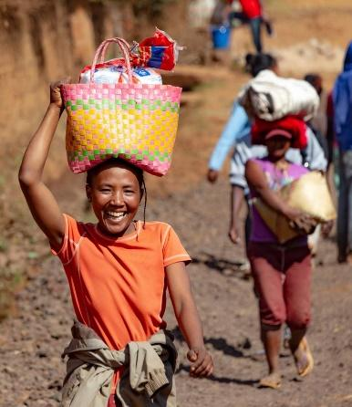
Due to cyclones, many of the fields get washed away. Many farmers suffer great losses when cyclones hit. The weather systems can cause the fields to become quickly unproductive, therefore new slopes must be cut every few years to ensure the production of food. This ancient agricultural technique was brought by the original immigrants from Indonesia. Land ownership and hierarchies are determined by its practice. For example: families may be considered wealthy if they own and are able to maintain a rice paddy field. The untouched jungles are also tied to cultural practices, as forests are the domain of ancestors and the site of many tombs and religious standing stones.

Scenario: Tavy is use by various ethnic groups to create usable farmland in rainforests to grow crops, however once the land is used up, degraded soil leads to an increase in pH. How might this affect the periwinkle species?

