ArcGIS Earth Installation
- Go to: http://www.esri.com/software/arcgis-earth
- Click on “Download for Free↓”
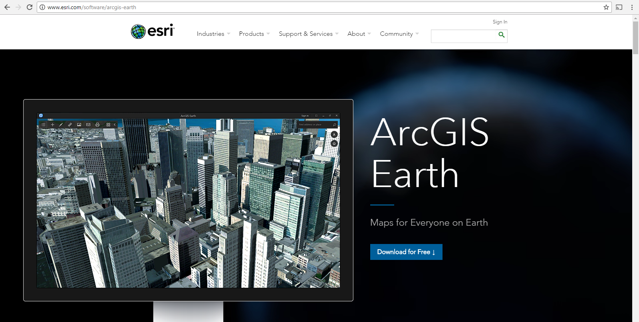
- Click on “Download ArcGIS Earth Now”
- Enter your Email address, Organization, Industry (K-12 Education) and then click on “Start Download”. You will see “Thank you! Your download is starting.” on the screen.
- Locate the downloaded executable file “ArcGIS_Earth_x64_Setup_1.5.exe” on your computer (usually saved under the Downloads folder) and double click on it.
- A new popup window will open and ask “Do you want to run this file?” Click on “Run”.
- ArcGIS Earth 1.5 setup files download will begin. Change the destination folder for the download if desired and click “Next”.
- You will receive the following message: “Installation files have been successfully extracted to your computer” Click on “Close” and setup program will be launched automatically.
- A new popup window will open saying “Welcome to the ArcGIS Earth Setup program”. Click on “Next”.
- Read the “Master Agreement”. Choose “I accept the master agreement” and click on “Next”.
- Choose “Anyone who uses this computer (all users)” if you want all the users on the computer to be able to use ArcGIS when logged in. Click on “Next”.
- Default installation folder will be “C:\Program Files\ArcGIS\Earth\”. Click on “Change” and change the destination folder if desired or simply click “Next”.
- Choose “Do not specify configuration file” Click on “Next”.
- The installation will begin once you click “Install” on the “Ready to Install Program” screen. Installation begins. Launch the program once the installation is complete.

ArcGIS Earth oceanographic cruise activity: Detailed instructions (See video for further instructions https://youtu.be/Gp34pjBbnlY). Images and layers can be found in DOI: 10.7266/N75719N0
- Open ArcGIS Earth from the desktop
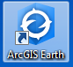
- Zoom in and out. To zoom in and out, you can use the middle wheel/button of your mouse. To zoom in, you can also double click or search for a location using the “Search Icon” on the right side menu. To zoom all the way back to the main page use the “Home Icon” on the right side menu. To drag the map hold the mouse left button and move the map.
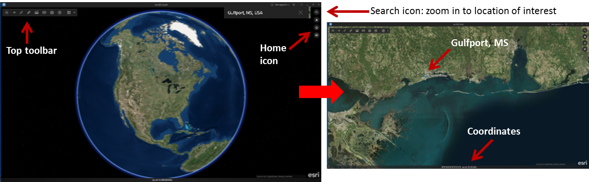
- Settings and Units. In the top toolbar select the “Settings” icon. Select the “Units” tab and make sure that the distance units are nautical miles. Use the location units of your preference.
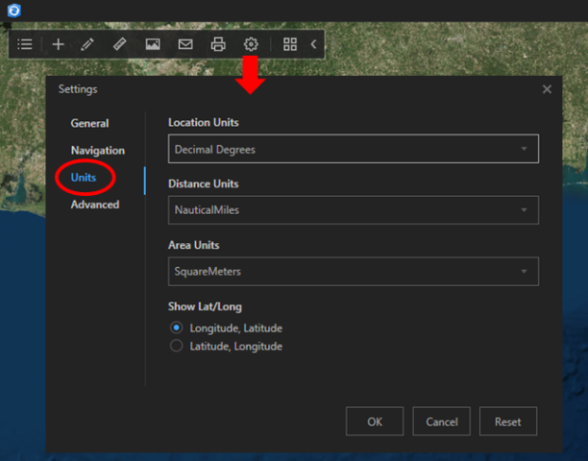
- Add data or layers. Click on the “Add Data” icon, second icon on the top left toolbar (plus sign). ArcGIS Earth provides several maps and layers that can be opened using the “ArcGIS Online Menu”. For the activity, you can open the salinity (e.g., 20151102_SSS_colormap_Gomex.kmz) or chlorophyll-a (e.g., npp.2015300.1027.2015306.1102.D.L4_LP.viirs.GOV.v01.750m_chlor_a.kmz) files provided. If you wish to open multiples files, hold the “Ctrl” key on your keyboard while selecting the files. To interpret the salinity model or chlorophyll-a data add the colorbar layers (cb_chlor_a.kmz and cb_SSS_ncom1km_24_to_38.kmz, respectively) provided with the activity.
- Turn on/off layers. To visualize any open layers you can click on the “Layer List” icon, first icon on the top left toolbar. To turn layers “on” and “off”, click on the box next to the layer. If the layer is “on” a blue checkmark will appear. The layer menu will close if you click again on the “Layer List” icon.
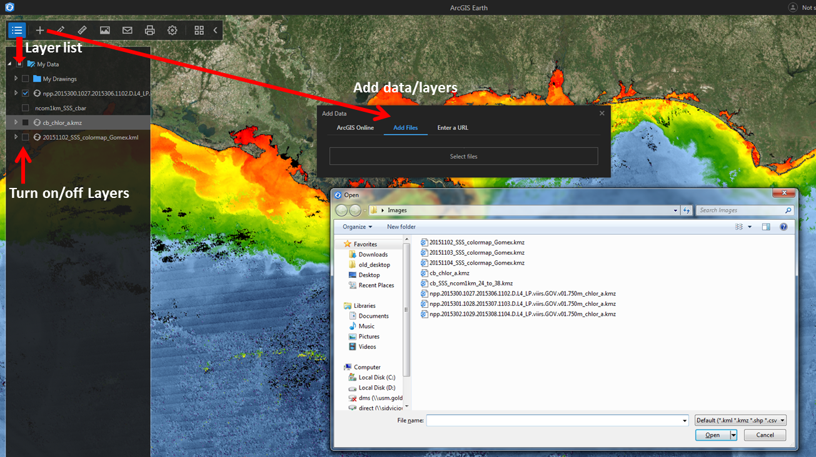
- Add a placemark or station. Click the “Draw” icon, third icon on the top left toolbar (shaped like a pencil), and select “Point.” This will bring up a menu with three tabs: general, view and info. The “General” tab allows naming stations or placemarks, selecting the type of icon to represent it, color of the icon and label, and size of the icon and label. A placemark can be used to help familiarize the students with the study area and identify different locations within the map, for example, Mississippi Sound or Mobile Bay. For the stations, the student can select any naming system (e.g., Station 1, Station 2). It is important to be consistent when doing an oceanographic cruise plan. We recommend using different colors and icons for placemarks and stations. The “View” tab shows the coordinates of the stations/placemarks. The “Info” tab allows adding information about the station/placemark.
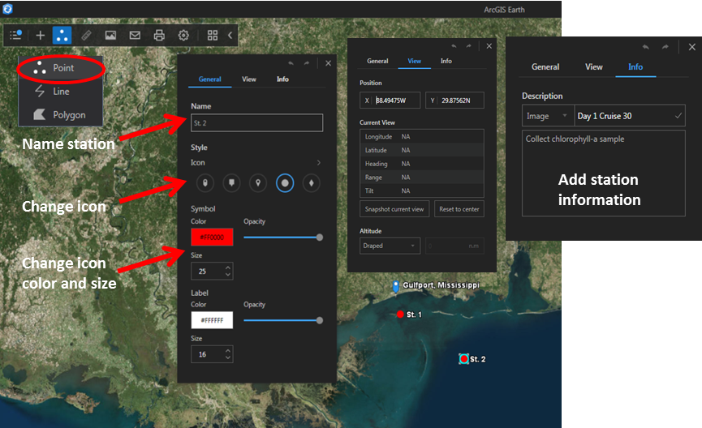
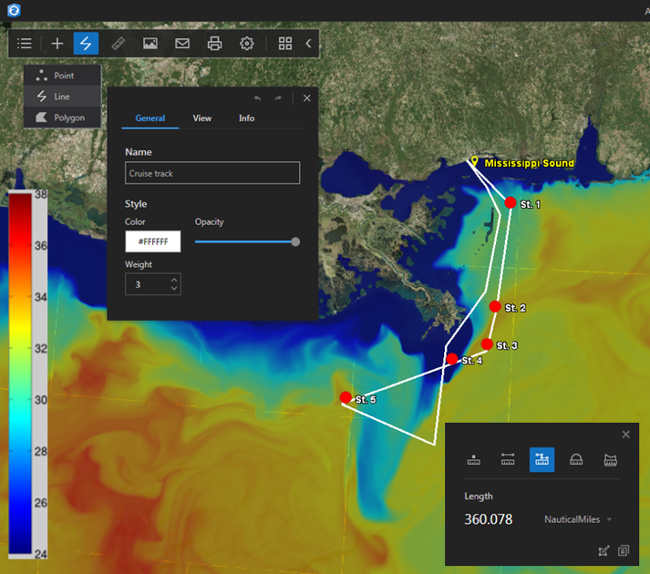
- Measure distance and calculate navigation time. Click the “Measure” icon, fourth icon on the top toolbar (shaped like a ruler), and select “Line” (second icon from the left) for the distance between two points or select “Path” (third icon from the left) for distance along multiple points or path. Simply click on the stations to get the distance between them. You can calculate the navigation time by dividing the distance between points or along a path by the speed of the vessel.
- Create cruise track. Click the “Draw” icon and select “Line”. Here you can create a line to represent the cruise track. Using the mouse, draw the track. You can change the name, color and thickness of the line, and add information. To complete the path, double click or close the “Line” menu and it will ask you to save, click “Yes.” The students should measure the length of the track using the measuring tool. Remember to use the “Path” tab in the measure menu. For the activity we suggested a 3-days cruise, therefore the navigation time should not be longer than 72 hours. Also, remember that each station will take about one hour.

- Edit or delete layers. Each layer, station, placemark, and cruise track should appear in the “Layer” menu, the first icon on the top left toolbar. If you right click on any layer, you should be able to delete, save, or edit (select properties).
- Save snapshot of the cruise map. You can save a picture of the screen by selecting the “Save image” icon on the top toolbar.
- Save the cruise track, stations and images as a “.kmz”. It is a good idea to save all the work, so you can easily open it later. For that, go to the “Layer” menu, right click next to “My Drawings” and click “Save as”.
- Compare salinity and chlorophyll-a. In the “Layer” menu, turn off the model salinity and turn on the chlorophyll-a image to compare the chlorophyll-a along the cruise track. The students can estimate the chlorophyll-a and/or salinity using the corresponding colorbar. We provided three days of salinity predictions and chlorophyll-a data, so they can see how the river plume changes over this time.
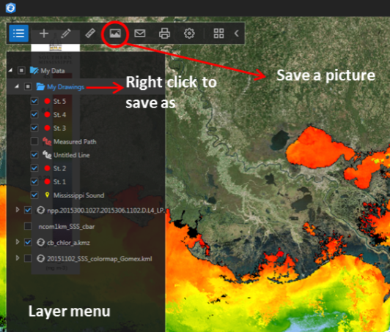

Additional resources:

The Challenger Expedition: https://www.youtube.com/watch?v=RFNBxSPWmCs
River plumes: http://new.coolclassroom.org/adventures/explore/plume
Eutrophication: https://www.nature.com/scitable/knowledge/library/eutrophication-causes-consequences-and-controls-in-aquatic-102364466
Gulf of Mexico Hypoxia Zone: https://www.epa.gov/ms-htf/learn-about-hypoxia-gulf-mexico
Harmful alga blooms: https://oceanservice.noaa.gov/hazards/hab/
Gulf Oil Spill: https://ocean.si.edu/conservation/pollution/gulf-oil-spill
The Mississippi River: https://www.youtube.com/watch?v=f8qcYbswzRk
Example cruise report: https://www.whoi.edu/beaufortgyre/pdfs/2010-07_Cruise_Report.pdf
Additional ocean color imagery in the .kmz format: http://optics.marine.usf.edu/ (Select satellite data products on the left menu, select the region and data. Each image has a little world globe icon in the right lower corner you can click to download the .kmz files.

Cruise Plan Guidelines

- Front page should have
- Cruise title or name
- Name of the vessel
- Name of chief scientist (person responsible for all the science aboard the vessel)
- Name of all crew members
- Role of each crew member
- State the objective and hypothesis
- Include a map with all the planned stations and a table with the coordinates
- List all the type of measurements that you plan to collect at each station. Include a brief description of the measurements and instruments to be used (if applies). Estimate the travel time in between stations (based on the distance to be travelled and average ship speed) and time to be spent for measurements at a station (for example, 1-1.5 hr).
- Include your budget (in this case, how many days of cruise time) and your plan to remain within your budget.
Cruise Report Guidelines (include all of the above and the following sections)
- Include cruise plan
- A new map with the stations over the model-derived salinity and satellite-derived chlorophyll-a images
- Provide a table with the measurements (in this case the students can create a table with the coordinates, station id, chlorophyll-a and salinity values estimated from the images)
- Provide any plots and statistics generated with the data collected, for example a plot of salinity and chlorophyll at different stations. Calculate the mean salinity and chlorophyll inside and outside the plume. Compare the results.
- Provide a conclusion. This section should state the hypothesis and whether the results support it or not.

