ARTICLE 1: Pressure with Height: Pressure decreases with increasing altitude
Modified from: http://ww2010.atmos.uiuc.edu/(Gh)/guides/mtr/prs/hght.rxml

The pressure at any level in the atmosphere may be interpreted as the total weight of the air above a unit area at any elevation. At higher elevations, there are fewer air molecules above a given surface than a similar surface at lower levels. For example, there are fewer molecules above the 50 km surface than are found above the 12 km surface, which is why the pressure is less at 50 km.
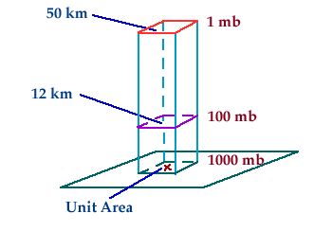
What this implies is that atmospheric pressure decreases with increasing height. Since most of the atmosphere's molecules are held close to the earth's surface by the force of gravity, air pressure decreases rapidly at first, then more slowly at higher levels.
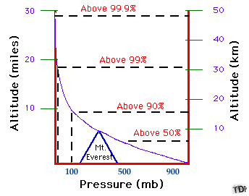
Since more than half of the atmosphere's molecules are located below an altitude of 5.5 km, atmospheric pressure decreases roughly 50% (to around 500 mb) within the lowest 5.5 km. Above 5.5 km, the pressure continues to decrease but at an increasingly slower rate.

ARTICLE 2: High-altitude balloon
Modified from Wikipedia: https://en.wikipedia.org/wiki/High-altitude_balloon
The BLAST high altitude balloon just before launch on June 12, 2005.

High-altitude balloons are unmanned balloons, usually filled with helium or hydrogen and rarely methane, that are released into the stratosphere, generally attaining between 60,000 to 120,000 ft (11 to 23 mi; 18 to 37 km). In 2002, a balloon named BU60-1 attained 53.0 km (32.9 mi; 173,900 ft).^{[1]}

The most common type of high altitude balloons are weather balloons. Other purposes include use as a platform for experiments in the upper atmosphere. Modern balloons generally contain electronic equipment such as radio transmitters, cameras, or satellite navigation systems, such as GPS receivers.

These balloons are launched into what is termed "near space"—- the area of Earth's atmosphere where there is very little air, but where the remaining amount generates too much drag for satellites to remain in orbit.

Due to the low cost of GPS and communications equipment, high altitude ballooning is a popular hobby, with organizations such as UKHAS assisting the development of payloads.^{[2][3]}

History: The first hydrogen balloon
In France during 1783, the first public experiment with hydrogen-filled balloons involved Jacques Charles, a French professor of physics, and the Robert brothers, renowned constructors of physics instruments.

Charles provided large quantities of hydrogen, which had only been produced in small quantities previously, by mixing 540 kg (1,190 lb) of iron and 270 kg (600 lb) of sulfuric acid. The balloon, called Charlière, took 5 days to fill and was launched from Champ de Mars in Paris where 300,000 people gathered to watch the spectacle. The balloon was launched and rose through the clouds. The expansion of the gas caused the balloon to tear and it descended 45 minutes later 20 km (12 mi) away from Paris.^{[4]}

ARTICLE 3: How does pressure change with ocean depth?
Modified from: http://oceanservice.noaa.gov/facts/pressure.html

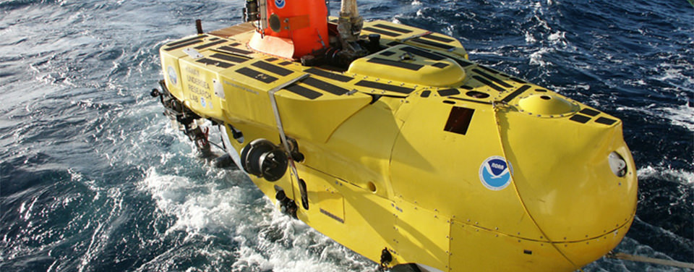

Pressure increases with ocean depth.

Pisces V is a three-person submersible that can operate at depths up to 6,500 feet. This vehicle allows scientists to observe the deep sea under tremendous ocean pressure.

At sea level, the air that surrounds us presses down on our bodies at 14.5 pounds per square inch. You don't feel it because the fluids in your body are pushing outward with the same force.
Dive down into the ocean even a few feet, though, and a noticeable change occurs. You can feel an increase of pressure on your eardrums. This is due to an increase in hydrostatic pressure, the force per unit area exerted by a liquid on an object.

The deeper you go under the sea, the greater the pressure of the water pushing down on you. For every 33 feet (10.06 meters) you go down, the pressure increases by 14.5 psi. In the deepest ocean, the pressure is equivalent to the weight of an elephant balanced on a postage stamp, or the equivalent of one person trying to support 50 jumbo jets!

Many animals that live in the sea have no trouble at all with high pressure. Whales, for instance, can withstand dramatic pressure changes because their bodies are more flexible. Their ribs are bound by loose, bendable cartilage, which allows the rib cage to collapse at pressures that would easily snap our bones.

A whale's lungs can also collapse safely under pressure, which keeps them from rupturing. This allows sperm whales to hunt for giant squid at depths of 7,000 feet or more.

