Introduction to the Rock Cycle and Rock Type Classification

Objective:

Students will be able to differentiate igneous (intrusive and extrusive), sedimentary, and metamorphic rocks by recording observations of thin sections of rock samples under the microscope, correctly identifying the rock type being observed, and providing evidence to support their conclusions. Students will also be able to make inferences about how porosity, permeability, and composition relates to natural resource availability.

Significance:

Understanding how rocks change form throughout the rock cycle is key to understanding the dynamic nature of the surface of the Earth and how these surface changes are driven by the inner layers of our planet. Through this lesson, students will gain a greater understanding of how materials are recycled by Earth processes. This is important because it will teach students about the vastness of geologic time and the origin of natural resources, especially extremely valuable resources like aquifers, fossil fuel deposits, and the formation of mineral ores.

Assessment:

Students will be assessed by their post-lab questions, which include a drawing of each thin section that was observed during the lab, a list of accurate thin section observations, a correct identification of each rock observed during the lab, and a supplemental argument providing evidence and logical support for the classification of each thin section. In addition, a set of multiple choice questions is provided in case that form of assessment is preferred.

Name: ____________________________________ Date: _______________ Period: _______
APES Unit 1: Earth Science
Exploring the Rock Cycle and Rock Types

Introduction: Throughout class today, we will be exploring what happens to rocks when they are exposed to heat, pressure, melting, erosion, and weathering. This is important because many valuable resources that humans use (like fossil fuels) are formed from these processes. First, we will do a quick review of the rock cycle and how these forces change rocks, then we will participate in a lab where you evaluate microscopic differences in rocks to determine how these rocks were formed while completing your lab questions. Finally, you will take an exit ticket to demonstrate your mastery of the information you learned in class.

Objective: Students will be able to differentiate igneous (intrusive and extrusive), sedimentary, and metamorphic rocks by recording observations of thin sections of rock samples under the microscope, correctly identifying different rock types, and providing evidence to support their conclusions. Students will also be able to make inferences about how porosity, permeability, and composition of rocks relates to natural resource availability.

Part I: Rock Cycle Video Review
Watch this video clip about the rock cycle: https://www.youtube.com/watch?v=EGK1KkLjdQY
and answer the following questions.

1. Describe each of the following rock types, and identify an example of each type of rock.
Rock Type | Description | One Example
Igneous Rock
Sedimentary Rock
Metamorphic Rock
2. Identify the name of the material that cools to form an igneous rock.

3. Describe the difference between extrusive and intrusive igneous rocks.

(Continue onto next page!)
4. Fill in the blanks about the rock cycle using the following terms (Heat, Erosion, Melting, Pressure, Weathering)

___________________ and ___________________ are processes which can turn an igneous or metamorphic rock into a sedimentary rock.

____________________ causes a metamorphic or sedimentary rock to become an igneous rock.

___________________ and ___________________ can transform any rock into a metamorphic one.

5. Identify which rock type you would find fossils in and explain why you would find them in that type.

Bonus question: Which rock type would you possibly find oil or natural gas in? Why?

Station A: Porosity and Permeability (no microscope needed). Hand sample #1.

1) Describe the rock on the table. Make as many observations as possible. Consider the following: color, shape, texture, hardness, shine, etc. Be as descriptive as possible.

2. Differentiating porosity and permeability. Although you can’t tell in the hand sample, sandstone contains a bunch of pores between quartz grains. These pores make good hiding places for oil, gas, or water. Geologists will often stain their samples so that pores are colored blue but grains appear white; it makes it easier to estimate porosity.

A. Porosity is a term used to describe the percentage of pores, or open spaces, found in rock or soil sample. Look at the two thin sections of sandstone shown below. what would you estimate the porosity of Sandstone A is?: ______________%

B. Explain how you came up with this estimate.

Sandstone A Sandstone B
Sandstone A
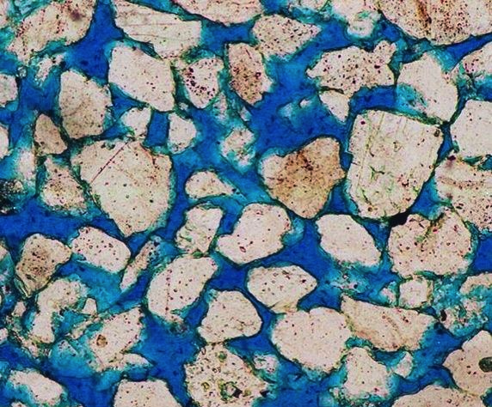
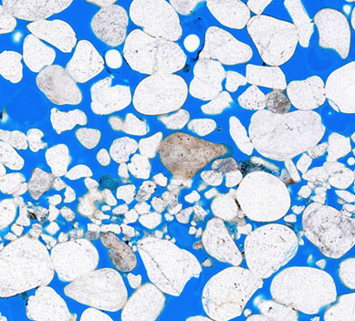

C. Permeability describes the ability of fluids to pass through pores. Higher permeability means fluids can more easily travel via pore space through a rock. Sandstone B has roughly the same porosity as Sandstone A, but different permeability. Which sample of sandstone (A or B) do you think has higher permeability?

D. Why do you think this sample has the higher permeability? Support your answer with evidence from the image below.

E. Which of the type types of sandstone would you chose to drill through for oil? Explain your reasoning.

Sandstone A Sandstone B
Sandstone A

]

Challenge Question: Resources like oil or natural gas are often trapped in rocks and are difficult to take out of rocks. What do you think could be one way in which we can extract a substance like oil from a rock with low permeability? In other words, how could you increase permeability to get that oil flowin’?
Station B: Sedimentary rock aka fossils under the microscope. Hand sample #2 and its thin section.

Check out the cool limestone! There are a lot of shell fossils in it. Limestone is made of the mineral calcite. Fossils are creatures that have been replaced by minerals, preserving their original shape.

1) Describe the rock on the table. Make as many observations as possible. Consider the following: color, shape, texture, hardness, shine, etc. Be as descriptive as possible.

2) Find the fossils in the thin section (under the microscope) and sketch your favorite:

3) Do you think the fossils are made out of the same mineral as the rock, yes or no? Explain your position with evidence from what you see in the microscope and what you know about how sedimentary rocks form/how fossils are made.

Station C: Mystery rock. Hand sample #3 and its thin section.
1) Describe the rock on the table. Make as many observations as possible. Consider the following: color, shape, texture, hardness, shine, etc. Be as descriptive as possible.

2) Looking at the rock in the thin section, use the Mineral ID chart to identify the two minerals that make up the different layers. Record those minerals here and explain how you identified them.

3) What type of rock is this (igneous, metamorphic, or sedimentary)? Explain how you knew using information from the Do Now video or from observations you made in question 1 and 2.

Station D: Igneous rocks. Hand sample # 4 and its thin sections

1) Describe the rock on the table. Make as many observations as possible. Consider the following: color, shape, texture, hardness, shine, etc. Be as descriptive as possible.

2) Use the mineral ID chart to identify the two minerals in thin section #4.

3) From the video, we know igneous rocks can be extrusive or intrusive. Which do you think cools faster, extrusive or intrusive rocks? Why?

4) Notice the holes that are in sample #4. Describe one way in which these holes could have formed.

5) What caused the difference between hole size on the two ends of rock #4? Identify one possible cause for this difference. (There is no right or wrong answer, just hypothesize!)

6) Based on what you have learned and the appearance of rock #4, do you think it is an intrusive or extrusive igneous rock?

Provide the rationale for your conclusion:

Station E: Igneous rocks. Hand sample # 4 and its thin sections

1) Describe the rock on the table. Make as many observations as possible. Consider the following: color, shape, texture, hardness, shine, etc. Be as descriptive as possible.

2) Identify three minerals in sample #5 under the microscope using your mineral identification guide. Provide your rationale for how you identified each mineral.

3) Use what you see in the thin section to identify the tiny black minerals on rock #5.

4) Crystals in igneous rock continue to form as magma cools. Will crystals be bigger or smaller in an intrusive or extrusive rock? Support your answer with reasoning.

Based on what you have learned and the appearance of rock #4, do you think it is an intrusive or extrusive igneous rock?

Provide the rationale for your conclusion:

Background Information and Mineral Reference Guide

What are thin sections and how do we use them?
Thin sections are really thin slices of rocks mounted on a glass microscope slide. Microscopic examination of a rock in thin section enables us to identify minerals, establish a rock's identity, and understand how the rock was formed. The type of microscope a geologist uses is a polarizing microscope.

How do polarizing microscopes work?
A normal beam of light (like from the Sun) consists of electromagnetic waves that vibrate in all directions. If you put a polarized filter in the path of that light wave, you limit its vibration direction to a single direction. Polarized sunglasses do this.

If you hold two pieces of polarized film 90 degrees from each other (“crossed”), no light will get through.

However, put a mineral in between those two filters and something very different happens.
Figure 1 (left) polarizing filters in same direction. (right) polarizing filters at 90 degrees.

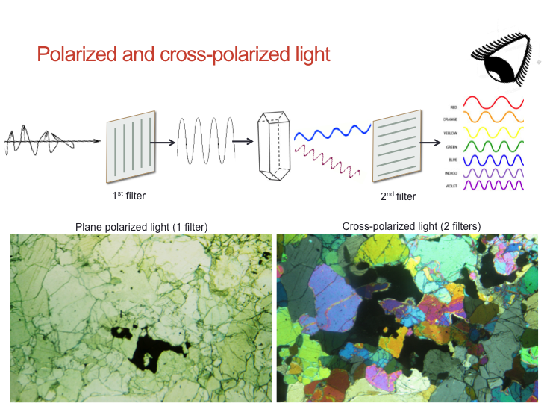
Most minerals will cause the initial polarized light wave to refract and split into two, so that when those two waves pass through the final filter, a single wave is filtered out before it gets to our eyes. This new wave will have a new wavelength, depending on the physical properties of the mineral. Different wavelengths of light will create different colors on the visible light spectrum, so different minerals will be different colors. The orientation of the crystal (which direction the crystal is tilted) affects how much light gets through, which is why some grains appear darker and some appear lighter.

Figure 2 -- If you put a mineral between two polarized filters, the physical properties (shape and orientation) of the mineral will change what color you see.

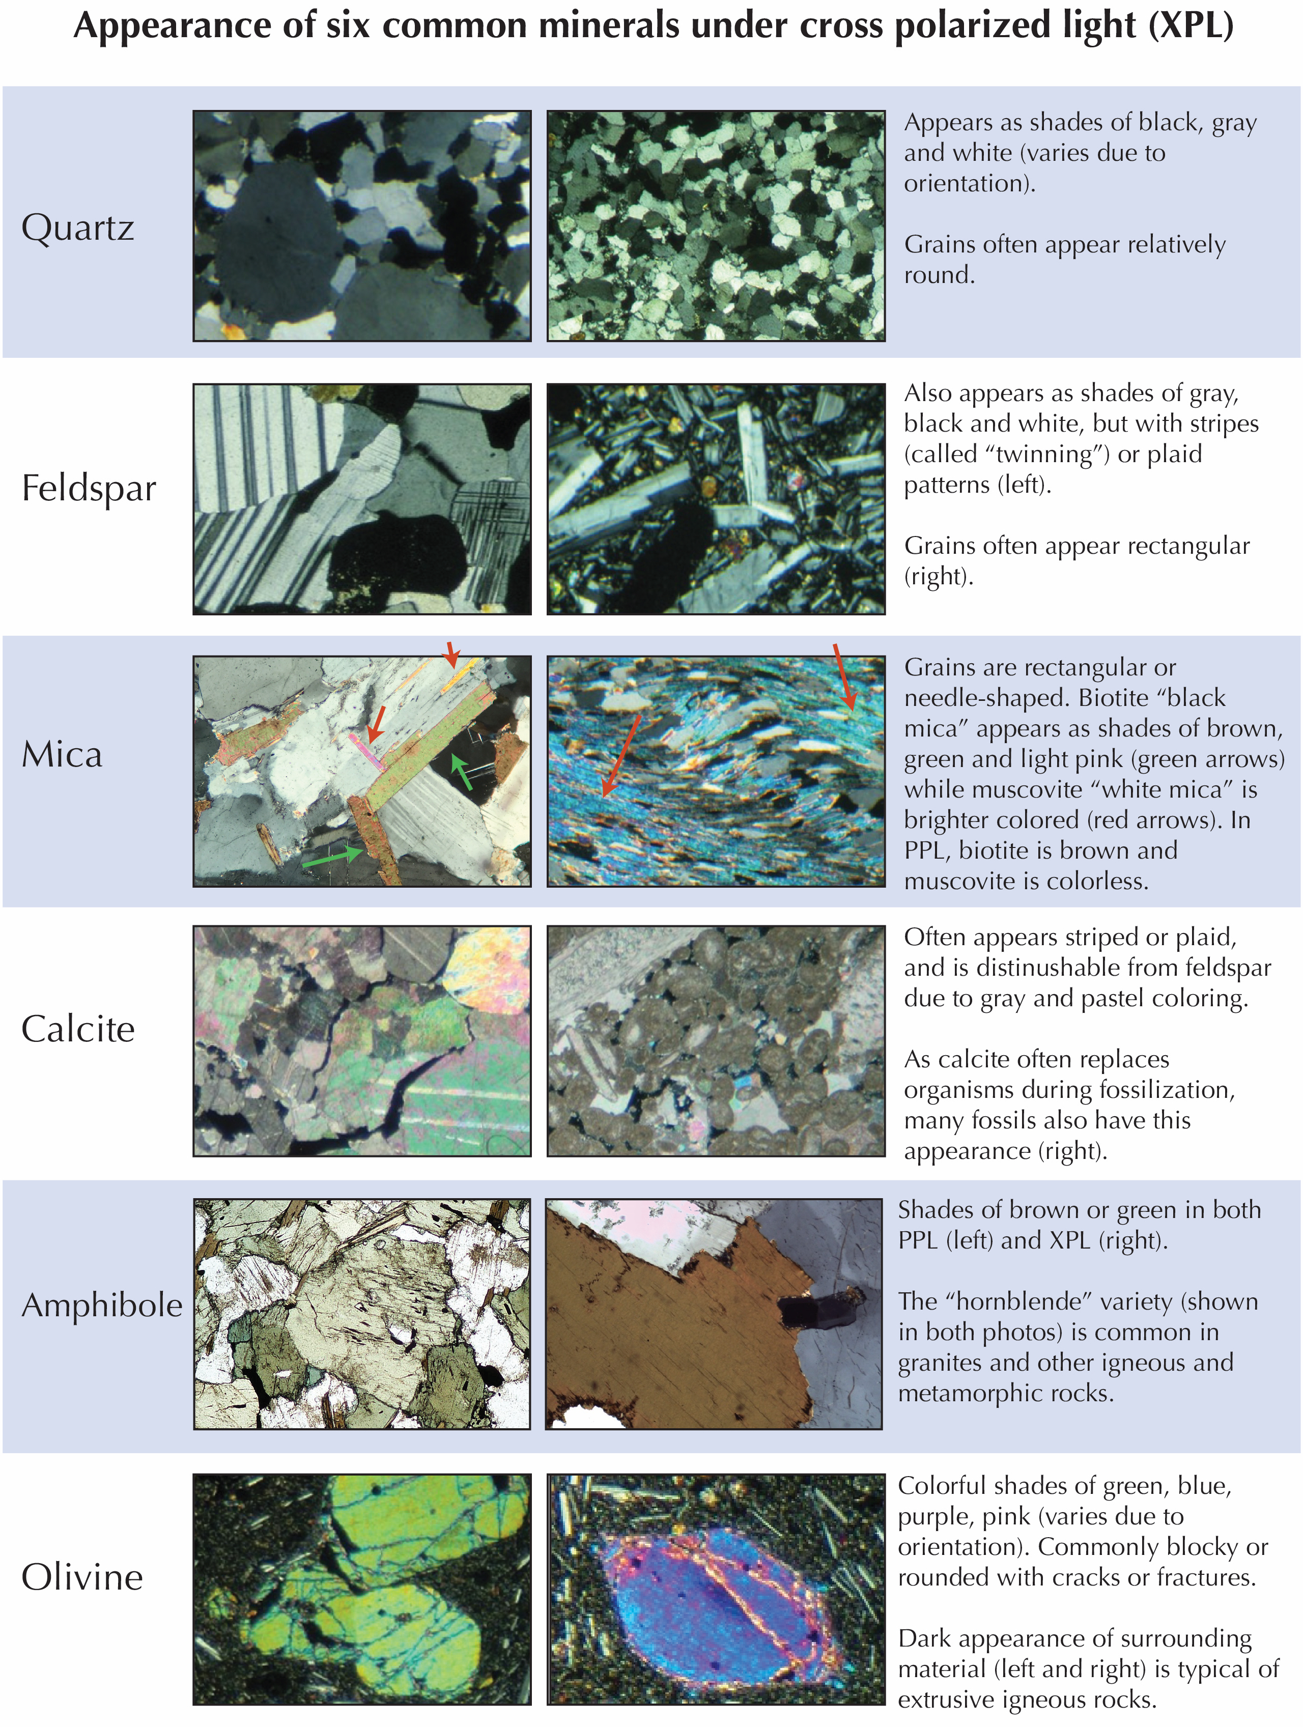
Name: _______________________________________ Date: _________ Period: _______
APES Unit 1: Earth Science
Exploring the Rock Cycle and Rock Types

Exit Ticket

Which of the following processes are responsible for the creation of sedimentary rocks?
- Heat
- Erosion
- Weathering
- Both A and B
- Both B and C
Which of the following processes are responsible for the creation of metamorphic rocks?
- Heat
- Pressure
- Erosion
- Both A and B
- Both A and C
The kind of rock expected to be found deep in the crust where it experiences high amounts of heat and pressure would be _________ and the type found near an active volcano would be _________.
- Igneous...metamorphic
- Sedimentary...igneous
- Metamorphic...sedimentary
- Metamorphic...igneous
- Igneous...sedimentary

Free Response Section 1: Choose two of the prompts below and answer them in complete sentences in the space below.
- Describe the formation of igneous rocks.
- Describe the formation of metamorphic rocks.
- Describe the formation of sedimentary rocks.

Free Response Section 2: Choose one of the prompts below and answer it in complete sentences in the space below.
- Identify which of the three types of rock would contain fossil fuel resources, and explain WHY that type of rock contains those resources.
- Identify which rock type is often the most permeable. What characteristics about its formation make this rock the most permeable?
- Alternate question: Identify what factors (either before or after rock formation) might affect the permeability of sedimentary, igneous, and/or metamorphic rocks. Why might this be important in the case of sedimentary rocks?

