Sort the following statements:
Made up of nucleotides Made up of monosaccharides
Most consist of three fatty acids bonded to a glycerol molecule Produce proteins
DNA and RNA Made up of amino acids
Contain peptide bonds commonly called fats and oils
Used for long term energy storage, insulation, and protection Contain C, H, O, and N
Have a 2:1 Hydrogen to Oxygen ratio Starch and Cellulose
Made up of a single carbon ring May have single or double bonds between carbons
Contain a hydrogen, carboxyl and amino group Contain a phosphate group, nitrogen base, and sugar
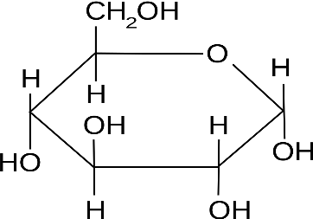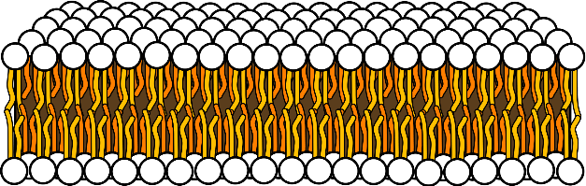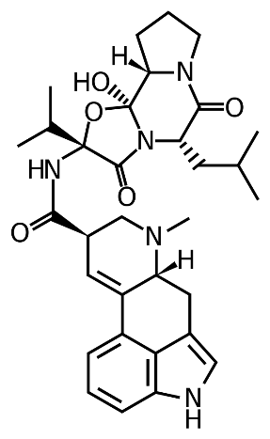
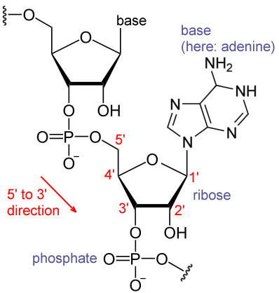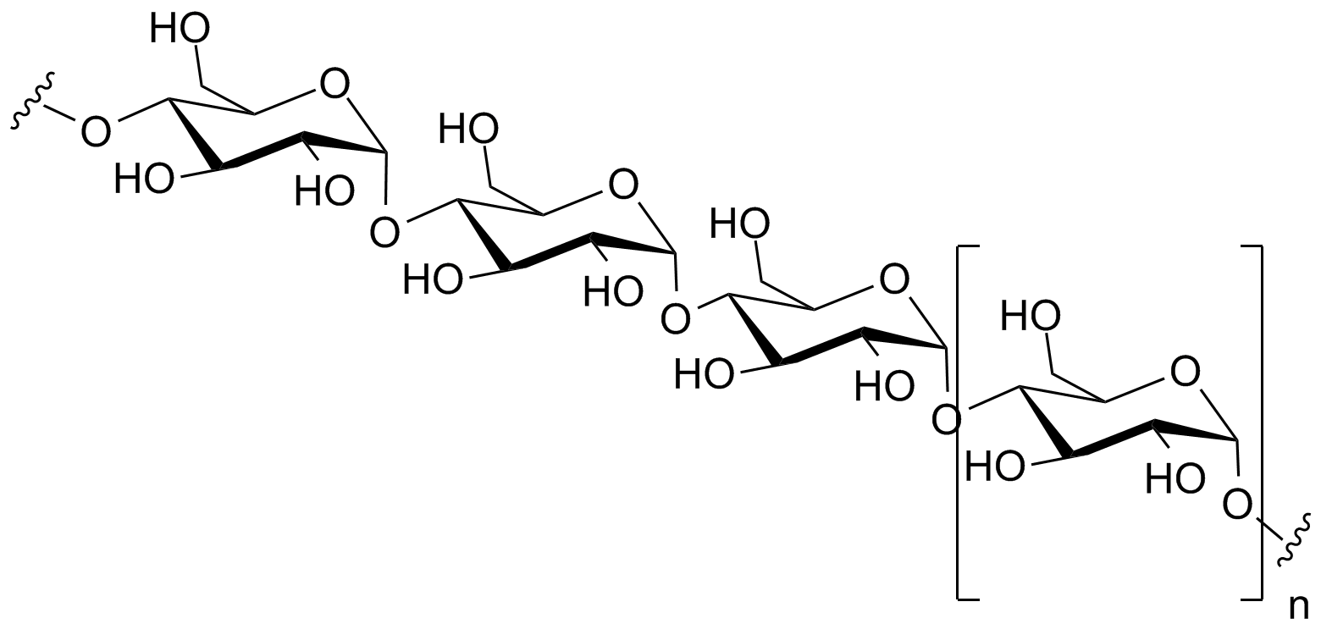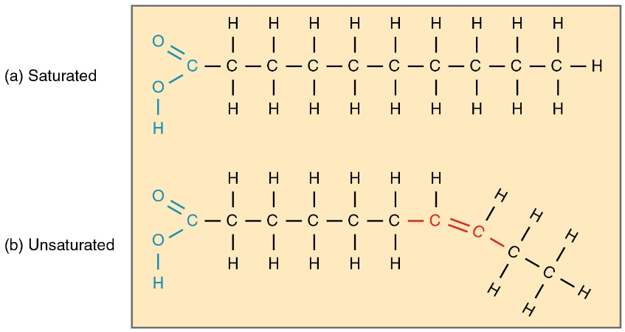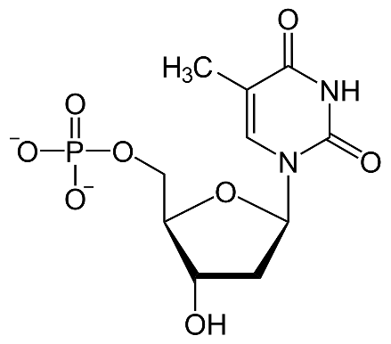
All images provided courtesy of WikiMedia Commons

