Biomolecule Learning Goal Quiz
1.) How can you tell a lipid is unsaturated?
2.) What is the function of proteins?
3.) What ratio do all carbohydrates have? (Make sure to include elements)
4.) How does the structure of the molecule impact the function:
a. 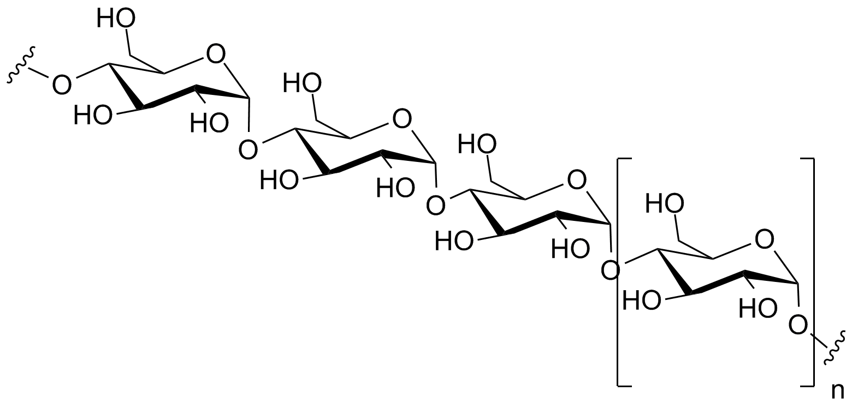
b. 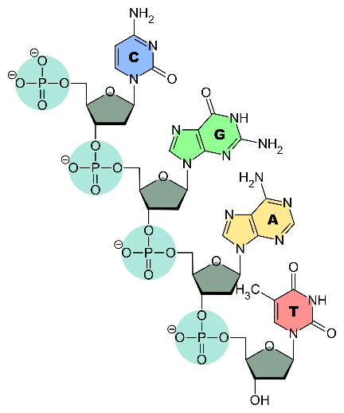
c. 