THE TER-MIGHTY GUTS
Special Note: The demonstration video referenced below can be found here: https://youtu.be/2g_oZ0b8ZSM
An Invertebrate Exploration of Endosymbiosis, Osmosis, and Homeostasis

OVERVIEW
Humans rely on millions of microbes in their intestines to digest food. Similarly in termites, microbes of the hindgut are responsible for the digestion of cellulose in plant matter. Parabasalid protists are a group of unicellular organisms with many flagella. Protists of the genera Trichonympha and Dinenympha are easily identifiable examples of these multi-flagellate, cellulose-digesting symbionts. Furthermore, these protists are considered obligatory endosymbionts as the host gut provides the homeostatic environment required for their survival.

In this inquiry-based activity, students will: (1) dissect a termite hindgut, (2) observe and record the symbiotic relationship between the endosymbionts and termites, and (3) investigate the responses of the endosymbiotic protists when their osmotic environment is disrupted. In groups, students create a concentration gradient between the inside of the protists (intracellular) and their surroundings (extracellular) using hypo-, hyper-, and isotonic saline solutions. Using a compound microscope, students observe and illustrate the response of endosymbionts to different concentrations of saline. Finally, students present their results and conclusions about osmotic mechanisms.

Prior to this activity, students should be familiar with homeostasis, osmosis, and classifications of symbiotic relationships. This 90-minute module provides a hands-on opportunity for 9th-12th grade students to practice using microscopes and stereoscopes, as well as gain exposure to invertebrate biology and dissection techniques. Students are encouraged throughout to ask questions, formulate testable predictions, visualize and record results, and draw conclusions based on observed patterns that emerge during the investigation. This lab directly connects the concepts of symbiosis, homeostasis, and osmosis, and provides a platform for further discussion of the human microbiome and evolution of symbiotic relationships.

KEYWORDS/VOCABULARY
Symbiosis | The relationship between two different organisms living in close physical association, typically to the advantage of both.
Parasitism | The relationship between species, where one species, the parasite, benefits at the expense of the other, the host.
Commensalism | An association between two organisms in which one benefits and the other derives neither benefit nor harm.
Mutualism | Relationships between two organisms that is beneficial to both organisms involved.  - Obligatory mutualism: species are in close proximity and interdependent with one another in a way that one cannot survive without the other.  - Facultative mutualism: interacting species derive benefit from each other but not being fully dependent that each cannot survive without the symbiotic partner.
Endosymbiont | Organism that lives within body or cells of another organism.
Diffusion | The intermingling of substances by the natural movement of their particles.
Homeostasis | The tendency toward a relatively stable equilibrium between interdependent elements, especially as maintained by physiological processes.
Tonicity | The relative concentration of solutions that determines the direction and extent of diffusion.
Osmosis | The process by which molecules of a solvent tend to pass through a semipermeable membrane from a less concentrated solution into a more concentrated one, thus equalizing the concentrations on each side of the membrane.
Osmotic Pressure | The net force that a solute exerts on a semipermeable membrane when it cannot pass through the semipermeable membrane.

LESSON OBJECTIVES
Students will:
- As a class, verbally review the general principles of symbiosis, homeostasis, and osmosis.
- In small groups, dissect a termite to isolate the hindgut.
- Prepare a wet-mount slide to view and identify the protists Trichonympha and Dinenympha.
- Observe the effects of a hypo-, hyper-, and isotonic environments on protists.
- Using a storyboard or poster format, students summarize and annotate their observations of the homeostatic environment normally and when disrupted by osmotic changes.
- Present results and conclusions through facilitated discussion or group presentations.

BACKGROUND
Symbiosis & Homeostasis
There are three major classifications of symbiotic relationships: mutualism, commensalism, and parasitism. Some organisms are obligate symbionts, meaning they cannot survive outside of their symbiotic relationship. This is true for organisms which live as endosymbionts, or inside the body of another organism. Humans host millions of microbial symbionts in and on our bodies, which help produce essential vitamins, digest food, and influence the immune system. These microorganisms are part of our internal environment, and thus contribute to the maintenance of human homeostasis.

Homeostasis & Osmosis
The internal microbes of all organisms must themselves maintain homeostasis. For example, the termite gut is a micro-niche in which endosymbionts live in an established osmotic equilibrium. Osmosis is the movement of water across a semi-permeable membrane due to an imbalance of solute or particles on either side. This imbalance generates a gradient based on the difference in concentration between two solutions separated by a semi-permeable membrane. To reach equilibrium, water moves across the membrane from an area of low solute concentration to one of higher solute concentration.
- In a hypotonic solution [lower concentration of solute outside the cell - as compared to the inside of the cell] the water moves into the cell and the cell becomes turgid and may even burst.
- In a hypertonic solution [higher concentration of solute outside the cell - as compared to the inside of the cell] the water moves out of the cell and the cell becomes shriveled.
- In an isotonic solution [same concentration of solute and water outside the cell - as compared to the inside of cell} the equal amounts of water move both in and out.

The Termite and its Protists; Trichonympha, and Dinenympha
Termites depend on their gut endosymbionts to digest the cellulose from their diet of woody plants. These unicellular species exist solely in the context of obligate endosymbiosis, relying on their termite host for survival. Two genera, Trichonympha and Dinenympha have numerous, whip-like flagella, which are used for feeding, sensation, and locomotion. Both termites and these protists benefit from a shared digestive system. Namely, these flagellates produce the enzymes necessary to help their host termite break down the lignocellulose. In return, the host termite provides a stable environment.

MATERIALS
- Termites (3 or 4 per group; see below for vendor information)
- Dissecting needles (2 per group)
- Petri dish (1-2 per group; 60mm x 15mm or 100mm x 15mm)
- Stereo-microscope (1 per group; also called stereoscopic or dissecting microscope)
- Microscope (1 per group)
- Microscope slides (2-4 per group)
- Glass coverslips (2-4 per group)
- Disposable pipettes (4-5 per group; 200 µL micropipettes may also be used)
- 10 mL of saline solutions - 0.85% - isotonic, 1.7% - hypertonic; distilled water - hypotonic (1 of each per group)

Safety Equipment
- Safety Goggles (removed for microscope work)
- Gloves

Additional Resources/Options
Two major vendors for school-laboratory termites are Carolina Biological and Ward-Scientific.

SUPPLEMENTAL RESOURCES
S1-Lesson Plan
S2-Teacher Slides
S3-Student Protocol
S4-Student Storyboard
S5-The Ter-mighty Guts: A Dissection

MODULE OUTLINE
Introduction (20 minutes)
Task A: Termite Dissection (20 minutes)
Task B: Observation of Endosymbionts (15 minutes)
Clean-Up (5-7 minutes)
Evaluation & Conclusion (20 minutes)

Set Up
Teachers or students can prepare the solutions 1-2 days before and store in closed containers at room temperature.
- 0.85% Saline (Isotonic to termite gut flagellates): Dissolve 0.85 grams NaCl (table salt) in 100 mL distilled water
- 1.7% Saline (Hypertonic to termite gut flagellates): Dissolve 1.7 grams NaCl (table salt) in 100 mL distilled water
- Distilled Water (Hypotonic to termite gut flagellates)

Lab stations should have:
- Items as listed in Materials
- S3-Student Protocol

If possible, the following should be displayed or accessible to students:
- S5-The Ter-mighty Guts: A Dissection as a reference during dissection and slide preparation
OR
- An example of a dissected termite with hindgut isolated
- A prepared microscope slide (isotonic) for students to use as a reference
  - NOTE: Even in isotonic solution, the protists will die within the 90 minutes.

Introduction (20 minutes)
To begin, teachers can facilitate a review of symbiosis and homeostasis in regards to organism survival. The provided slides (S2-Teacher Slides) can be used as needed for both a review and an outline of the lab protocol. In discussing symbiosis, teachers should introduce the mutualistic relationship of the termites with their protist endosymbionts, emphasizing the benefits of a shared digestive system.

Students may understand homeostasis in the context of humans, such as sweating or shivering to maintain body temperature. Teachers can then remind students of two other mechanisms of homeostasis: diffusion (movement of solutes) and osmosis (movement of water). This investigation focuses on osmosis; the passage of water through a semi-permeable membrane from a less concentrated solution into a more concentrated solution. Osmosis seeks to equalize the concentration of both water and solvent on each side of the semi-permeable membrane. Images should be used to illustrate these concepts (S2-Teacher Slides). Images also clarify the classification of tonicity by defining the prefixes of iso-, hyper-, and hypo-.

Before beginning the dissection, the teacher should also review the lab protocol with the class. Students should be encouraged to ask questions about the procedure until they have a clear understanding of each step. Teachers should remind students to carefully handle dissecting needles and should be set down so they are totally on a flat surface when not being used. This review is to ensure that everyone is comfortable handling and operating all of the equipment associated with the activity. The class is then split into groups and assigned a lab station. By following the video (S5-The Ter-mighty Guts: A Dissection) and with support of a teacher that rotates between stations, students can begin the termite dissection.

Task A: Termite Dissection (20 minutes)
Students take note of the materials at their lab bench, check their microscope and stereoscope (if present), and read the detailed lab protocol (S3-Student Protocol). The video (S5-The Ter-mighty Guts: A Dissection) should be looping throughout and pictures (S2-Teacher Slides) serve as helpful visuals. Throughout the activity, teachers circulate often to help groups identify the gut, or focus their scopes. Groups should share tasks amongst themselves.

- Place one drop (50μl) of 0.85% saline on a glass microscope slide using a micropipette.
- Use forceps to catch a termite around the head, being careful not to squeeze the abdomen, and place the termite in the saline on the slide.
- Place the slide on the stage of the stereomicroscope. While observing through the stereomicroscope, remove the gut by manipulating the dissecting needles.
- Gently pull the gut apart into small pieces, much like scrambling an egg.
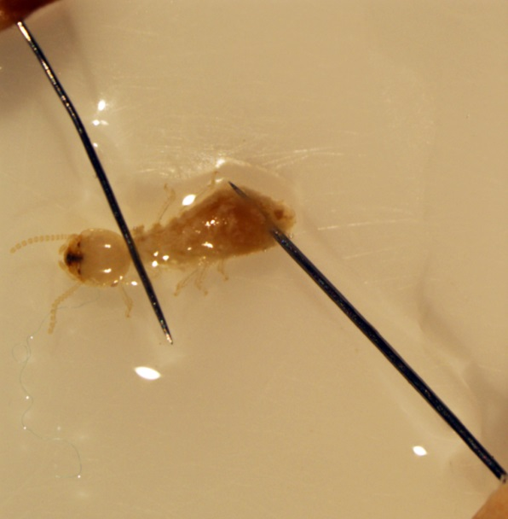
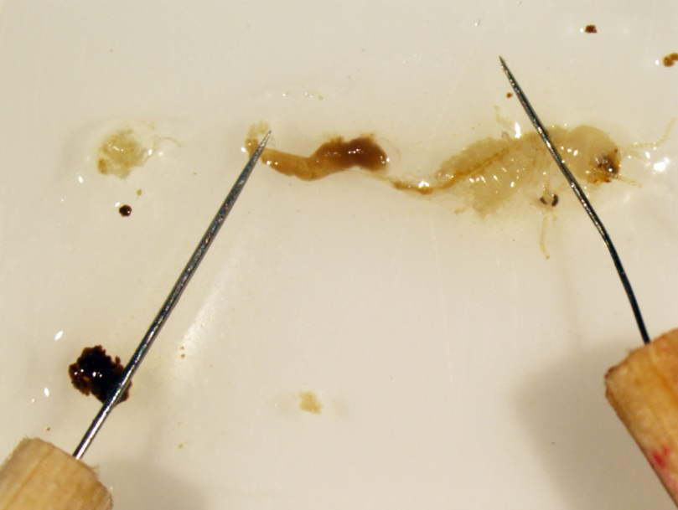
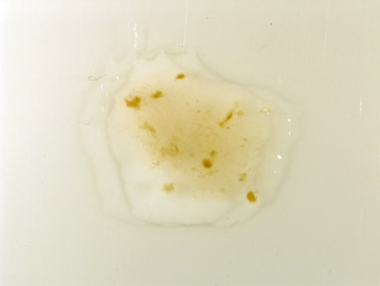
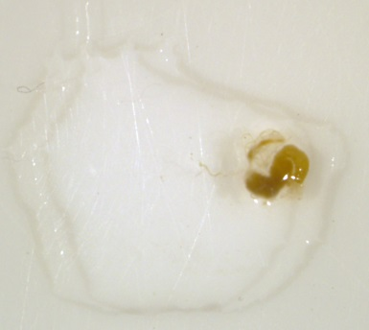

- Gently place a glass coverslip over your sample.
- Using a new slide and another termite, pipette 50μl of distilled water in the center of the slide. Follow the previous steps.
- Using a new slide and another termite, place 50μl of 1.7% saline in the center of the slide. Follow the previous steps.

Task B: Observation of Endosymbionts (15 minutes)
- Place the wet-mount on the stage of the compound microscope.
- Focus the microscope at 20X, and then 40X to locate Trichonympha in each sample.
- Draw or take a picture of observed organisms through the microscope (S4-Student Storyboard).
  - What differences are observable between samples?
  - What might account for these differences?
- Students may also make these observations of Dinenympha.

Students continue to make and record observations every 3 minutes over the next 15 minutes, at which point they will see a rupturing/shriveling of the endosymbionts. Students should compare their first slide (the “normal” protists) with the remaining two (protists in either hypo- or hyper- tonic solutions). Once students find the endosymbionts they can make note of their observations and illustrate their results in storyboard format on the provided handout (S4-Student Storyboard).

The hypotonic solution (distilled water) creates a concentration gradient, and the difference in osmotic pressure causes water to move across the semi-permeable membrane from the outside (extracellular) to the inside (intracellular). Within 3-5 minutes, students should observe swelling in the cell’s appearance, caused by a build-up of water. Within 15 minutes, the protist will rupture. The hypertonic solution (1.7% saline) creates a concentration gradient of solute and water between the intracellular space and extracellular space. The difference in osmotic pressure in this instance causes water to move across the semi-permeable membrane from the inside to the outside. Within 3-5 minutes, students should observe some shriveling in the cell’s appearance, caused by the exit of water from the cell. Within 15 minutes, the protist will shrivel entirely.

Clean Up (5-7 minutes)
All dissected termites, saline solution, and pipettes can be thrown away. Microscope slides and used coverslips should be disposed of in a sharps/broken glass biohazard container.

Evaluation & Conclusion (20 minutes)
As groups finish cleaning their lab station, they can finish their storyboard (S4) including written explanations and/or begin their poster (see below).

EVALUATION & SKILLS
Storyboard
Students may post or submit their storyboards (S4-Storyboards). This should depict a single Trichonympha cell at each stage of osmosis under hypotonic or hypertonic conditions in four drawings: a healthy cell, a slightly enlarged protist or the slightly shriveled protist, a fully engorged or fully shriveled cell, and a cell after bursting or when it stops moving. The four stages should be labeled and arranged in the correct order with written explanations.

Poster
Each group creates a poster summarizing the investigation. The poster should include background, definitions, diagrams or photos, results, and conclusions.

Discussion
Using the Suggested Debrief Questions, teachers can facilitate a class discussion with a focus on the concepts of symbiosis, osmosis, and homeostasis.

Suggested Debrief Questions
- Which classification of symbiotic relationships did we observe in this lab?
- How does the host organism benefit from an obligate endosymbiont?
- How does the obligate endosymbiont benefit from the host organism?
- In the last activity, we observed cells as they ruptured. What happened to them?
- How do diffusion and osmosis contribute to the maintenance of homeostasis?

Extension Activities
- A discussion into the larger context of homeostasis as it relates to human health. Teachers can provide information or make an assignment to research information related to common health issues and diseases, such as diabetes or cancer, which point directly to issues concerning homeostatic mechanisms.
- A discussion of evolutionary connections as to how termites and humans evolved in conjunction with their endosymbionts.

REFLECTIONS
- We found it important to use and refer to diagrams as much as possible when presenting the introductory lecture.
- The level of difficulty associated with this lesson presented a challenge to groups. Due to this, instructors should plan to circulate often.
- There should be plenty of extra materials, including termites, so that the groups are allowed to retry the activity if their first attempts are unsuccessful. We recommend having 5-6 termites on hand for each group during the activity.
- This lesson is designed for a 90-minute class period. However, the lesson or activities may be altered for a longer or shorter class period. The lesson is adapted for an introductory high school biology course, but can be altered for different academic levels.
  - The isotonic solution could be prepared by the teacher for each group so each group only prepares two of the slides and compares them with the teacher slide.
  - For less experienced students: have the students complete the distilled water activity only, and provide prepared slides of the endosymbionts in other solutions.
  - For advanced students: provide the students with three different saline solutions (isotonic, hypotonic, and hypertonic), and they identify each type by observing its effect on the endosymbionts inside the termite gut.

STANDARDS
Next Generation  Science Standards | Disciplinary Core Ideas | LS1.A: Structure and Function: Feedback mechanisms maintain a living system’s internal conditions within certain limits and mediate behaviors, allowing it to remain alive and functional even as external conditions change within some range.  - HS-LS1-3. Plan and conduct an investigation to provide evidence that feedback mechanisms maintain homeostasis.  LS2.C: Ecosystem Dynamics, Functioning, and Resilience: A complex set of interactions within an ecosystem can keep its numbers and types of organism relatively constant over long periods of time under stable conditions. If a modest biological or physical disturbance to an ecosystem occurs, it may return to its more or less original status as opposed to becoming a very different ecosystem. Extreme fluctuations in conditions or the size of any population, however, can challenge the functioning of ecosystems.  - HS-LS2-6. Evaluate the claims, evidence, and reasoning that the complex interactions in ecosystems maintain relatively consistent numbers and types of organisms in stable conditions, but changing conditions may results in a new ecosystem.
 | Science & Engineering Practices | Developing and Using Models  Planning and Carrying out Investigations  Constructing Explanations and Designing Solutions  Engaging in Argument from Evidence
Common Core State Standards | SL.11-12.5 Make strategic use of digital media (e.g., textual, graphical, audio, visual, and interactive elements) in presentations to enhance understanding of findings, reasoning, and evidence and to add interest.  WHST.9-12.7 Conduct short as well as more sustained research projects to answer a question to solve a problem; narrow or broaden the inquiry when appropriate; synthesize multiple sources on the subject, demonstrating understanding of the subject under investigations.

RESOURCES
Lloyd-Price J, Abu-Ali G, & Huttenhower C. (2016) The healthy human microbiome. Genome Medicine. 8:51. doi:10.1186/s13073-016-0307-y.
National Science Teachers Association (2013). Safety in the Science Classroom, Laboratory, or Field Studies. Arlington, VA. Retrieved from www.nsta.org/docs/SafetyInTheScienceClassroomLabAndField.pdf
Noll Laboratory, University of Connecticut, Termite Project (2016). Funded by National Science Foundation’s Emerging Frontiers in Research and Innovation. Retrieved from: http://www.kennethnoll.uconn.edu/nsf-termite-project/index.html
Shaw, S.R. (2014). Planet of the bugs: Evolution and the rise of insects. Chicago: University of Chicago Press.

