Teacher notes
*The following amounts refer to classes with 12 lab groups performing the lab at 6 lab tables.

Preparation/Ordering of Chemicals:
Any chemical supply company can be used. Included is information for Flinn Scientific (www.flinnsci.com). As of January, 2017, Flinn carries all chemicals listed below. Flinn’s catalog is called “Flinn Science Catalog Reference Manual” and is published each year. If you’ve never ordered from Flinn, you can request their catalog on the website. This catalog is a good reference for solution preparation (including chlorine water as mentioned below), safety tips, and chemical disposal.

Alkali Metal Halide Salt solutions:
The following can be ordered as salts or as pre-made solutions:
- Potassium chloride
- Potassium bromide
- Potassium iodide
Prepare 0.2-molar solutions of each of the above. Sodium salts are an appropriate alternative. Each group only needs a few drops. For easy distribution, a set of 6 small dropper bottles can be made so there is one at each lab table for two groups to share.

Aqueous Molecular Halogen solutions:
Chlorine and bromine must be used under a fume hood! For simplicity, I typically keep the iodine under the fume hood as well. With multiple groups, it may be useful to make two or three small bottles of each solution so students do not have to wait in line to obtain their chemicals. Be sure that students know their test tubes must be sealed with a rubber stopper before leaving the fume hood.

Chlorine water (Item #C0055)
- A 500-mL bottle will be enough for at least 8 classes
- This has a very short shelf-life, 6 months at best. However, I have used chlorine water that was still in its original protective packaging from 3 years prior, with perfect results for this lab purpose.
- Chlorine water is basically a mixture of hydrochloric acid and bleach, which allows a certain concentration of chlorine molecules to stay dissolved in the water due to equilibrium effects. If you cannot order it, Flinn’s catalog has several different “recipes” to make your own.

Bromine water
- I prefer to order bromine ampules (Item #B0149). These come in a set of 3 and include 1 gram of bromine in each sealed glass ampule. The shelf-life of bromine in this packaging is listed as “excellent” in the Flinn catalog. I have successfully used these after 5 years with no apparent degradation.
- The contents of one glass ampule are emptied into 100 mL of distilled water to make the bromine water. Once it is dissolved in water, its shelf-life reduces drastically. I typically make this solution on the morning of the lab for my first class and I try to schedule all labs so they use it within a week.
- 100 mL will be sufficient for at least 2 classes.

Iodine water
- Any iodine-potassium iodide solution that does not contain alcohol is suitable. The shelf-life for each of these solutions is listed as “fair to poor”, however I am still using a solution from 4 years ago and it has not affected the results of this lab.
- Iodine tincture can be purchased at a drugstore, but this has alcohol in it. I have not tested whether or not this would affect the results.
- Similar to the others, a 100-mL bottle will be enough for at least 2 classes.

Nonpolar Organic Solvent
- Cyclohexane was the original solvent I used many years ago, when I first encountered this reaction type as a teacher. One year I was low on cyclohexane so I searched for an alternative.
  - First, I tried mineral spirits that I found at a Home Depot. It is basically a mixture of hydrocarbons, so it seemed suitable for my use. This worked, but the colors were not as bright as with the cyclohexane, so I wasn’t yet satisfied.
  - An article I found (Scott 1991) listed mineral oil as an excellent substitute for halogenated nonpolar solvents for a variety of reasons. Though cyclohexane is not halogenated, it does occasionally have the problem mentioned in the article of building up pressure in the tube when shaken.
- Paraffin Oil-also called light mineral oil-(Item #M0064) is now my preferred solvent because it does not require the use of a fume hood and it does not build up pressure when shaken. Also, it can be purchased from a drugstore (as an intestinal lubricant). Its results for this lab are nearly identical in both color and intensity to cyclohexane. Its only drawback is that it forms an emulsion if shaken too hard and it will take time to settle back into layers. See “lab tips” for how to minimize emulsification.

Making the color reference set
If you’d like to show the colors to the class from the front of the room, I’d suggest large test tubes and approximately 1” of each portion. There will be 6 tubes. All tubes will contain oil and each will contain either an aqueous molecular halogen or an aqueous ionic halide. These remain at the front of the room for student reference.
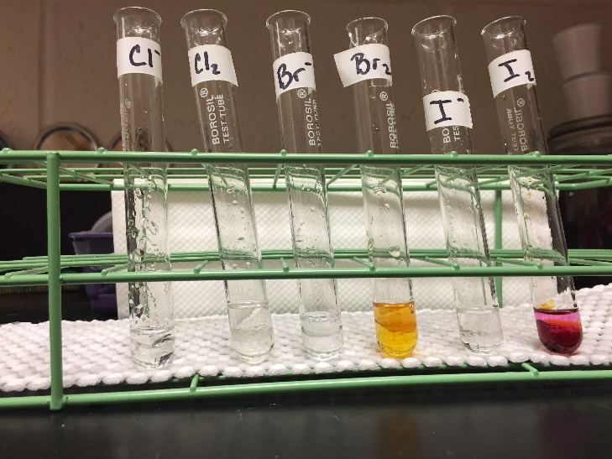
Each halogen turns a distinct color in the organic solvent as listed below (for paraffin oil):
  - Cl₂ is a very pale yellow (it is difficult to see the color in the photo below)
  - Br₂ is orange
  - I₂ is purple
The ion forms of the halogens (halides) do not have a color in water solution or in the organic solvent.

Preparing for safety
Chemical splash goggles, gloves, and aprons should be worn throughout the laboratory procedure. Students will be working with molecular halogens in water solution. The iodine solution is not very volatile, but the bromine and chlorine solutions produce a strong bleach-like odor and are irritants. All three should only be dispensed under the fume hood and students should be instructed to keep caps on these bottles as much as possible while obtaining their samples. Also, once these samples are in their individual test tubes, the test tubes must remain stoppered when not under the fume hood. Depending on the organic solvent chosen, this may also need to be dispensed under the fume hood with the same precautions as the molecular halogens.

It is important to prepare the students for success by explaining procedures and alerting them to how they will gather their equipment and chemicals, especially if they have not used these lab procedures in the past. If the classroom has only one small fume hood, then a classroom rotation may be necessary to avoid crowding as each lab group must visit the fume hood to gather supplies. Each teacher should consider the layout of their own classroom and should guide the students appropriately toward safe and efficient procedures.

Expected Results
The pale yellow of the chlorine molecule in oil will not be present in any of the final tubes. Two of the tubes will have the orange of bromine and four of the tubes will have the purple of the iodine. If the tubes are not mixed well enough, the orange may be pale and some might call it yellow and the purple might be pale and students might call it pink. If students compare to the reference tubes, they will see that the light orange color they might see is quite different from the pale yellow color of the reference. The only color similar to their pink will be purple. Indeed the “pink” is really just a light purple.

Aqueous halogen and halide mixed | Oil layer added | Final results after thorough mixing
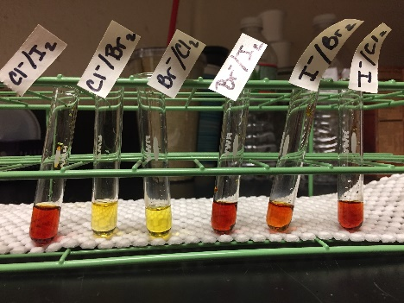 | 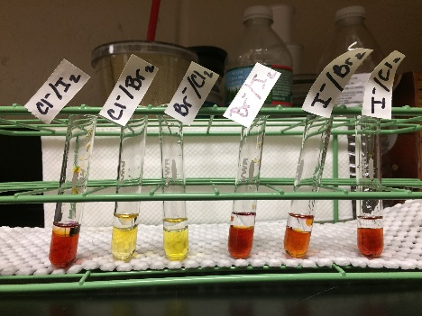 | 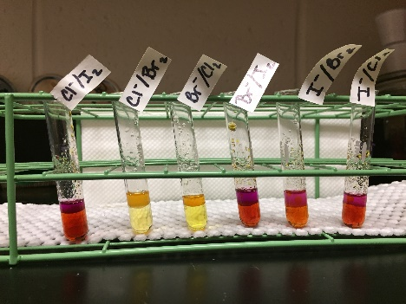
When mixed in aqueous solution, the primary color of solution will be that of the aqueous halogen that is least reactive. The reddish-brown color of I₂(aq) can be seen in four of the tubes, while the yellow-orange color of Br₂ is seen in two of the tubes. | After adding the oil layer, some of the halogen may begin to migrate as seen in the first tube. However, to get a deep color in the oil layer, the tube must be mixed well. A clean glass rod or “flicking” the tube will accomplish this. | Once mixed, the characteristic color of each halogen in oil (top layer) can be seen. Above, the first and last three tubes have the deep purple color of iodine, while the 2nd and 3rd tubes have the orange color of bromine.

Lab tips
- The directions tell students to “swirl” the test tube vigorously after adding the oil. I avoided the word “shake” because this often leads students to over-do the motion. That could lead to emulsification which might take a long time to settle. A better method is to hold the test tube firmly at the top and use a finger to tap in a downward fashion on the side of the test tube, toward the bottom. This promotes a swirling motion. Mixing is needed for the molecular halogen to find its way into the oil layer. It is useful to demonstrate this to students. Alternatively, you could use a clean glass rod for each tube. In this case you will have to be careful not to use tubes that are so small they will overflow with the extra volume of the glass rod.
- For disposal, I put 1-2 waste beakers under the fume hood with squirt bottles. Students use the squirt bottles to rinse as much as possible of their solutions into the waste containers before returning to their tables to wash them.

Disposal – Be sure to check your local disposal policies before putting anything in trash or drain!
One option is to treat the waste before disposal using waste disposal methods like those found in the Flinn catalog. Another option is to collect the waste and schedule a hazardous waste pick-up.

As my school does not have a good system for waste pick-up, I prefer the method described below:

The final waste beakers will have a large amount of water and a small layer of oil on top.
- Use a plastic pipet to remove the oil from the top and place it into a disposable cup. This will allow the halogens in the water layer to vaporize from the surface.
- Leave the waste beaker and cup in the fume hood with the window sashes closed. The color of the water and of the oil will fade.
- A nearly full 1-L beaker took 2 days to be completely colorless. Once colorless, the halogens will no longer be present and it is safe to pour down the drain. You can verify the lack of halogen by wafting. If you cannot detect the characteristic bleach odor then the halogens have vaporized.
- The cup of oil from a 1-L beaker of waste took about a week to fade to colorless. If your oil does not decolorize, further waste treatment may be needed (see Flinn catalog disposal methods 12a and 18b).

Teacher Background
The molecular halogens are minimally soluble in water and are much more soluble in nonpolar organic solvents. The ionic halides are largely soluble in water and only minimally so in nonpolar organic solvents. Thus, if both water and a nonpolar organic solvent are present, most of the molecules will partition into the organic layer while most of the ions partition into the aqueous layer. Each halogen dissolves in the organic solvent to form a uniquely colored solution. Therefore, after creating all combinations of ion and molecule, an organic solvent is added to each mixture and the mixture is swirled with enough vigor to allow the molecules to migrate from the water into the organic layer. This allows students to observe the color of the top (organic) layer to determine which halogen is present in its molecular form at the end of the process. Fortunately, due to the relative intensity of each of the colors, the correct color will be observed even if there is some excess of the reacting molecule still present. This means that student results will not be affected by their precision.

The Lesson
The pre-lab activity will go a bit faster than the one from the first lab because the students will be familiar with the ideas. The discussion, however, will take a bit longer. Though there is only one pattern to be found in this lab, it is important to give students the time to make sense of how they will analyze this set of reactions. I like to start by having students first read the new terms and try to express them in their own words (possibly to someone sitting next to them). I then use these terms while guiding a discussion about the lab.

When doing the lab, I instruct students to fill in the first three columns of their data table and then to complete the “Meaning” section after they are finished all reactions, but before they clean up. This gives them the opportunity to continue looking back at their test tubes while analyzing the data. As this last step guides them toward thinking about electron affinity, students typically have an easy time analyzing the data to find the pattern.

ANSWERS
Some Concept Questions
- Circle the ions and put a square around the element molecules.

F F₂ F⁻ Cl Cl₂ Cl⁻ Br Br₂ Br ⁻ I I₂ I ⁻ At At₂ At –

- Explain what would have to happen in the atom for the following change to occur:
Br₂ 2Br –
Each bromine atom in the molecule will gain one electron to make two separate bromine ions.

- Is the process above something that can happen if bromine does not interact with anything? Explain.
No. The bromine molecule cannot gain electrons from nowhere. Another atom must supply the electrons.

- Explain what is happening (follow the electrons) in the following reaction:
X₂ + 2Y⁻ 2X⁻ + Y₂
The two X atoms in the X₂ molecule each attract an electron away from a Y⁻ ion, making the two Y atoms join together into a Y₂ molecule and the X⁻ ions are now separate.

- Use the following data to determine whether element X or element Y has a higher “electron affinity”.
X₂ + 2Y⁻ 2X⁻ + Y₂

2X⁻ + Y₂ no change

Element X has a higher electron affinity. I know this because the X atoms in the molecule were able to attract the electrons away from Y⁻, but the Y atoms in the molecule were not able to attract the electrons away from X⁻.

Post-Lab Questions

- List the halogens you observed from lowest to highest electron affinity as determined by your data.
Iodine – Bromine – Chlorine

  - Explain how you came to your conclusions to answer the above question.
Many correct answers here.

  - According to your data, what is the pattern in electron affinity from top to bottom of a group on the periodic table?
Since chlorine has the highest electron affinity according to question 1, from top to bottom the electron affinity decreases.

- Use electron configurations to draw Bohr diagrams for each of the halogens studied in the lab. Place them in the boxes according to their placement on the periodic table.

  - What is the main difference in the diagrams for each element?

As the elements get lower on the periodic table, more energy levels are occupied, making the outer electron shell farther away and more shielded from the nucleus.

- Use Coulomb’s Law and atomic structure to justify WHY the electron affinity changed in the way you described in question 1b.

According to Coulomb’s Law, the attraction between the nucleus and electrons decreases with increasing distance. Since the outer level is where the extra electron will go, if the outer electron level is farther from the nucleus, it will be less attracted to the nucleus and have a lower attraction for extra electrons. Electron affinity is measured as the energy released when an atom gains an electron. More energy released would be a result of stronger attraction for that electron. Therefore, the elements with fewer occupied energy levels (toward the top of the periodic table) have a stronger attraction and a higher electron affinity than those with more occupied levels (toward the bottom of the periodic table).

- Fluorine is not used in this lab because it is very hazardous. If we could have used fluorine, what would have happened when the neutral fluorine molecule was mixed with the chloride ion (Cl ⁻)? Explain how you know, using your data.

The neutral fluorine would attract the electron away from the chloride ion and the oil layer would become pale yellow, due to the presence of molecular chlorine. Here is the equation that represents the reaction:
F₂ + 2 Cl⁻ 2F⁻ + Cl₂

I know this because, according to the pattern, fluorine will have a higher electron affinity than chlorine, which means fluorine can attract an electron away from chlorine.

References

Scott, T. M. 1991. The Suitability of Mineral Oil as a Halogen Extraction Solvent. Journal of Chemical Education 68(11): 950.

