Teacher Notes
*The following amounts refer to classes with 12 lab groups performing the lab at 6 lab tables.

Preparation and ordering of chemicals
Any chemical supply company can be used. Included is information for Flinn Scientific (www.flinnsci.com). As of January, 2017, Flinn carries all chemicals listed below. Flinn’s catalog is called “Flinn Science Catalog Reference Manual” and is published each year. If you’ve never ordered from Flinn, you can request their catalog on the website. This catalog is a good reference for solution preparation, safety tips, and chemical disposal.

Hydrochloric Acid, 1M
- This can be ordered in a variety of concentrations from 0.1-molar to 12-molar, which is the highest possible concentration. As I use this acid often and in a variety of ways, I usually order the 12M and dilute as needed. For safety or space purposes, some teachers may choose to order the acid in the concentration in which they will be using it.
- This can be distributed in dropper bottles to each lab group or table. Each group will only need a few milliliters of solution.

Metals
Each teacher will have his/her own method of distribution. I like to use small plastic containers like film canisters to supply each lab table or lab group with a sample of each metal.

Aluminum
- I typically use aluminum wire (Item #A0175) and tell students to sand it just before the reaction. The 100-g wire is approximately 90 feet long. I give students samples about 1-inch long, so this will last several years.
After 2 minutes
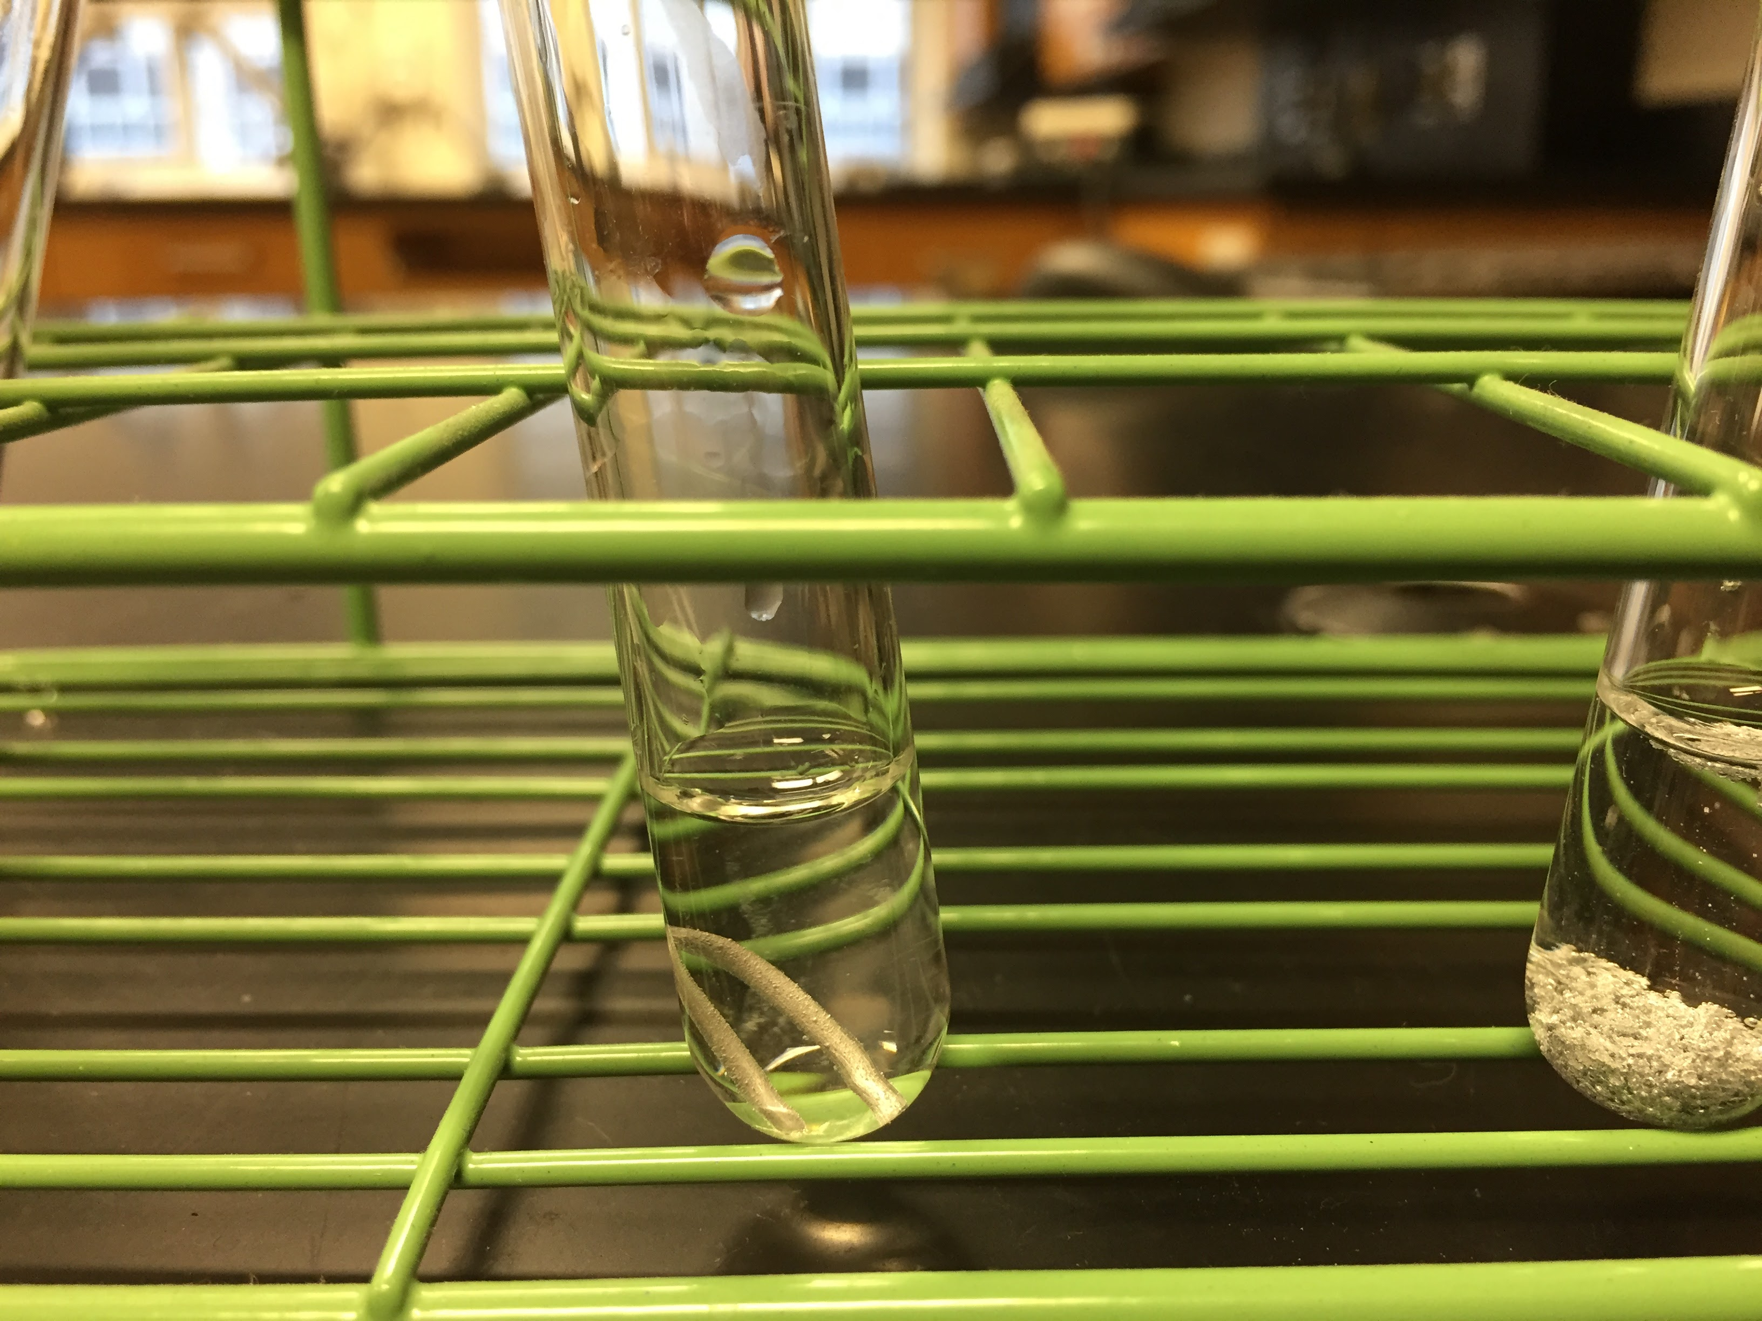
- Theoretically, aluminum should react with hydrochloric acid. If the acid is concentrated enough, it will eventually react away the oxide coating, allowing the acid to contact the pure aluminum on the inside of the sample. This is not something I address with students at this point in the year.
- The aluminum has stayed in acid in the test tubes for as long as 20 minutes with no reaction (even after the hot water bath). After the hot water bath, some bubbles can be seen but that could just be from boiling. Therefore, the students consider this to be unreactive or very minimally reactive.

Calcium
- Calcium turnings (Item #C0008) are the only form of elemental calcium I have seen. The 100-g bottle will last for a couple of years, but should be kept in its original packaging bag and can to minimize oxidation.

- In the pictures below, I show the original piece of calcium. It is about ½ cm by 1 cm in size. You can see that its surface has been almost completely oxidized. It is difficult to tell in the photo, but you can still see some of the shiny calcium under the white layer. This sample is from a bottle of calcium that is about 3 years old. It still reacts quickly, as shown in the pictures.

Calcium turning | After 5 seconds | After 20 sec | After 30 sec | After 60 sec

Magnesium
- I have tried magnesium ribbon (Item #M0139) and magnesium granules (Item #M0212). When using the ribbon, I instruct students to sand them just before the reaction. Even when freshly sanded, the ribbon reacts slower than the granules. (Granules may also be called turnings.)
- In the pictures below, the tube on the left contains a 1” strip of freshly sanded magnesium ribbon. The tube on the right contains about a pea-sized sample of magnesium granules. I added acid to both at the same time in order to compare their reactions.

After 5 seconds | After 30 seconds | After 60 seconds
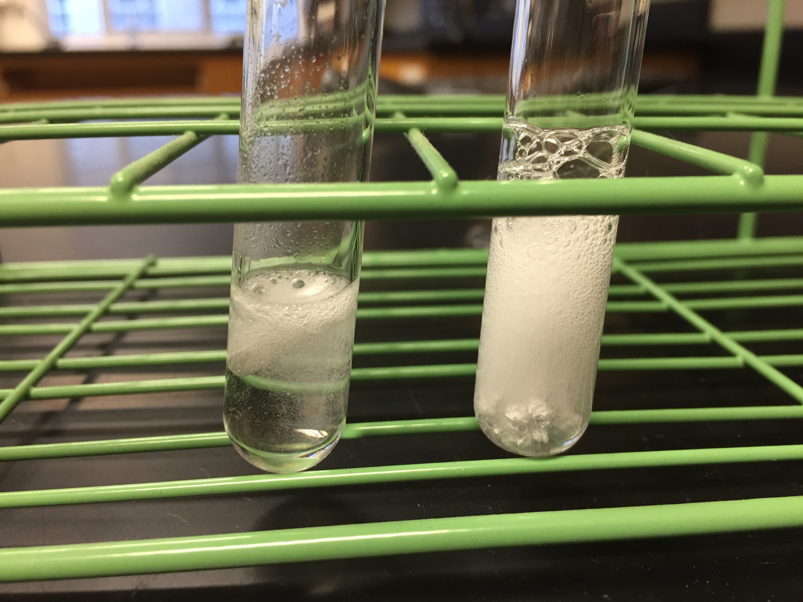 | 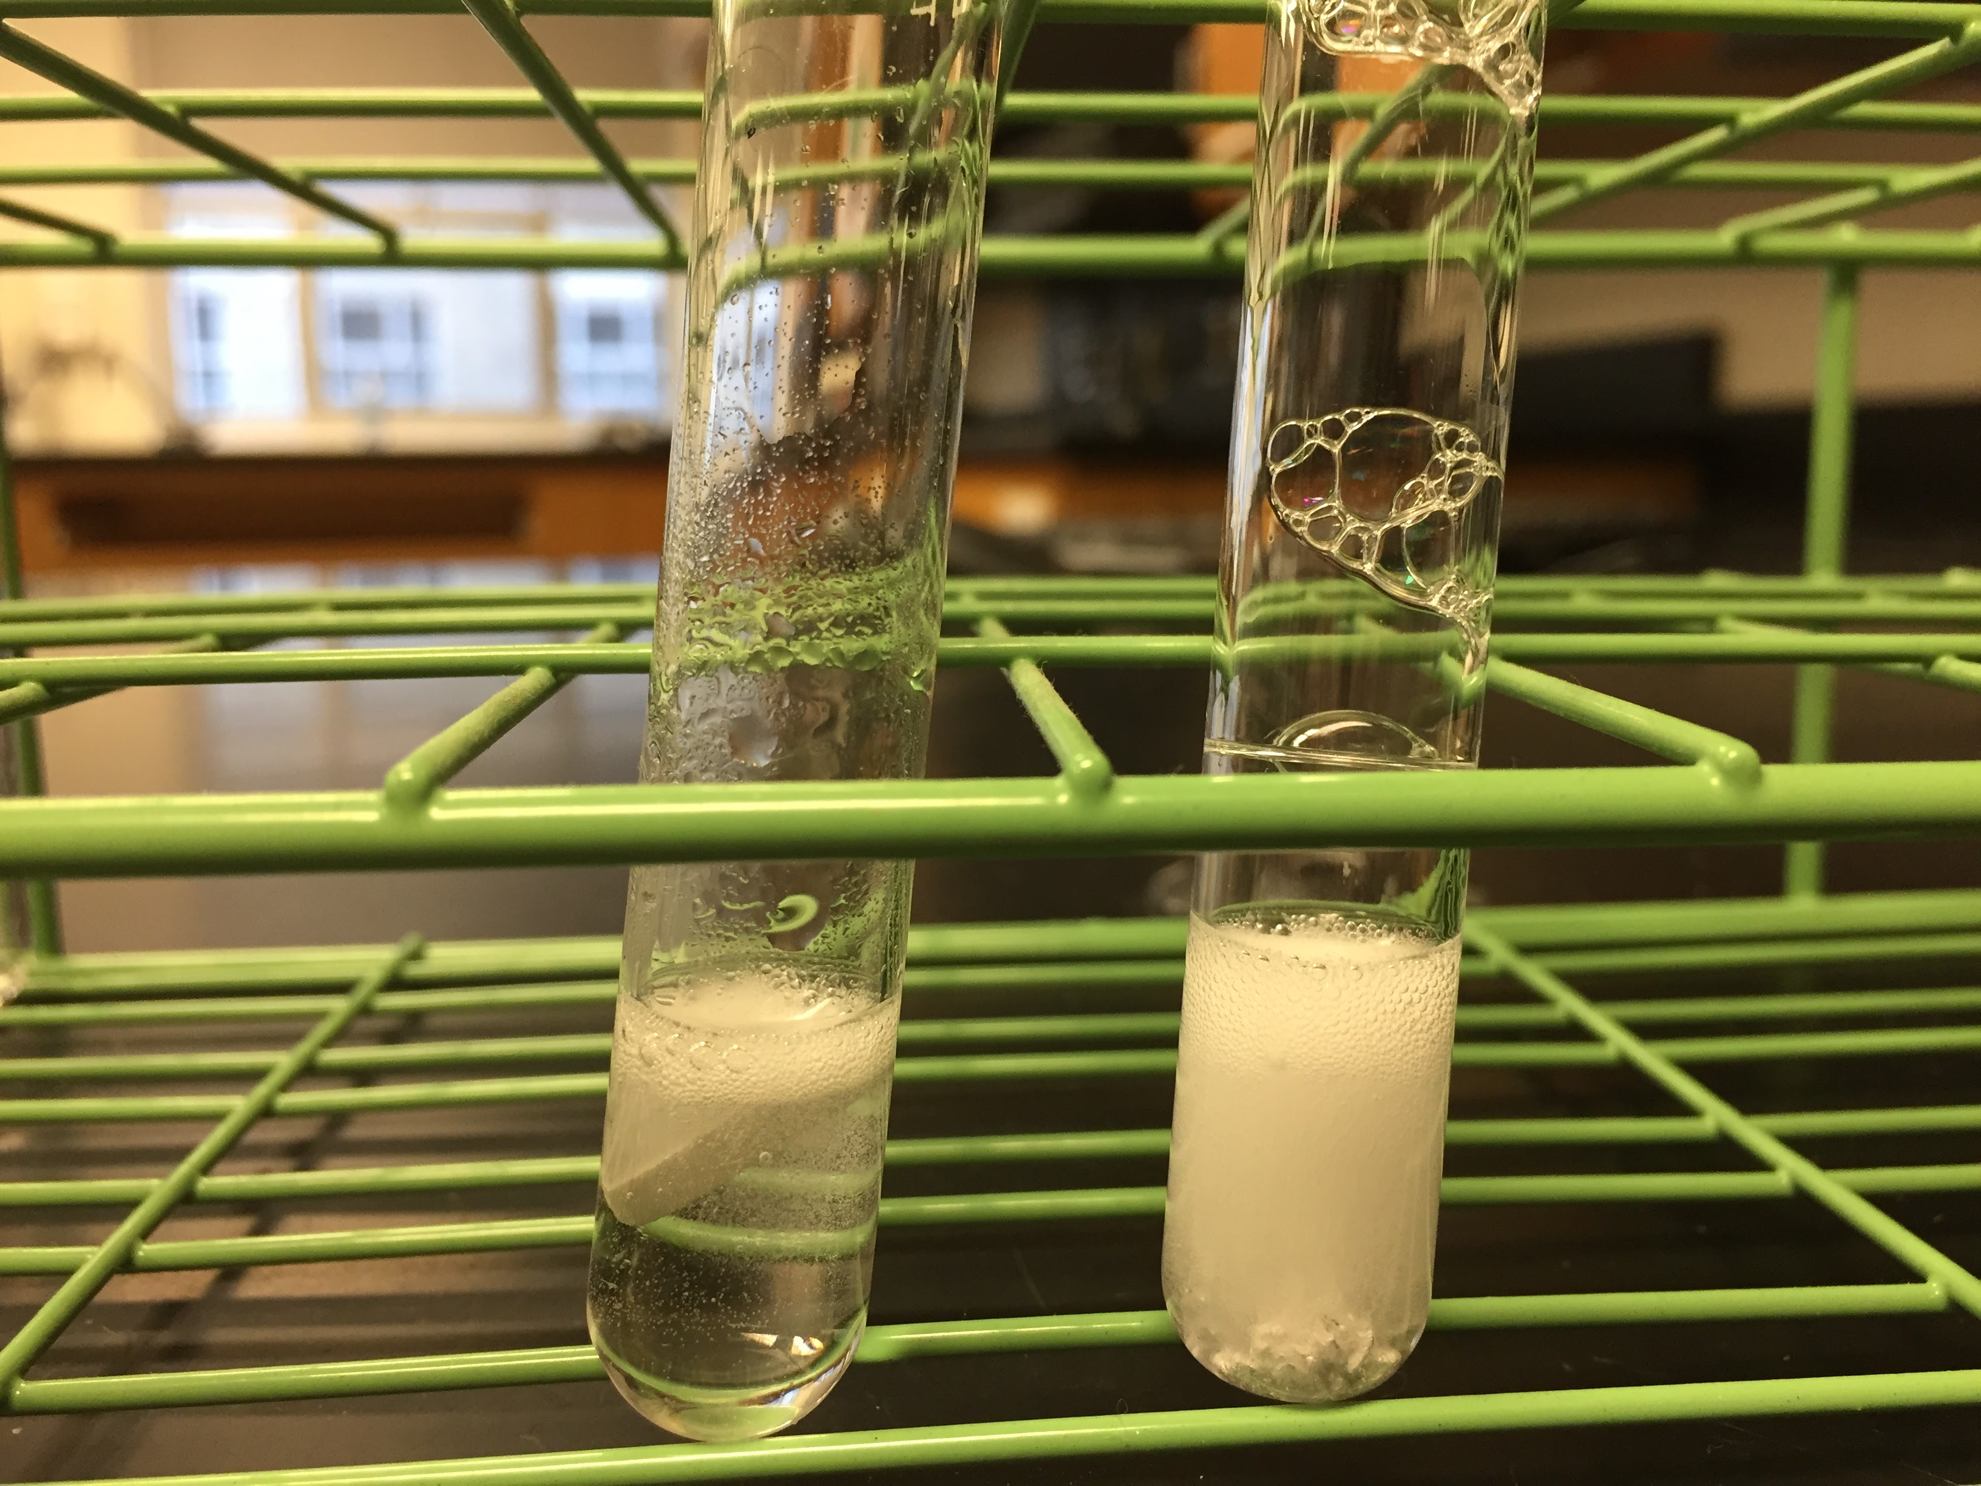 | 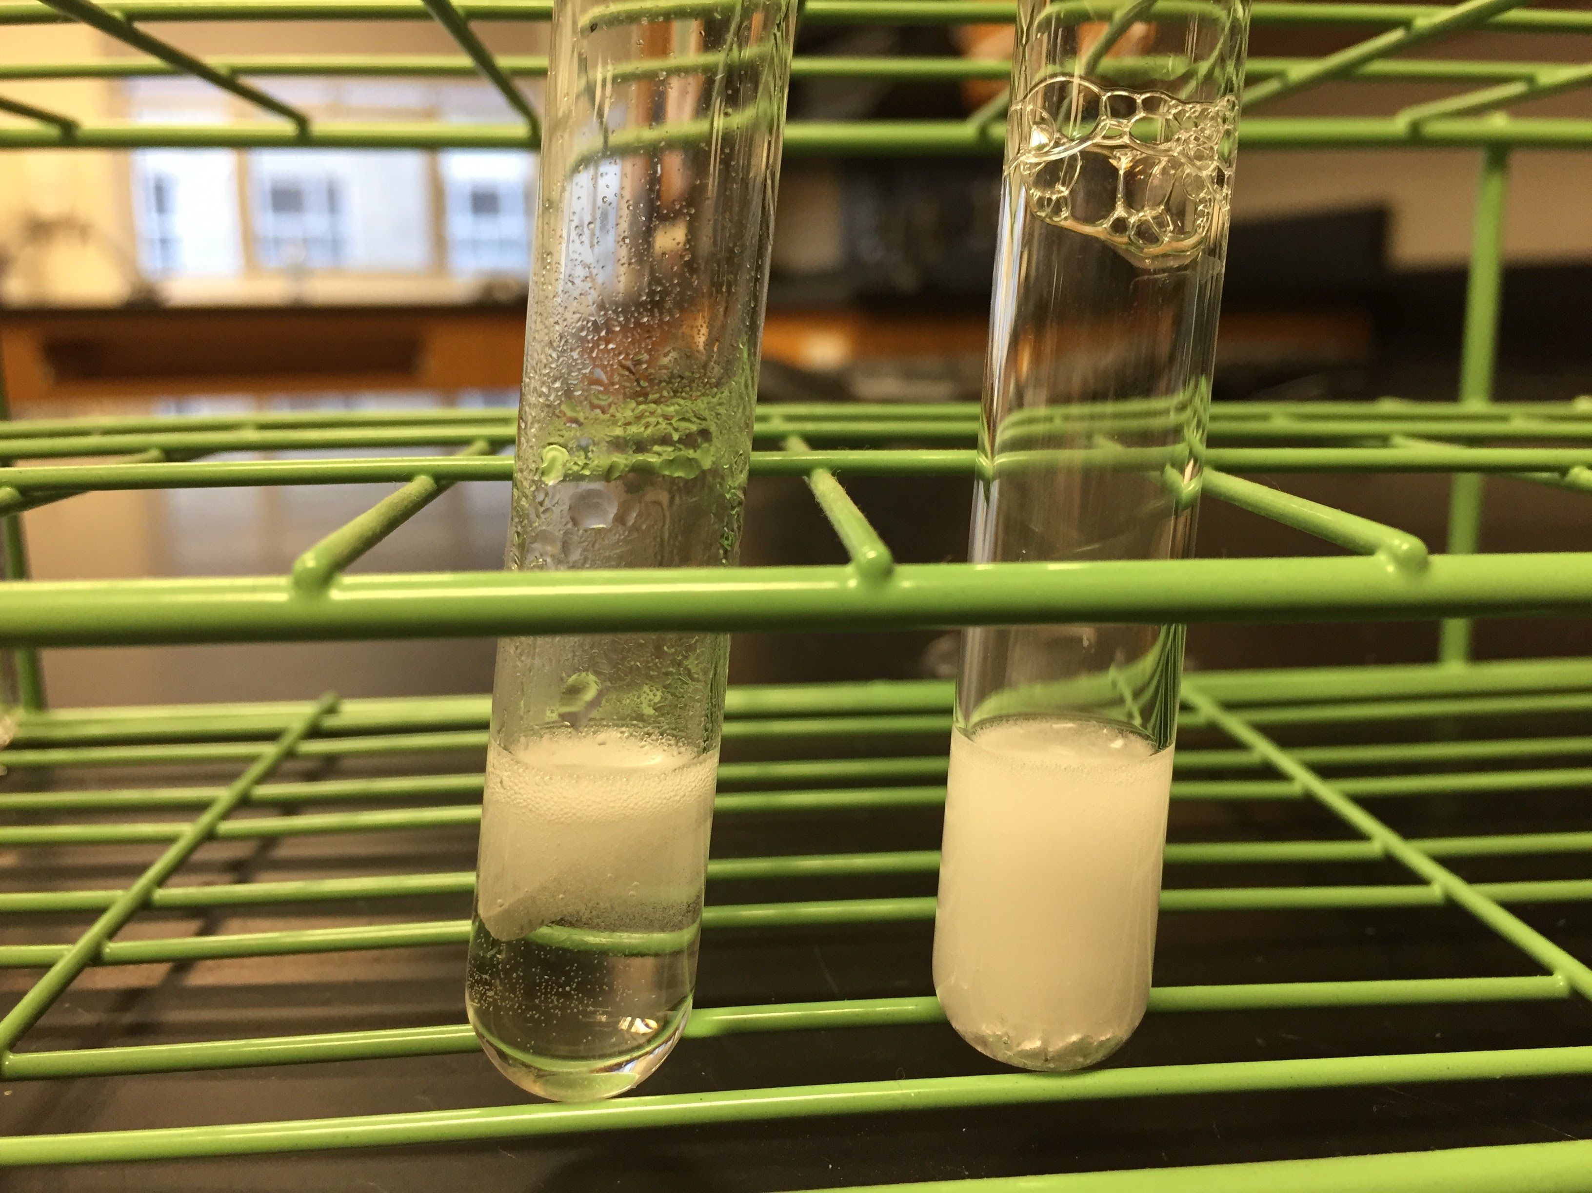

- Both forms of magnesium will work for this lab. If you are worried about how oxidized your calcium is, then the magnesium ribbon may be better because it is not as fast and intense as the turnings and students should easily conclude that it is not as reactive as calcium.

Zinc
- I have tried strips from zinc sheet (Item #Z0039), mossy zinc (Item #Z0003), and zinc dust (Item #Z0005). The strips and the mossy zinc work well. The reaction with the zinc powder is not as evident.
- In the pictures below, the tubes contain, from left to right, a freshly sanded small piece cut from zinc sheet, a single piece of mossy zinc, and a pea-sized sample of zinc dust.

After 30 seconds | After 1 minute | After 2 minutes
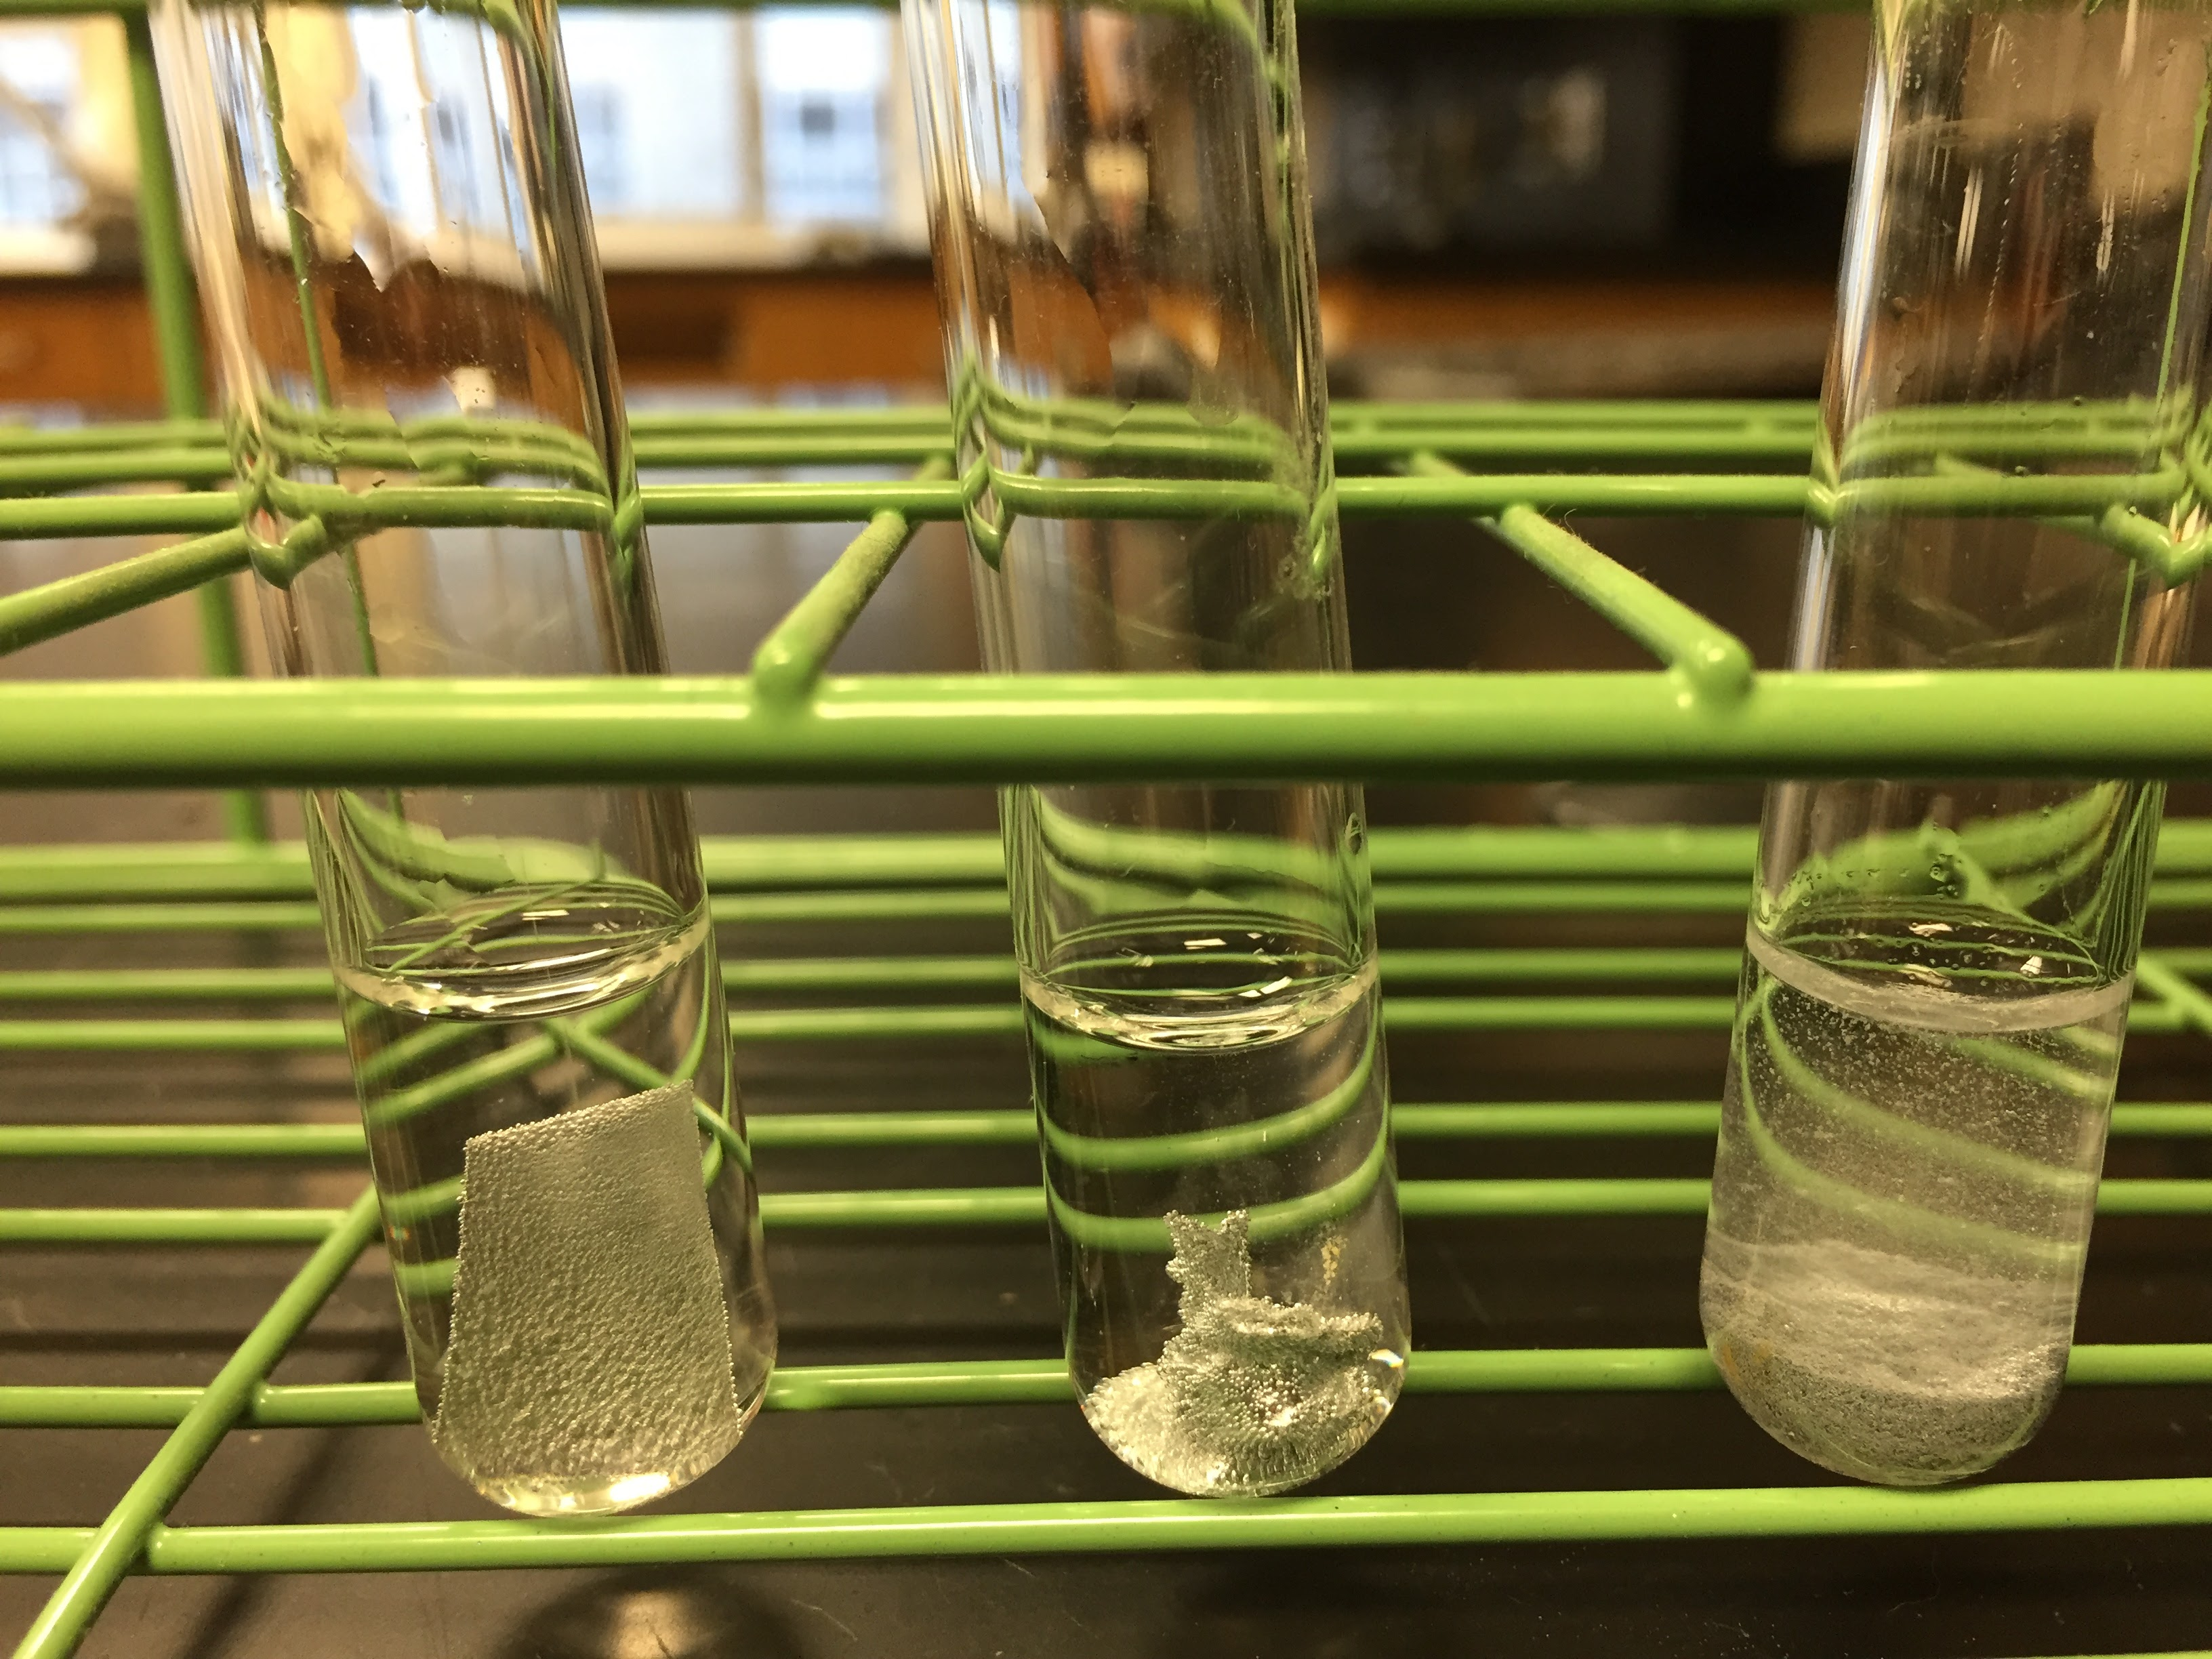 | 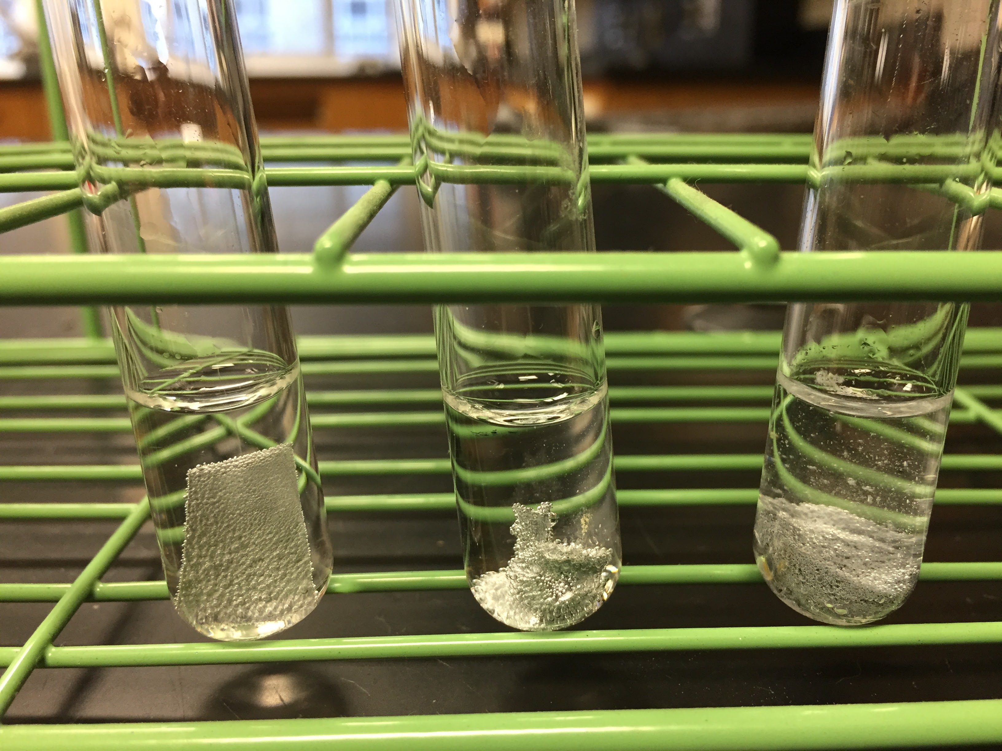 | 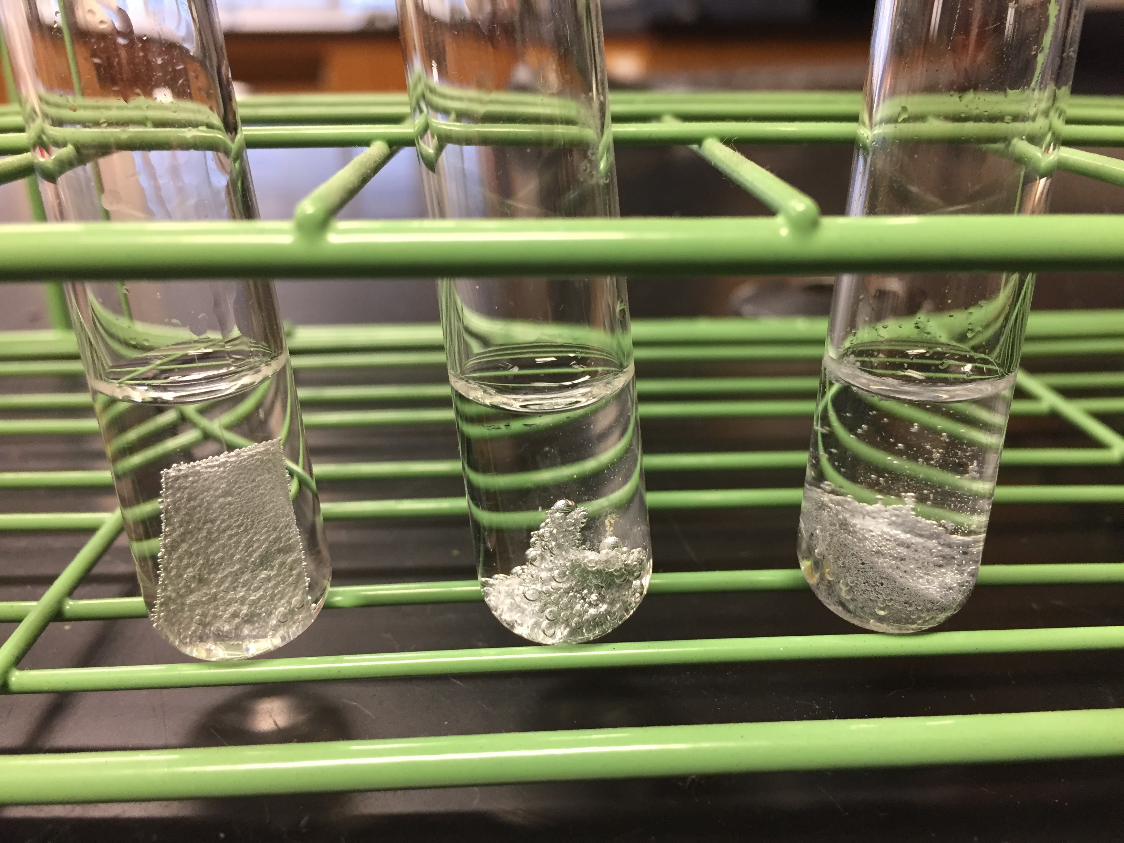

- You can see bubbles forming gradually on the surface of the zinc sheet and the mossy zinc. There are also bubbles emanating from the zinc dust, but they may not be as evident to a student, as it somewhat looks like dust settling, rather than bubbles.
- Best choices are either the zinc sheet or the mossy zinc. Both will have reactions much slower than that of magnesium, but much more evident than aluminum.

Preparing for safety
Chemical splash goggles, gloves, and aprons should be worn throughout the laboratory procedure. Students will be working with 1-molar hydrochloric acid. Safety precautions should be discussed and students should learn that any acid spills should be neutralized before wiping them up.

It is important to prepare the students for success by explaining procedures and alerting them to how they will gather their equipment and chemicals, especially if they have not used these lab procedures in the past. Each teacher should consider the layout of their own classroom and should guide the students appropriately toward safe and efficient procedures.

Lab tips
- Whenever working with metals and reactivity, I instruct students to use sandpaper to remove some of the protective oxide coating. In this lab, students will only sand metals that come as strips, sheets, or wires.
- Be sure to tell the students to add the acid while the test tube is in the rack and not in their hands. Alternatively, they could hold the tube with test tube tongs or rest it in a beaker. The calcium reaction will happen quickly and it surprises students when it runs up the tube and out onto their hands. They are so shocked that they don’t put the tube down! I have never had anyone injured because of this. I usually fast-walk to the table and grab a beaker or guide their hand to the test tube rack and instruct the student to thoroughly wash his/her hands.

- The amount of acid used is small and the hydroxide formed from the calcium reaction will neutralize any acid remaining in the other tubes if all tubes are mixed. Before disposing, be sure to allow the entire calcium sample to react. You can do this by adding water if any calcium remains in the tube. For disposal, I suggest one of two methods:
  - Place a paper towel in the bottom of the sink and pour contents of all tubes into it. Run water over it to thoroughly wash away the acid. Gather the metals in the paper towel and place them in the trash.
  - Pour the contents of all tubes into a beaker and add water. Decant as much as possible of the liquid into the sink and repeat four times. This will allow the excess acid to be partially neutralized and diluted so it can go down the drain. It also washes the acid off the metals so they can be discarded in the trash.
- You should always have baking soda on hand when working with acids to quickly neutralize any spills.

My school recently adopted a new schedule. In a 4-day rotation, I will see each class for two 57-minute periods and one 77-minute period. The following lesson schedule is a result of those class times. The laboratory portion can easily be completed in a 40-minute class.

The Lesson
The pre-lab activity will not take a full period. However, I have found it useful to plan this part of the lesson to occur on the day before the lab portion. This encompasses some discussion and some questions for students to work through. The goal of this portion is for students to understand how we will use reactivity to model the property of ionization energy. Note that I do not show hydrogen in its diatomic form because students have not yet studied molecules or chemical reactions.

If this lab is being performed by students who are already comfortable working in a lab, it will only take about 20 minutes. If students have little lab experience, then it will take longer as students are more hesitant and careful. I like to review the main ideas from the pre-lab in the beginning of the class period, then discuss safety and distribution/clean-up of chemicals. After students finish the lab, they are directed to complete the conclusion in their lab notebook and then begin on the post-lab questions. As this is an introductory lab, it may be useful to allow lab groups to complete the post-lab together.

ANSWERS
Some Concept Questions

- Consider some common metals you have seen. Are metals made of atoms or ions? How do you know?
Atoms. Metals are elements and elements are made of neutral atoms.

- Circle all of the ions in the following set:

H H⁺ Na Na⁺ K K⁺ Ca Ca²⁺ Mg Mg²⁺ Zn Zn²⁺ Al Al³⁺

- Explain what would have to happen in the atom for each of the following changes to occur:
Na Na ⁺ Al Al³⁺ H⁺ H
Sodium atom would have to lose 1 electron | Aluminum atom would have to lose 3 electrons | Hydrogen ion would have to gain 1 electron

- Explain what is happening (hint: follow the electron) in the following reaction:
H⁺ + M H + M⁺
The hydrogen ion is attracting an electron away from the M atom. H goes from positive to neutral and M goes from neutral to positive.

- Use the following data to determine whether element A or element B has a higher “ionization energy”.
H⁺ + A immediate bubbling
H⁺ + B no reaction
Element B has a higher ionization energy. I know this because the H⁺ was able to attract an electron away from A as evidenced by the reaction. That means that the electron on B must be more attracted to its nucleus than to the H⁺, so it would take more energy to pull it away from the atom, leading to a higher ionization energy.

Post-Lab Questions

- Use the results from your data table to rank the metals from LEAST to MOST reactive.

Aluminum, zinc, magnesium, calcium

- Use the answer to question 1 to list the elements in order of increasing ionization energy. (Will it be the same order or the opposite from the previous question?)

The opposite. Calcium, magnesium, zinc, aluminum.

- Which of the tested elements are in the same group on the periodic table?

Calcium and magnesium

  - Assuming these elements represent the larger pattern, does ionization energy of atoms increase or decrease going from the top to the bottom of a periodic table group?

According to the pattern in #2, calcium has a lower ionization energy than magnesium, so the pattern shows that ionization energy increases going from top to bottom of the group.

  - Use the electron configuration for each of these elements to create a Bohr diagram. Place them in the boxes according to their position on the periodic table. For each element, circle the electrons that would be lost if a reaction occurs.

  - Connect Coulomb’s Law with atomic structure to explain WHY the pattern in 3a makes sense.
The electrons being removed from calcium are farther away from the nucleus than those of magnesium. According to Coulomb’s Law, when charges are farther from each other, their attraction is lower. Though calcium has more protons than magnesium, its extra energy level shields these from having an effect on the attraction.

- Identify any two elements that are in the same period on the periodic table? (There are two sets.)
Either calcium and zinc or magnesium and aluminum

  - Assuming these elements represent the larger pattern, does ionization energy increase or decrease going from left to right across a period of the periodic table?
Since the pattern in #2 states that zinc has a higher ionization energy than calcium (or aluminum has a higher ionization energy than magnesium), the ionization energy must increase going from left to right across the period.

  - Use the electron configurations for each of these elements to draw a Bohr diagram. Place them in the boxes in their relative positions on the periodic table. For each element, circle the electrons that would be lost if a reaction occurs.
One set or the other!

    - In which period are these elements placed on the periodic table?
Three (for Mg/Al) or Four (for Ca/Zn)

    - What is the highest major energy level in each of these atoms that contains electrons?
Three (for Mg/Al) or Four (for Ca/Zn)

    - Which atom has more positive charge in its nucleus?
Aluminum or Zinc

    - Connect Coulomb’s Law with atomic structure to explain why the pattern in 4a makes sense.
Since aluminum has more protons in its nucleus, but the same number of occupied energy levels, Coulomb’s Law states that the attractive force will be higher for aluminum because there is a higher charge on the nucleus. Since the outer electrons on magnesium and aluminum are on the same energy level, their distance from the nucleus is similar.

- Considering the patterns, how would you expect the reactivity of gallium in acid to compare to the reactivity of aluminum in acid? Explain your reasoning.
Since gallium is below aluminum on the periodic table, I’d expect its ionization energy to be lower and its reaction to be faster.

- Describe the reaction you would expect with strontium metal in acid? Explain your reasoning.
Since strontium is below calcium on the periodic table, I’d expect it to react even more violently because it’s ionization energy is lower, allowing the H⁺ ion to easily attract its outer electrons.

