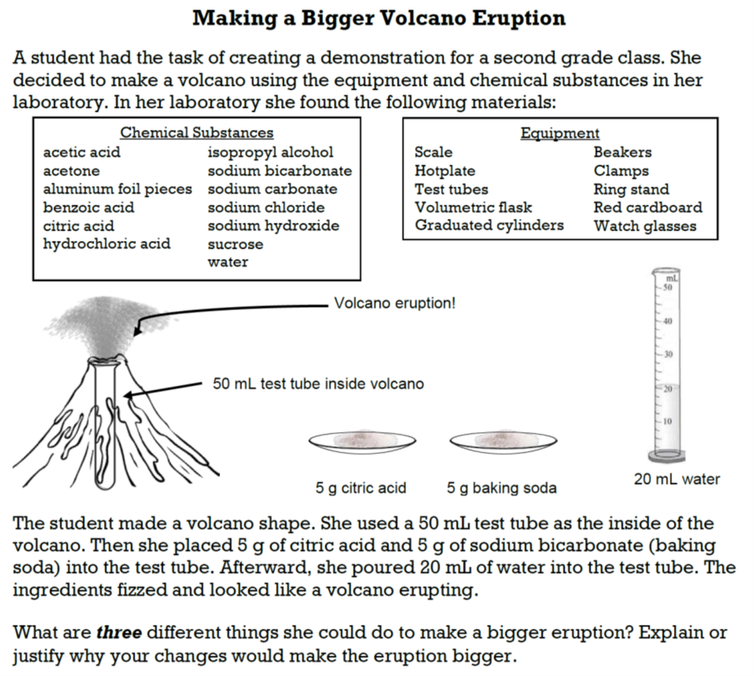
Volcano demonstration formative assessment probe (the “volcano probe”).

