Data collection sheet for the Explore phase activity.
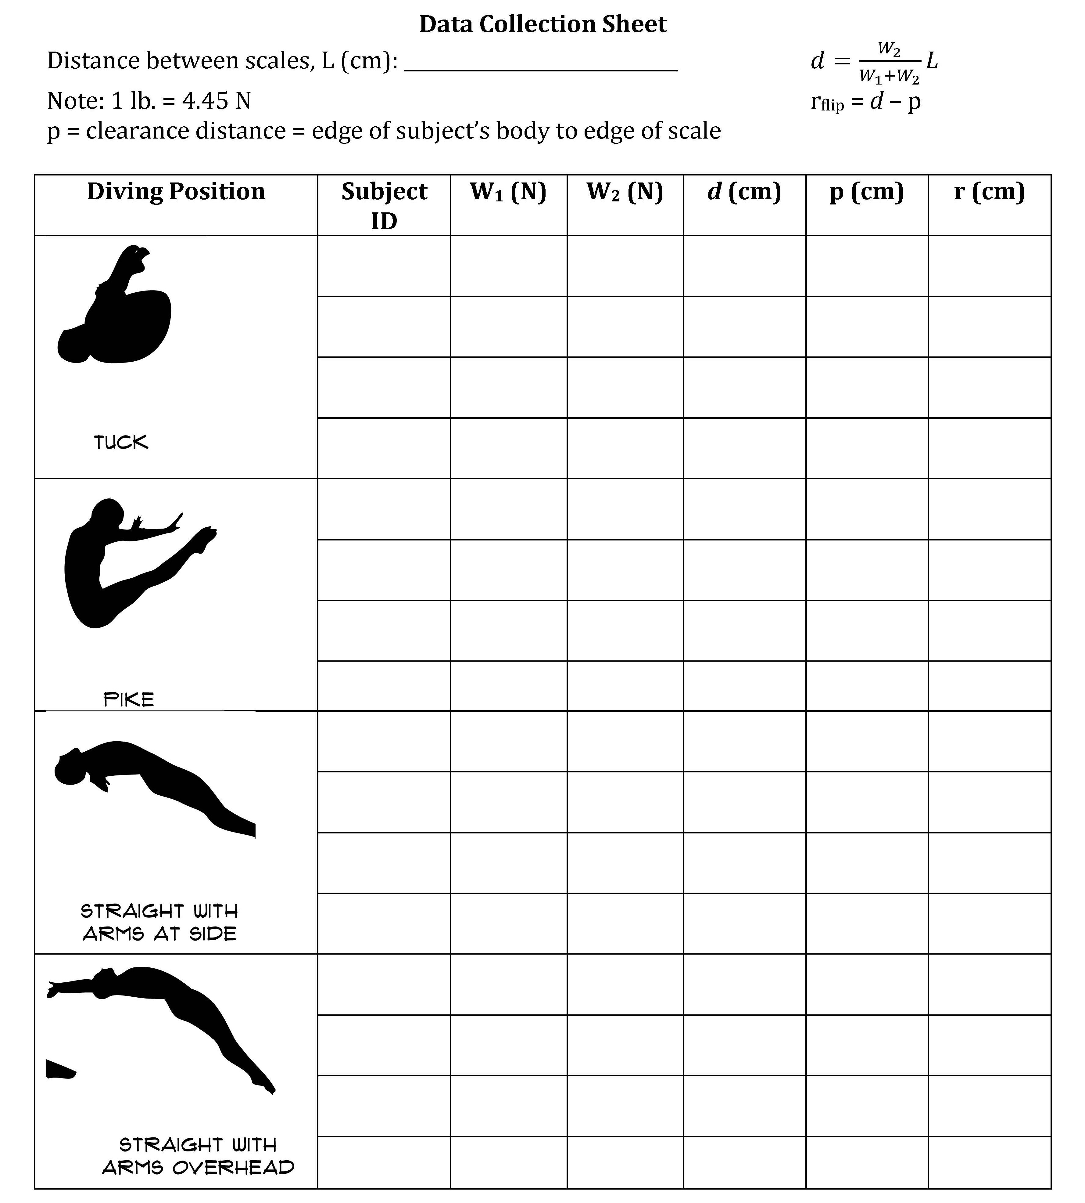

Data analysis prompts for Explore phase activity.

