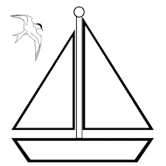
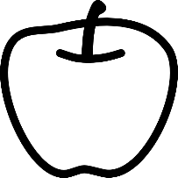
Apple Sailboats

- ASK
What is the Problem?
Johnny Appleseed loved to plant apple trees. He planted apple seeds together so that they would grow into an orchard. Johnny made cider from the apples.
I bet Johnny Appleseed knew that apples float. I wonder if he ever used an apple to make a toy sailboat. Wind moves a sailboat by pushing on the sail. A sailboat can take the apple seeds down the river. Boys and girls can play with apple boats, too!
We can make an apple sailboat. How do you make the boat go straight? How do you make the boat go far? What will your boat look like?

What is the Goal?
To design and build an apple sailboat.

What are the Rules?
You will work with a friend.
A good boat will go straight.
A good boat will go fast.
A good boat will not tip over.
You will make a boat from only these materials

- Apple (1)
- Paper
- Scotch Tape
- Toothpicks (6)
- Short wood skewer (2)
- Plastic coffee stirrer (2)
- Wood coffee stirrer (2)
- Craft Stick (2)

You will use these tools to make your boat

- Scissors
- Marker
- Pencil
- Knife (used by teacher)

You will test your boat with these things
- Plastic bin
- Water
- Small Box Fan

What do we know about boats?
What does a boat look like?

What are the parts of a boat?
hull mast sail keel

- IMAGINE
Brainstorm how each material may be used and changed
How can you use

- the apple?
- the paper?
- the toothpicks?
- the short wood skewer?
- the plastic coffee stirrer?
- the wood coffee stirrer?
- the craft stick?

How can you change

- the apple?
- the paper?
- the toothpicks?
- the short wood skewer?
- the plastic coffee stirrer?
- the wood coffee stirrer?
- the craft stick?

Brainstorm how materials can be used together to solve the problem
How do you want to cut the apple to make the hull?
- How many pieces?
- What shape will the pieces be?

How do you want to cut the paper to make the sail?
- What shape?
- How big?
- How will the sail attach to the boat?

How do you want to make your mast?
- How tall?
- How many?
- Which material?
- Where does the mast go?

How do you want to make your keel?
- How long?
- Which material?
- Where does the rudder go?

We will make a model of our apple boat first.
Use Play-Doh to make a model of the hull.

Make the sail and mast. Put the sail and mast in the Play-Doh model.
- Does your model fall over?

Draw a picture of your sailboat design:

- TRY
Use materials to show the teacher an idea
- Show the teacher how to cut the apple to make the hull.
- Use the marker to draw on the apple.

Create the Design

Test the Design

- TRY AGAIN
Reflect on testing results
What did your boat do well?

What did your boat not do well?

Reflect on how to improve
How can you fix your boat?

How can you make your boat go faster?

How can you make your boat go straight?

Create the new Design

Test the new Design

