Can you Connect?
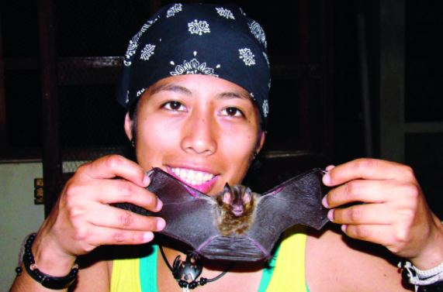
Meet: Kathrin Barboza

- Born in Bolivia, South America
- She is a biologist (a scientist who studies life)
- She is known as an expert in bats!
- Scan the QR code to learn more!
https://bolivianthoughts.com/2013/11/17/-bolivian-kathrin-barboza-defender-of-bats-that-impacts-science/
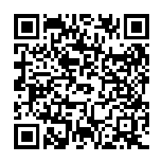

Can you Connect?
Meet: Mae Jemison
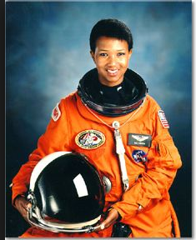

- The first African-American woman in space!
- She was born in Alabama
- Her father was a roofer and carpenter
- Not only is she an astronaut, she’s also a medical doctor!
- Scan the QR code to learn more!
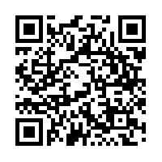
https://www.biography.com/people/mae-c-jemison-9542378

Can you Connect?
Meet: Maria Fadiman
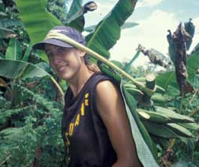

- Raised in California
- She is a botanist (a scientist who studies plants)
- Maria loves the rainforest!
- She enjoys learning about how plants can help people every day
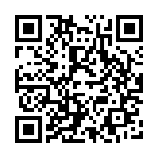
- Scan the QR code to learn more!

http://www.nationalgeographic.com/explorers-/bios/maria-fadiman/
Can you Connect?
Meet: Chung-Pei Ma
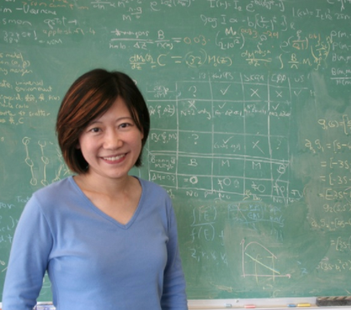
- Born in Taiwan
- She is an astrophysicist (a scientist who uses math, physics, and chemistry to study space)
- She plays the violin
- She and her team discovered some of the largest known black holes!
- Scan the QR code to learn more about black holes in space and her discoveries
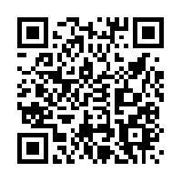
http://www.pbs.org/newshour/bb/science-july-dec11-blackholes_12-06/

Can you Connect?
Meet: Jane Goodall
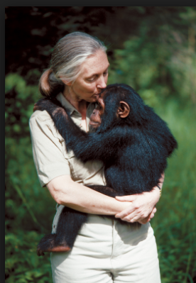
- She was born in London, England
- She is a primatologist ( A scientist who studies animals that are primates)
- She is considered the world’s expert on chimpanzees!
- Scan the QR code and learn more about Jane Goodall
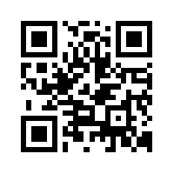
http://www.janegoodall.org/

