The instructions that follow are for a styrofoam cup.
Required materials for Buddy’s companion bot include the following items (per group of 3 - 4 students): 1 Styrofoam cup, 1 LED light, 1 pair of scissors, 1 CR2032 button battery, 40 cm conductive tape, one small binder clip. For illustrations on the internal circuitry of the companion bot using a styrofoam cup, see figures 1-14 below.
*Safety note: Before beginning the Elaborate component of the lesson, provide each student with vented PPE goggles to protect their eyes from the potential of flying sharps. School scissors should be used to cut conductive tape. The authors used Maker Tape from www.browndowngadgets.com. Due to the size of CR2032 Button Batteries remind students to use the batteries for the project and not to place them in their mouth.

First, bend the LED stems in opposite directions (Fig. 4). On most brands of LED bulbs, the longer stem is the positive lead while the shorter stem is negative (Figs. 2 and 5). Locate the negative and positive LED stems. Clip the c-tape into two equal sections. Remove a small portion of adhesive backing from the c-tape and wrap one end around the positive LED stem (Fig. 4). Repeat this process with the second piece of c-tape on the remaining negative LED stem. Pinch the c-tape around each LED stem to insure a snug fit. Insert the LED bulb into the center of the bottom of the styrofoam cup, so it is sticking through the styrofoam (Fig. 7). Gently remove any remaining adhesive backing to secure the conductive tape against the walls of the cup. On the inside of the styrofoam cup, mark the positive and negative sides of the LED stems (Fig. 7). Extend the c-tape outside the cup, so excess can be used for building a switch (Figs. 8 and 9).

Switches require proper connection and placement of the battery. Teachers may want to retain and account for all batteries until placing them in the bots. Move the excess c-tape close to the rim of the cup. Place the battery’s positive side on top of the tape connected to the positive LED stem (Fig. 10). Attach the binder clip atop the battery and c-tape to keep them connected. Affix the negative excess tape to the outside of the cup and under the clip, connecting it to the negative side of the battery. Once the circuit is complete, the LED bulb will illuminate (see Figs. 5 - 11 below). Prevent the c-tape from touching while the battery is connected; doing so can short the bulb (Fig. 9).

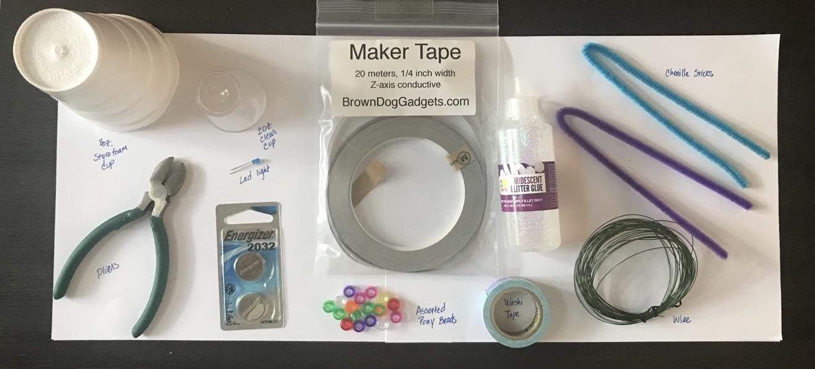
Fig. 1. All needed materials
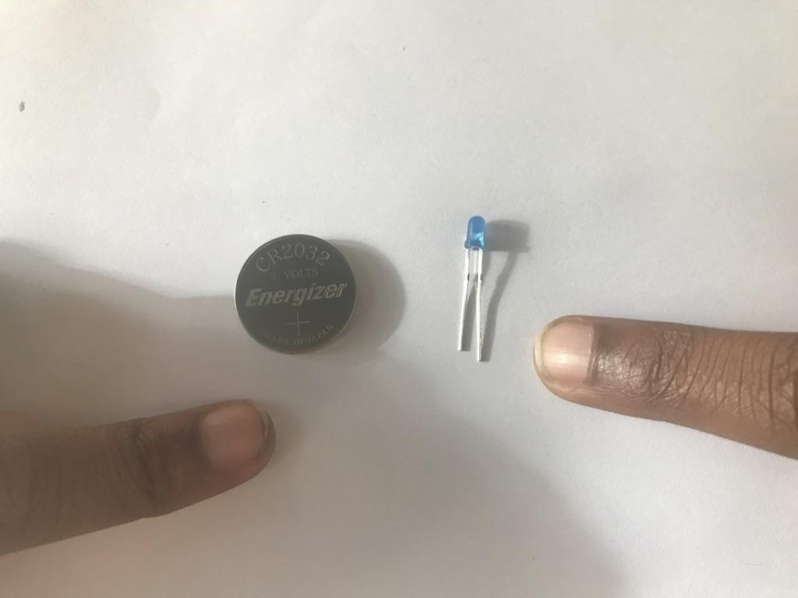Fig. 2 Battery and LED bulb with different stem lengths 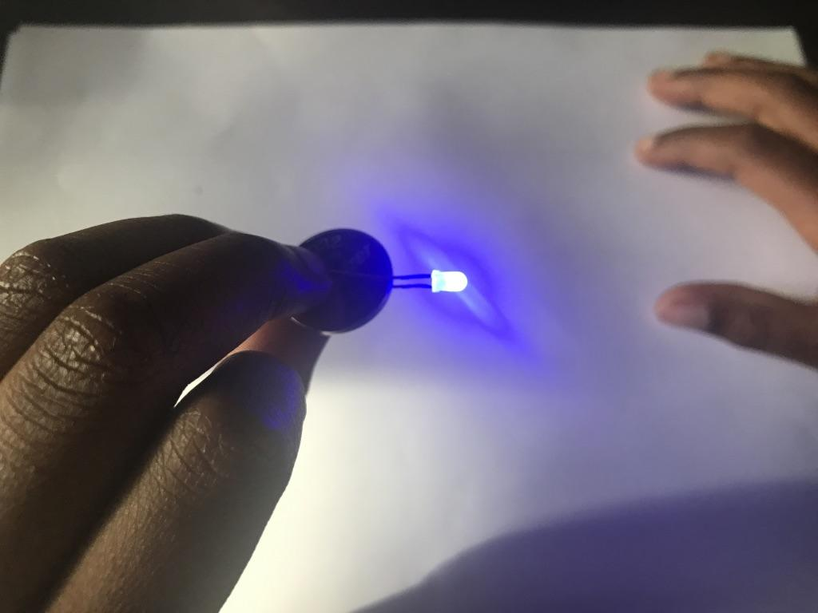Fig. 3. Battery inserted between LED stems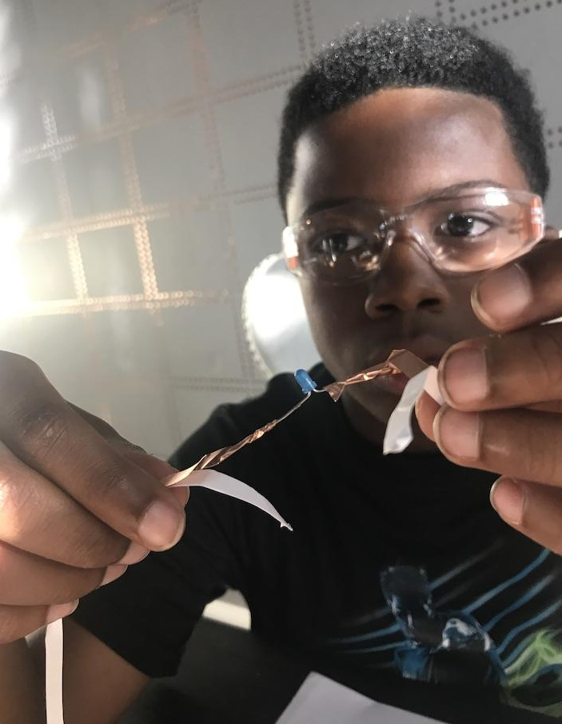 Fig. 4. Copper tape wrapped around LED stems
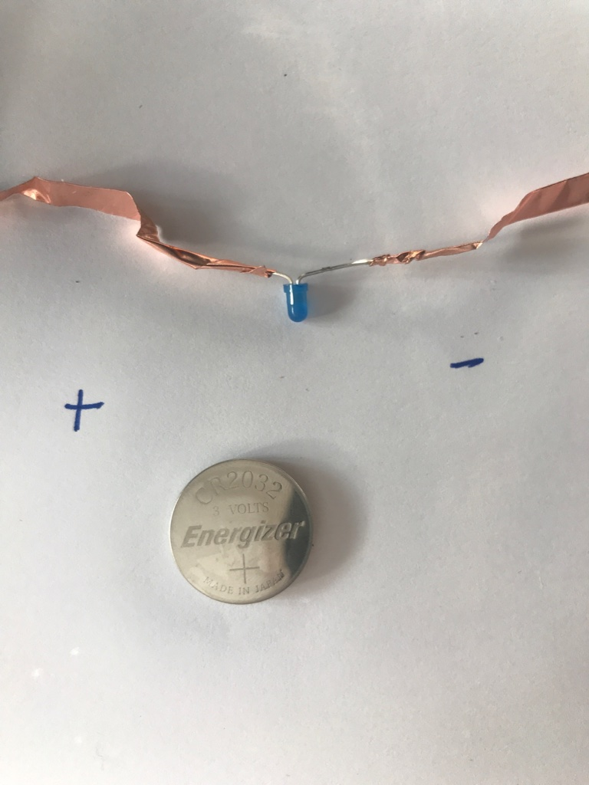 Fig. 5 Label positive and negative LED stem sides 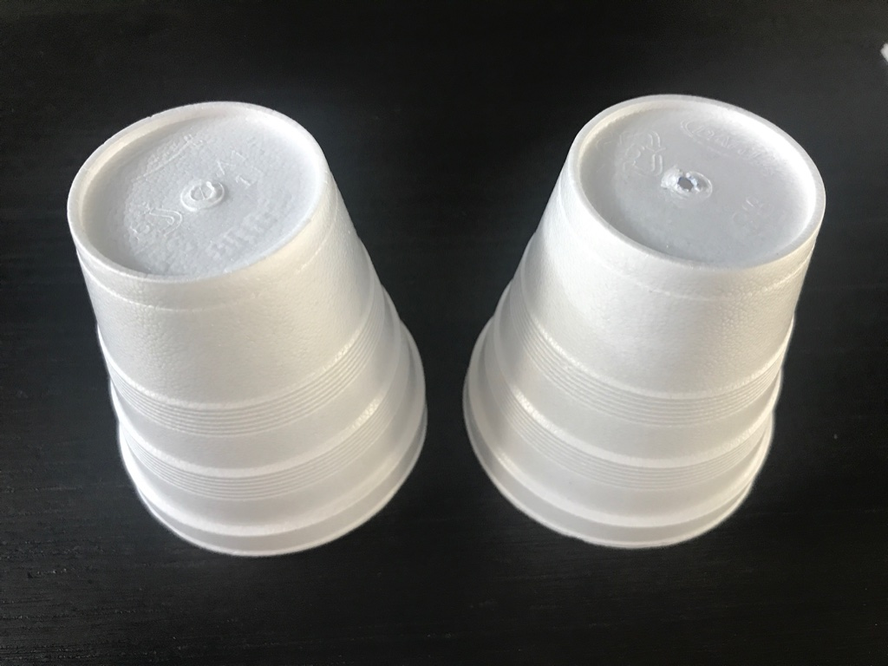Fig. 6 Styrofoam cup without and with hole 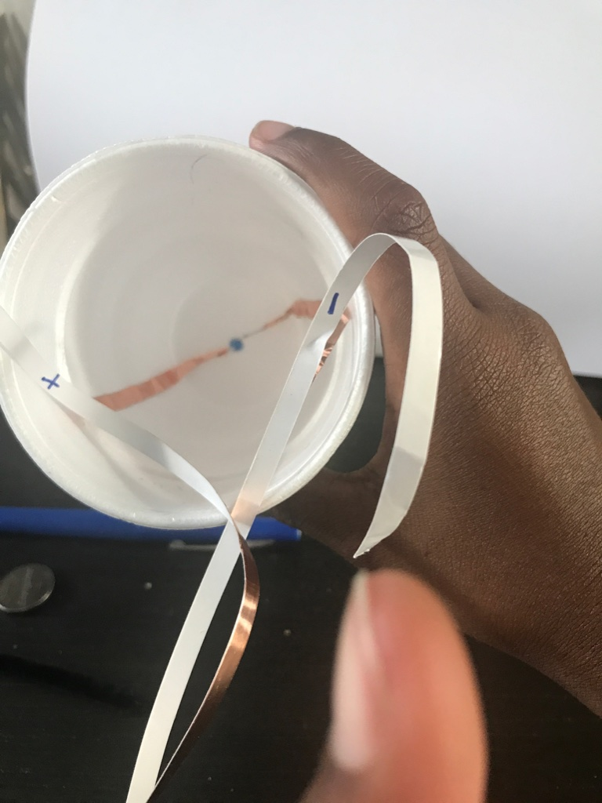 Fig. 7. Labeled copper tape adhered to cup
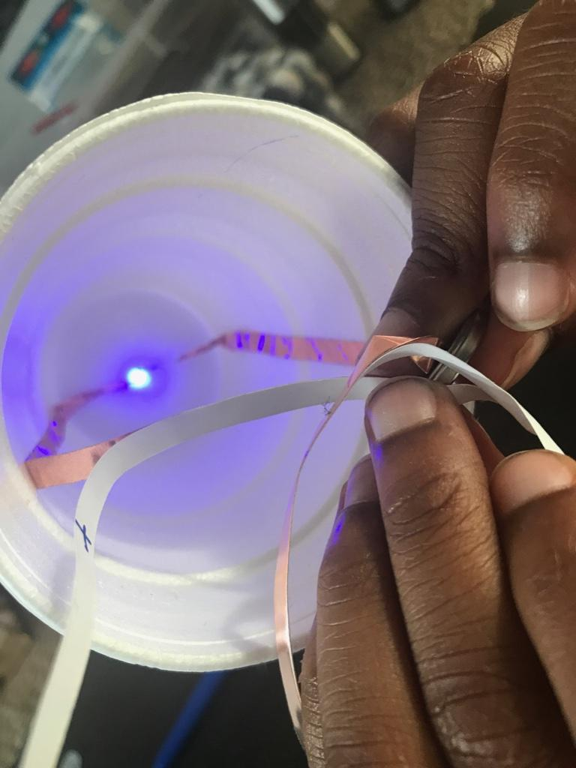 Fig. 8 Matched positive LED stem with positive battery side

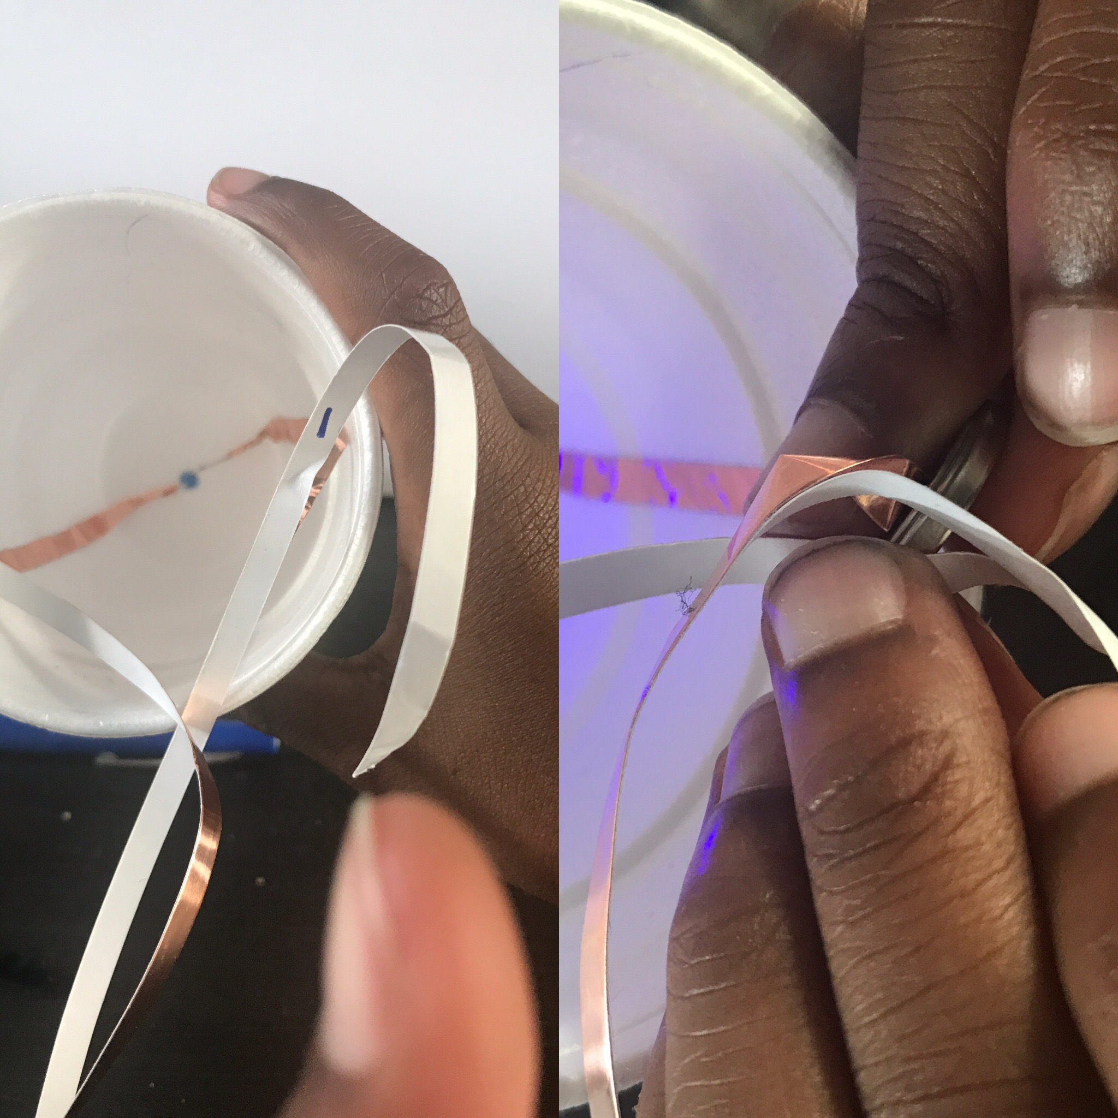Fig. 9 Prevent crossed copper tape or wire when battery added
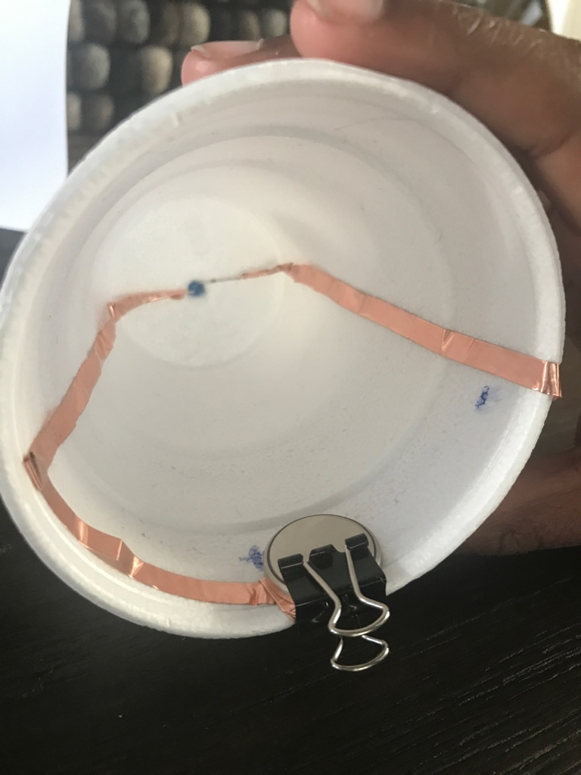Fig. 10 Copper tape covered LED stems connected to battery
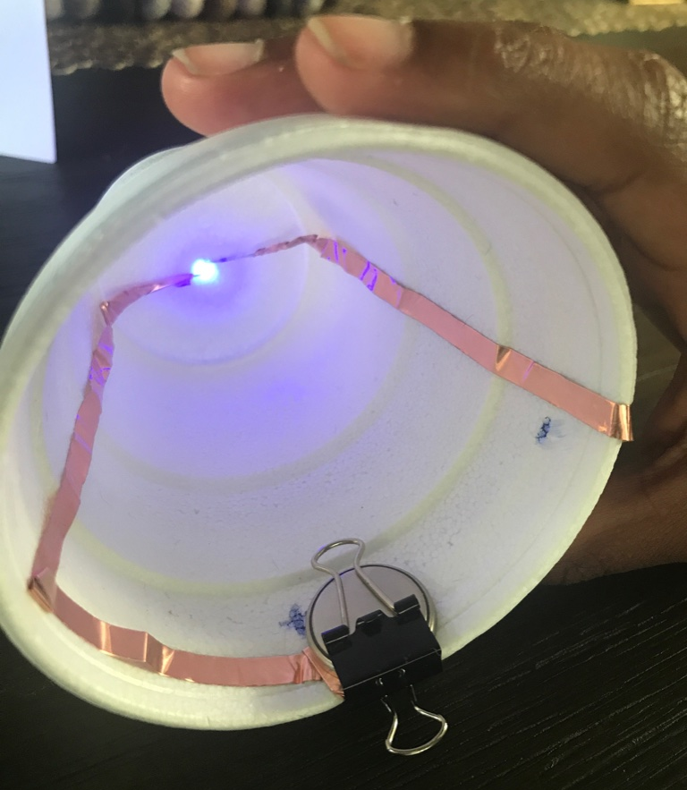Fig. 11 Flipped clip to turn on LED

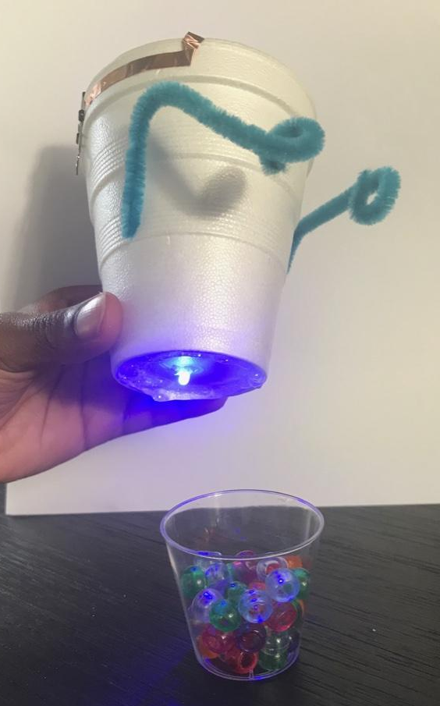 Fig. 12 Placed glue around styrofoam cup and LED 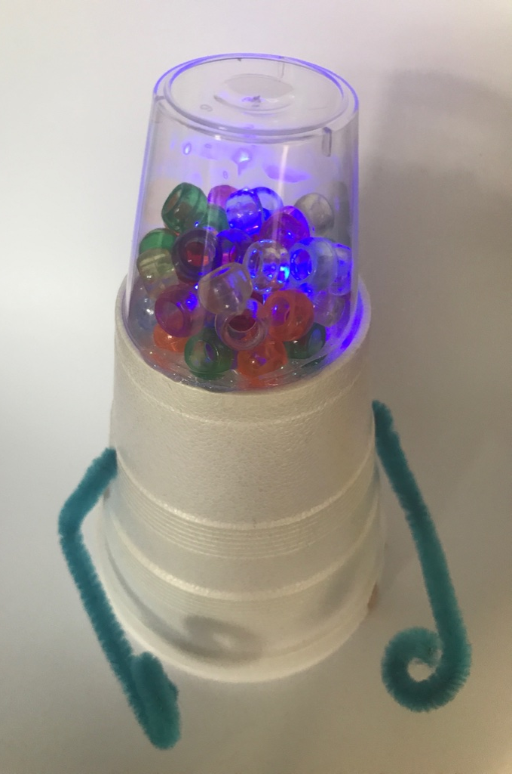 Fig. 13 Affixed clear cup to styrofoam cup
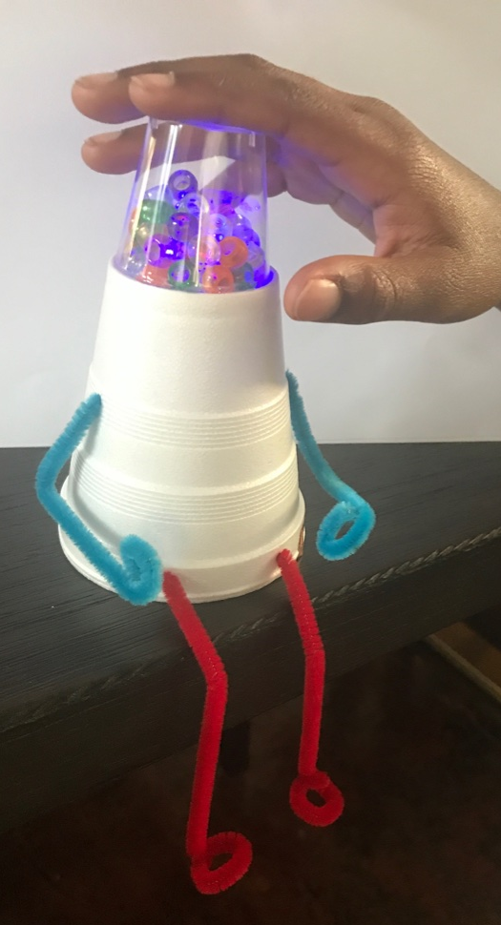Fig. 14 Added chenille stick legs

