Paper Airplane Reading for Students

Forces Demonstrated by Paper Airplanes

Drag and Gravity
A paper airplane with drag is pushing a lot of air creating resistance or drag. If you want a paper airplane to fly far then you want to design a paper airplane with as little drag as possible. Paper airplanes also have to overcome the force of gravity. When we throw paper airplanes they do not keep flying continuously, instead, they fall down to the ground because of the force of gravity. Gravity is an invisible force that pulls objects to the center of our planet Earth. Objects, like the Earth, with greater mass pull more than objects with less mass (paper airplanes). Keeping the paper airplane’s weight to a minimum will help fight against the pull of gravity.

Thrust and Lift
The forward movement of a paper airplane is called thrust. Pilots use their muscles to thrust the paper airplane forward. After the initial thrust, the paper airplanes become gliders. Lift is a result of the air below the paper airplane wing pushing up more than the air above the wing of the airplane pushing down. The difference in pressure is actually what makes the paper airplane fly. The airplane will move faster when the pressure over the wings is reduced by making the air move over it quickly such as wings that are curved. The forces of thrust and lift help your paper airplane to make a longer flight.
When the four forces are balanced they will achieve a longer flight. Planes like the basic dart are designed to be thrown with a lot of force. They depend on that extra thrust to overcome gravity since they do not usually have a lot of drag and or lift.

How Do Paper Airplanes Fly?
Paper airplanes are usually gliders. A paper airplane includes a body and wings. The wings of the paper airplane create a difference in pressure which allow the plane to rest or “sit” on the air. The wings push down on the air underneath them which causes higher pressure under the wings than on top of the wings. Thus, the air above the wings has lower pressure. This difference in pressure is called lift which allows the paper airplane to fly.

Figure 1 shows and identifies the various basic parts found on most airplanes.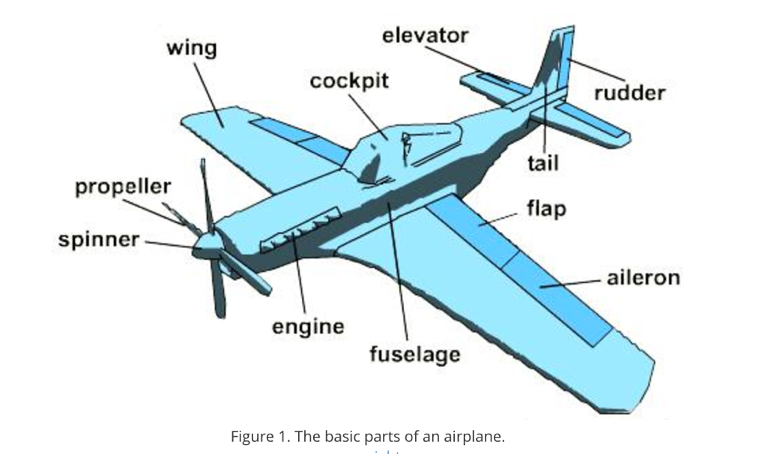
The performance of a paper airplane may be changed by adding features like rudders, tails, ailerons and/or flaps. The flaps can help turn the plane while a rudder may help stabilize the plane (Figure 1 retrieved from: https://www.teachengineering.org/lessons/view/cub_airplanes_lesson06).
References
Willis, S. (2005). Tell Me why Planes Have Wings. Salariya Publishers.

