Go Fly a Kite!
NGSS Performance Expectation:
K-2 ETS 1-3. Analyze data from tests of two objects designed to solve the same problem to compare the strengths and weaknesses of how each performs.
English Language Arts Common Core State Standards:
CCSS.ELA-LITERACY.RF.K.1 Demonstrate understanding of the organization and basic features of print.
CCSS.ELA-LITERACY.RL.K.1 With prompting and support, ask and answer questions about key details in a text.
Background:
Kites are a fun way to learn about gliders and lift in the air. In this activity, you will explore what materials, shapes, or sizes might be best for a kite.
Questions to Consider:
What is the best shape for your kite? What is the best size? What is the best material? What does ‘best’ mean for you: How high it flies? How long it flies? How easy it is to get in the air? How might you measure this?
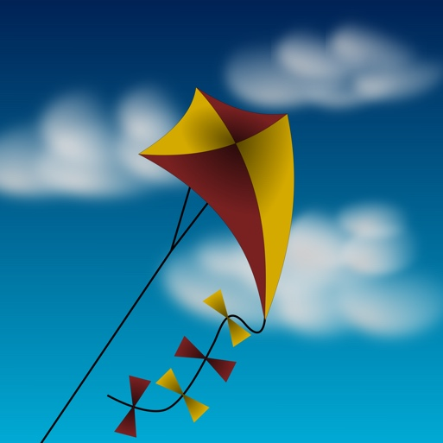
Materials:
- Just a Kite by Mercer Mayer
- Printer paper
- Cardstock
- Construction paper
- Tissue paper
- Straws
- Tape
- Hole punch
- Scissors
- String
- Kite template
Reading Guide:
Before doing the activity, read Just a Kite. A reader’s guide can be found in the “Lab Assistant’s Page” section of the backpack.

Safety Notes:
Make sure children remember to:
- Listen and follow directions
- Use equipment (like scissors and the hole punch) safely and responsibly. If necessary, have an adult use this equipment.

Procedures:

- Provide your child with the different materials and allow your child to choose one to make their kite.
- Trace the kite template and cut it out.
- Tape the straws down on your kite as indicated on the template.
- Place tape where the string-holes will be for your kite (this reinforces the holes). Then punch holes through the tape and kite.
- Tie a 12-inch string through each hole. Attach the two strings to a longer string to fly the kite.
- Fly the kite either by using a fan or running outside to catch the wind.
- Ask: What does a ‘good’ flight look like? How do they know? How might they redesign their kite to make it a ‘better’ flight?

Extensions:
- Allow your child to redesign their kite several times using materials not in the bag. Encourage your child to record their observations or measurements in a way that makes sense to them.
- Allow your child to try flying their kites in different weather conditions, locations, or times of day. Ask them what they think the ‘best’ conditions are to fly a kite and have them justify their answer.
Online Resources:

- PBS Zoom Activities
http://pbskids.org/zoom/activities/sci/
- MyBestKite.com
http://www.my-best-kite.com/how-to-make-a-kite.html

Local (city/state) Resources:

- Discovery Center
http://www.dcidaho.org/
- The Treasure Valley Kite Festival is every March/April in Kleiner Park in Meridian.
https://www.facebook.com/TVKitefestival/

From the library:

- Planes Fly! by George Ella Lyon
- How to Make a Kite by Colleen Hord
- Clorinda Takes Flight by Robert Kinerk
Student Recording Sheet

DESIGN: Why did you choose a certain material to make your kite?

TRY IT OUT!: Draw what happened when you launched your kite.

REDESIGN: Try a different material or design. What does it look like? Draw it here.

TRY IT AGAIN!: Try out your new kite. Draw a picture of what happened. Did anything different happen this time?
Lab Assistant’s Page (For Adults’ Eyes Only)

Discuss What Happened…
Reading Guide...
Read Just a Kite. As the story is read, encourage your child to use their finger to follow along with the words as they are spoken aloud. Encourage them think about what you need to fly a kite. You might want to ask questions such as:
- Why does it need to be windy for a kite to fly.?
- Several of the pictures show a variety of kites. What shape is your favorite? Why?
- Look at the picture of Grandpa building the kite. What materials do you think he used?
The Science Behind Kites…
When the wind catches a kite and allows it to fly, you are seeing lift. Bernoulli’s Principle is often used to explain lift in terms of airplanes. When air hits the front of an airfoil-shaped wing, some air goes over the top of the wing and some goes below the wing. The air on the top has a longer distance to travel, but must do so in the same amount of time, causing the air on top to move faster. These faster moving particles have more room to spread out, causing an area of low pressure. The slower moving particles underneath the wing are more tightly packed, creating an area of low pressure. The area of high pressure pushes towards the area of low pressure to try to equalize the pressure. This is lift. In terms of a kite, think of it as a vertical airplane wing. The air behind the kite is the area of high pressure and the air in front of the kite is the area of low pressure, ‘pushing’ the kite forward in the sky. Because the kite is tethered to whoever is flying it, it continues to fly higher and spin around.
The Engineering Process...
Children are natural engineers! They want to figure out how things work, or how to make things work for them. Key to the engineering process is having students design something, test it, make improvements upon the design, and test it again. You may also want to challenge your child by introducing constraints or new challenges so they have to change their designs.

