Supplement: Example Summative Assessments for Fast Plants Investigations

Note: Working with students in earlier grades (e.g., K-3), we have found that we need to use a combination of written and oral questions/probes to fully understand students’ thinking about the investigation.

Written Assessment Item 1: Justifying a claim based on evidence

What do you think the Just Right amount of light for Wisconsin Fast Plants is? Write an argument to answer this question that tells what you think and what your evidence is.

- Try to write the argument so that someone who is not a member of Mrs. Wade’s classroom could understand it. You might need to explain what your evidence means and why it is important for answering the question.
- Use your Fast Plant Investigation Journal and the different displays we have made (the number of seedpods, the heights of plants on different days) to help you find evidence.

Teacher questions for individual conversations or when moving around the room as students are writing their claims and evidence

- What did you find out the Just Right amount of light for Fast Plants was?
- How did you know? What was your evidence?
  - Probe: Were there other kinds of evidence you used?
- Which do you think is the most useful kind of evidence for understanding whether a plant is successful: height, color of leaves, or number of seedpods? Why?
- Why did we use WFP’s and do an investigation indoors instead of just going right outdoors to look at the conditions in the backyard?
  - Probe: Do you think there were any problems with using this investigation to understand what happens in the backyard?
  - Probe: Would it have been better if we used one of the plants in the backyard in our indoors investigation?

Written/Oral Assessment Item 2: Critique of Fictional Students’ Evidence
Another class set up an investigation to see if the amount of moisture mattered for the growth of the marigold plant.
- They had all the plants in lightboxes with the light on all the time.
- Some plants they gave 1 small cup of water to per day, some plants they gave 5 cups of water to per day, and some plants got 10 cups of water a day.

On Day 42, Joshua thought that the plant with less water was more successful. Here is his evidence sheet.
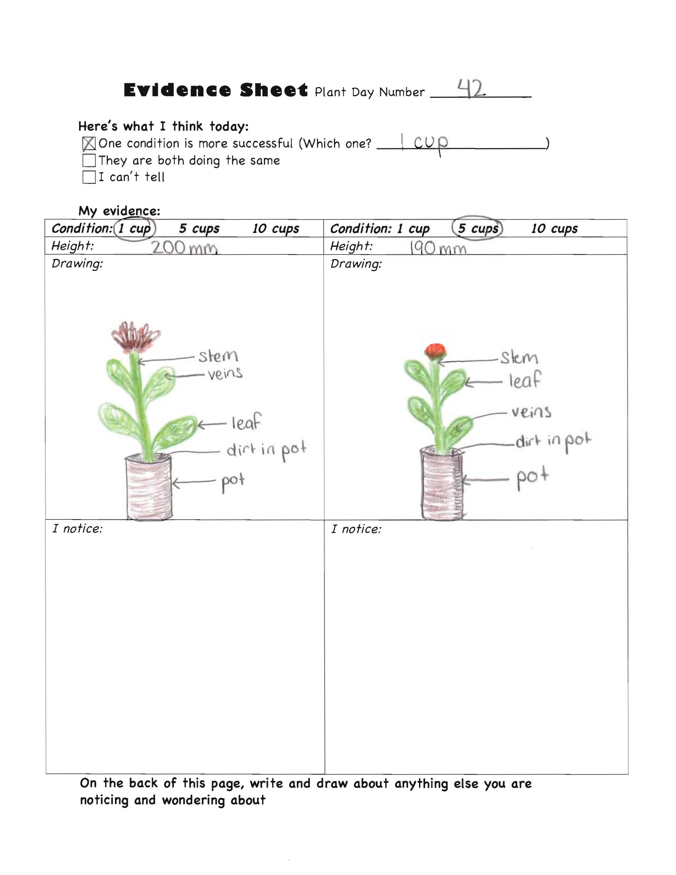
- Do you think that Josh’s evidence page is convincing? Does it do a good job of making you sure you agree? Why or why not?

- What questions would you ask to decide if you agreed with Josh?

- How should Josh improve his evidence page?

