Virtual Image in a Plane Mirror
Phenomenon: When a candle in front of a plastic/glass surface is lit, the unlit candle behind plastic or glass appears to be aflame if placed at the same distance behind the surface. This happens because plastic and glass both reflect and transmit light. When the plastic/glass is replaced with a mirror, and no light is able to go through, the mirror forms a virtual image of the lit candle at the same distance behind the surface of the mirror.
Learning target: an image caused by a mirror reflection is located at the same distance behind the mirror as the object is placed in front of the mirror.
Fun student challenge: can you set a candle of fire without using flame?
Common misconceptions uncovered by the investigation:
- The law of reflection works only for special angles or plane surfaces
- Light from a light source travels perpendicular to the reflective surface and then reflects at some angle to enter the eye.
Materials: Lazy Susan turntable, CD case, plane mirror, two birthday candles of the same height, matches/lighter, modeling clay, ruler, aluminum foil, permanent marker.
Safety Warning: when working with fire, be sure to cover the surface of the turntable with foil and ALWAYS WEAR SAFETY GOGGLES!
This investigation can be done as a small group station for a class of adults. However, due to the use of the open flame, if taught to k-8 students, it is recommended as an interactive demonstration conducted by the teacher. Real candles can also be replaced with night-lights.

STUDENT DIRECTIONS
PART A: CD case
STEP 1. Cover the Lazy Susan with a large sheet of aluminum foil. Place an open CD case in the middle. Stand one candle in front of the see-through plastic surface about 4 inches away, and secure it with clay. Using a permanent marker, draw a line connecting the candle and the case surface at the right angle; label it D₁. Light the candle.
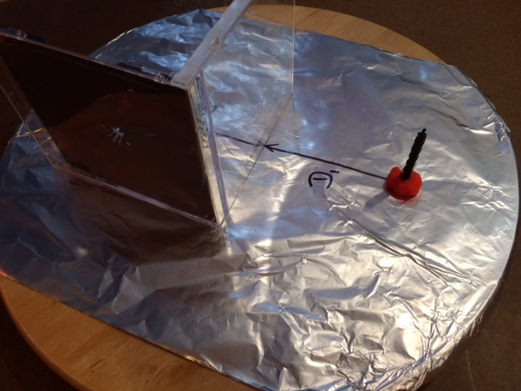

STEP 2. Place the second unlit candle behind the CD case.

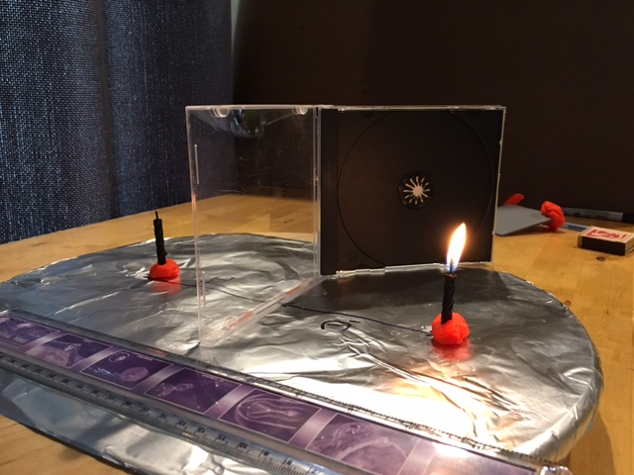
STEP 3. When looking through the plastic plane, start moving the unlit candle back and forth until you find the exact location of the virtual image of the lit candle. When you find the exact spot, the two images will overlap, and the unlit candle, when looking through the plastic, will appear aflame!

STEP 4. Continue to adjust the position of the unlit candle by turning the Lazy Susan until the unlit candle ‘catches of fire’.

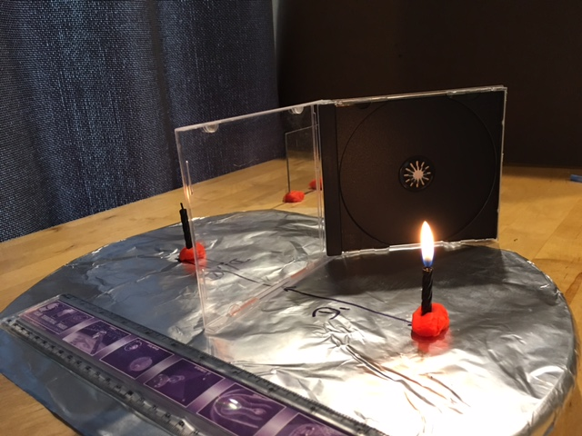

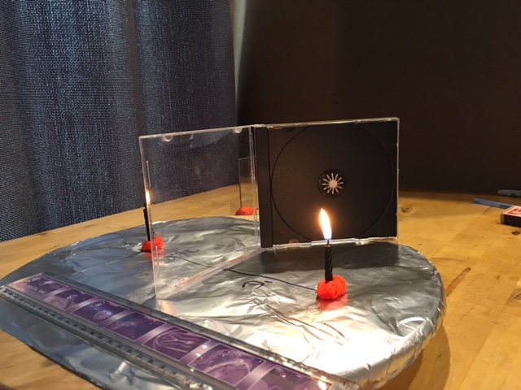
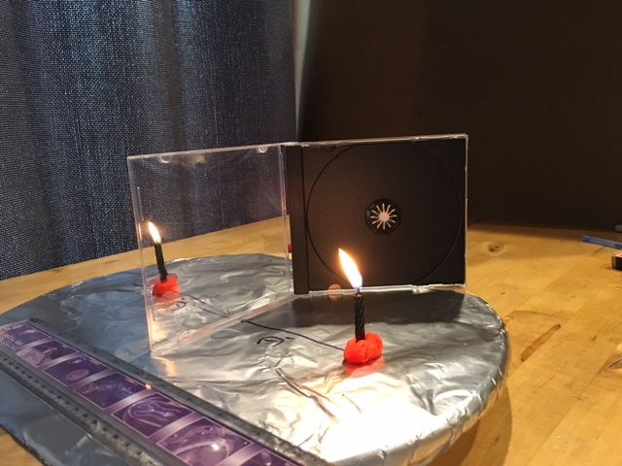
STEP 5. Using a permanent marker, draw a line perpendicular to the surface of the CD case, connecting the unlit candle and the plastic surface. Label D₂.
STEP 6. Sketch your set up and record a minimum of five observations. What have you learned so far? What questions does your team have about the observations you have made? Record your questions.

PART B: Plane Mirror
STEP 6. Replace the CD case with a mirror and secure it with clay in a vertical position
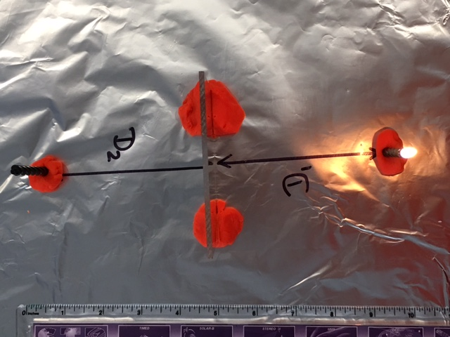
Repeat the experiment: catch the unlit candle of fire!!!
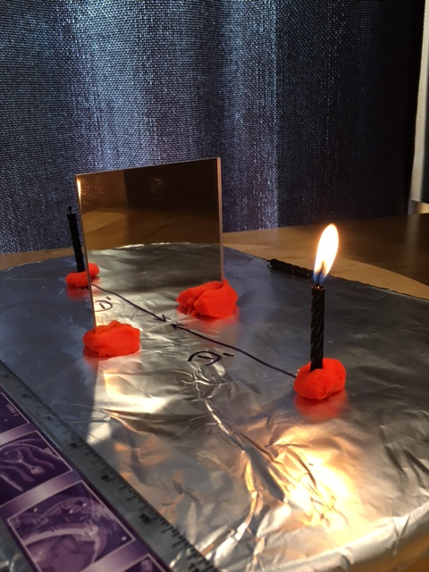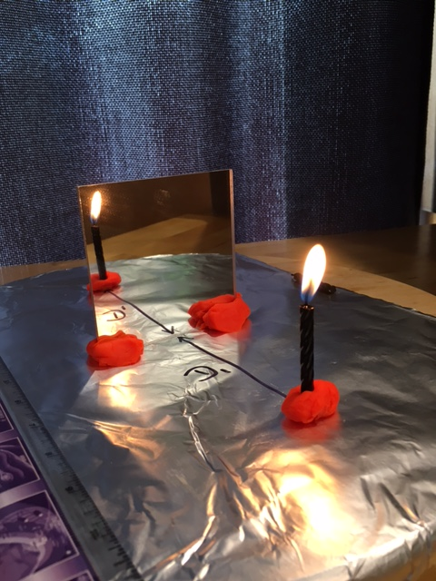

STEP 7. Have each member of the group repeat the experiment and record the distance from the unlit candle to the mirror for each trial.
Group member | Distance in front of mirror, D₁, cm | Distance behind the mirror, D₂, cm
 | 10
 | 10
 | 10
 | 10
AVERAGE | 10

STEP 8.
Explain your findings. What have your learned? Refer to the list of questions you generated in STEP 6 and see if you can answer any of them.
Work with your group to produce a sketch, which will help you explain your findings to others. Be ready to explain your model to the rest of the class. Be sure to use evidence from your experiment to argue that your model is correct.
STEP 9. Whole class discussion follows. Using the participants’ models, the instructor leads the learners to understand the difference between a virtual (created by reflected light) and real (created by transmitted light) image. As groups share their models, the instructor pinpoints common misconceptions about the reflecting nature of light (see earlier).
Fun Extension: place the unlit candle in a beaker or glass of water and look through a CD case. Dim the lights. What do you observe? (The reflected image overlaps with the candle in the beaker, making it look as if it is burning under water!)

Adapted with permission Mader, J., & Winn, M. (2008). Teaching Physics for the First Time. AAPT Press. Available from: American Association of Physics Teachers. One Physics Ellipse, College Park, MD 20740.
Images in this document are for teacher’s information only. If used with students, the images should be deleted.

