How Oliver kept his teeth sparkling white!

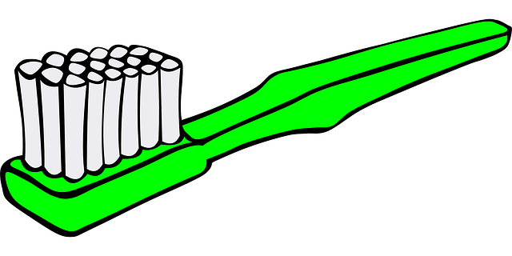

By: ____________________________

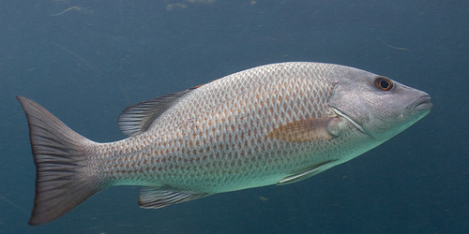

A hippo, named Oliver, and a Barbell fish, named Penny, were the best of friends. The two friends would play, laugh, and have a great time together. They would even dine out near the river banks and share a meal together.
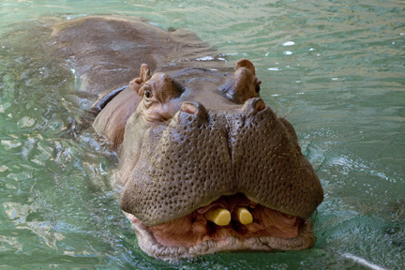

Page 1

When dinning out, Oliver could eat a lot to fill his large stomach. But, Penny would not. She only ate a small amount to fill her little stomach. Oliver would chew and swallow a big meal of short grass and reeds on land. Penny would wait near the water’s edge for Oliver to come back. Once he was back into the cool water, Oliver would open his large jaws and Penny would eat the scraps of the leftover grass from his teeth. Both friends would have happy, full stomachs. Oliver always had sparkling teeth, thanks to Penny cleaning the leftovers from Oliver’s teeth and gums. Oliver’s other friends often noticed his beautiful teeth and wondered what his secret was. They would ask, “How do you keep your teeth so white?” Oliver would always tell them, “I’ve got a secret weapon.”
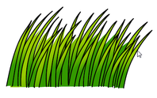
Many of Penny’s other friends thought that Penny should not be friends with Oliver. They thought the two were an unlikely pair because they were so very different. Some even thought that Penny, a fish, was so brave hanging out with Oliver, a hippo. They often said,” Aren’t you afraid that Oliver will swallow you when you swim into his mouth?” Penny always replied, “Oliver is my friend for life.”
Page 3

One day, Penny got some bad news. She and her family were moving away. No longer could the two friends share laughs or meals. This made Oliver so sad. Oliver also realized that without Penny, he was no longer going to have the best- looking teeth. Oliver was going to have to find a new way to keep his teeth dazzling white. He thought for a while, and decided he needed to start using a toothbrush to help clean his teeth. But, he didn’t want any old toothbrush. He wanted a toothbrush designed especially for him that could get in between his gums and teeth just like Penny had always done.

Page 4
Help design a toothbrush for Oliver. Draw a picture and label at least one feature that will help Oliver remove any leftover pieces of grass from his gums. Make sure the toothbrush is large enough to fit in Oliver’s mouth.

Page 5
What materials did you use to create a toothbrush for Oliver?

_____________________________________
Page 6
Were you able to build a toothbrush that would clean the leftover hamburger from Oliver’s teeth and gums? Yes No
If not, how can you improve your toothbrush?

_____________________________________
Page 7

