How Pete kept his teeth sparkling white!

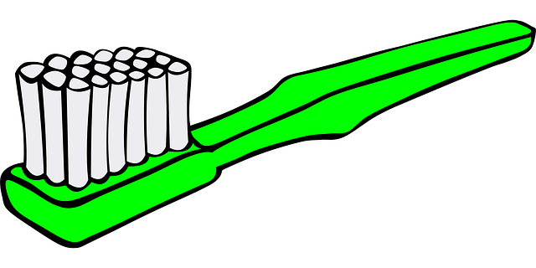

By: ______________________________

A crocodile named Pete, and a Plover bird name Joan, were the best of friends. The two friends would play, laugh, and have a great time together. They would even dine out by the river banks and share a meal together.
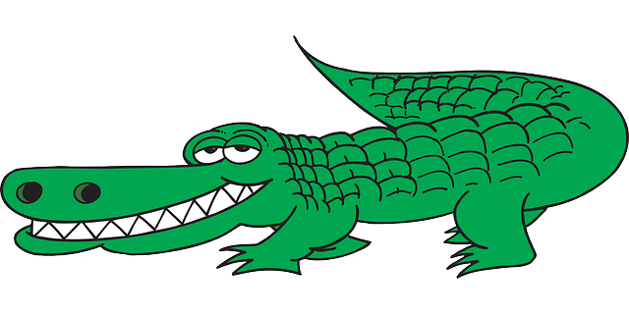
Page 1
When dining out, Pete could eat a lot to fill his large stomach. But, Joan would not. She only ate a small amount to fill her little stomach. Pete would catch, chew, and swallow a big meal of hamburger. Joan would watch and wait for Pete to finish. Once he was finished, Pete would open his large jaws, and Joan would eat the scraps of the meat from his teeth. Both friends would leave the river banks happy. Pete always had sparkling teeth, thanks to Joan cleaning up the leftovers. Pete’s other friends often noticed his beautiful teeth and wondered what his secret was. They would ask, “How do you keep your teeth so white?” Pete would always tell them, “I’ve got a secret weapon.”
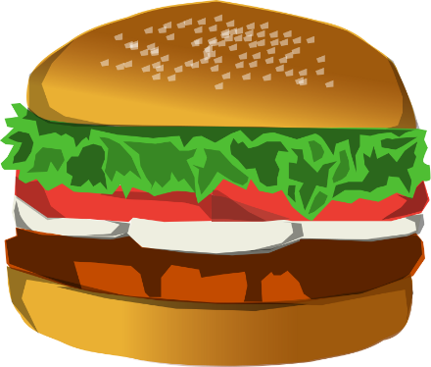
Page 2
Many of Joan’s other friends thought that Joan should not be friends with Pete. They thought the two were an unlikely pair, because they were so very different. Some even thought that Joan, a bird, was so brave hanging out with Pete, a crocodile. They often said,” Aren’t you afraid that Pete will eat you when you hop into his mouth?” Joan always replied, “Pete is my friend for life.”

Page 3

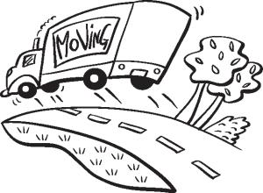
One day, Joan got some bad news. She and her family were moving away. No longer could the two friends share laughs or meals. This made Pete so sad. Pete also realized that without Joan, he was no longer going to have the best- looking teeth. Pete was going to have to find a new way to keep his teeth dazzling white. He thought for a while, and decided he needed to start using a toothbrush to help clean his teeth clean. But, he didn’t want any old toothbrush. He wanted a toothbrush designed especially for him that could get in between his gums and teeth just like Joan had always done.
Page 4

Help design a toothbrush for Pete. Draw a picture and label at least one feature that will help Pete remove any leftover pieces of hamburger from his teeth and gums. Make sure the toothbrush is large enough to fit in Pete’s mouth.

Page 5
What materials did you use to create a toothbrush for Pete?

Page 6
Were you able to build a toothbrush that would clean the leftover hamburger from Pete’s teeth and gums? Yes No
If not, how can you improve your toothbrush?

_____________________________________
Page 7

