Soda Can Crusher Design Challenge Materials
Materials | Picture | Quantity | Size | Website
Pegboard |  | 1 full size board | Product number 974626 | Carolina Biological Supply  974626 - PEGBOARD ,24 X 14 X 1/4"
L Shape Corner Brace Joint Right Angle Bracket | 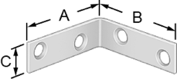 | Approximately 10 pieces | 2 2 5/8 | https://www.mcmaster.com/#corner-brackets/=15o15m7
Socket Head Cap Screw | 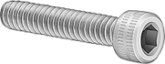 | 1 box=100 pieces | 10-32 x 5/8 | https://www.mcmaster.com/#=15o12vr
Hex Nuts | 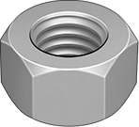 | 1 box= 100 pieces | 5/8 | https://www.mcmaster.com/#hex-nuts/=15o1d8r
Flat Washer |  | 1 box= 100 pieces | 18-8 Stainless Steel  No. 10 | https://www.mcmaster.com/#standard-flat-washers/=15o16h3
Standard adjustable wrench | 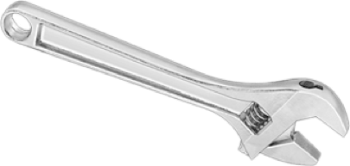 | One per group | Any size | It can be found in any hardware store
Hex Key Set | 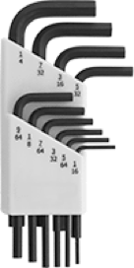 | One set per group | It comes in various size | It can be found in any hardware store

Customers | Do you think that you need a soda can crusher in your kitchen? |  |  | Have you ever considered buying a soda crusher? |  | How much money are you willing to pay for a soda can crusher? |  |  | What qualities are you looking for in a soda can crusher?  Please rank on a 1-5 scale (5 is the most important)
 | YES | MAYBE | NO | YES | NO | $10-$20 | $20-$40 | $40-$60
 |  |  |  |  |  |  |  |  | Ease of use | Reliability | Aesthetics | Portability | Space Needed
1
2
3
4
5
6
7
8
9
10
Need Analysis Questions

Peer Evaluation Rubric
Feedback from Group __________for Group____________
1-lowest score and 5-highest score
 | Strengths | Weaknesses
Ease of use

1 2 3 4 5
Reliability

1 2 3 4 5
Aesthetics

1 2 3 4 5
Portability

1 2 3 4 5
Space Needed

1 2 3 4 5
Suggestions for Improving the Overall Design

