Science Investigation
Pitch and Volume
By Vita Somers
Guest Speaker: Adam Nussbaum
Students will observe that sound waves travel and can make something move.
Students will be able to distinguish between pitch and volume.
Students will be able to identify how sounds with different pitch and volume are produced.

What we know:
Sound is caused by vibrations.
Sound travels in waves.
Sound waves go in our ears. Our ears send a signal to our brain, and we hear the sound.
Sound can echo.

Questions for today:
How can we prove that sound waves exist?
Experiment: Place plastic wrap tightly over a glass bowl. Place some rice on the plastic. Bang a drum next to the bowl.
What do you observe? What is making the rice move?
(We can see the rice move on the plastic when the vibrations from the drum hit it.)
What is pitch? (Pitch is how high or low a sound is.)
Which drum and/or cymbal have the lowest pitch? Why?
(The bigger the drum or cymbal, the lower the pitch.)
Which drum and/or cymbal have the highest pitch? Why?
(The smaller the drum or cymbal, the higher the pitch.)
What is volume? (Volume means how loud or quiet a sound is.)
How can we change the volume of the drum or cymbal?
(If we bang the drum lightly, the volume will be quieter. If we bang the drum hard, the volume will be louder.)

Name ___________________ Date __/__/__
Sound Investigation Drums and Cymbals
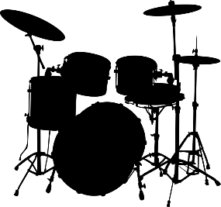
Place the bowl with plastic wrap next to the drum. Sprinkle some rice on top. Now, bang the drum. What happens to the rice? Why? Draw a picture below to show what you observed.

What is pitch?
Pitch is _______________________________
_____________________________________

Color the drum with the lowest pitch.
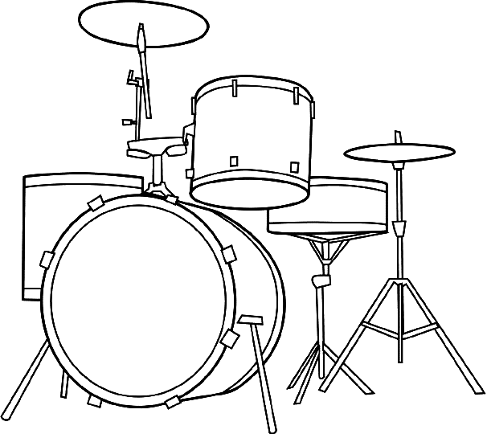
Color the drum with the highest pitch.

What is volume?
Volume is _____________________________
____________________________________.

How can we make a soft sound with a drum?
__________________________________________________________________________
How can we make a loud sound with a drum?
__________________________________________________________________________

