Checklist for Engineering Design Project: Come Rain or Shine
Grade
Did I Do It Like an Engineer?
Did I Meet the Project Goals/Criteria? |  | Not  Yet | Starting  to | Yes!
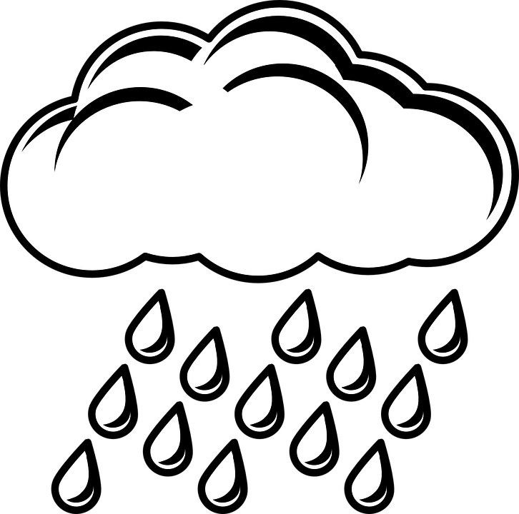 | I caught as much of the rainwater/snowmelt  (1 cup) that fell on the roof as I could.
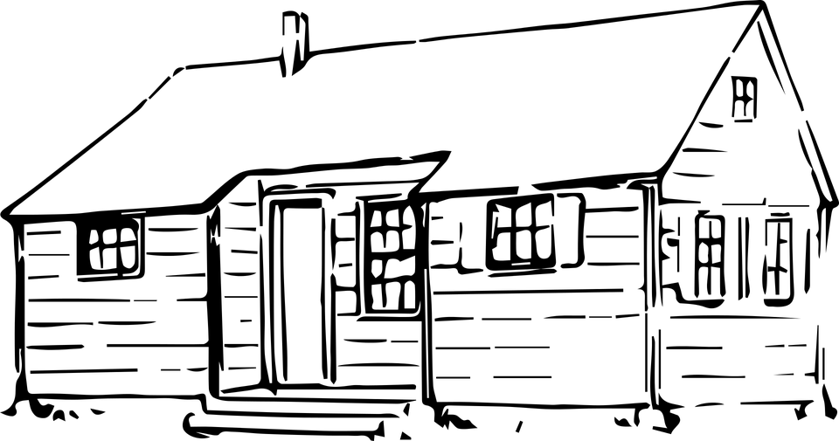 | I created a roof with no leaks. The inside of the building remained dry.
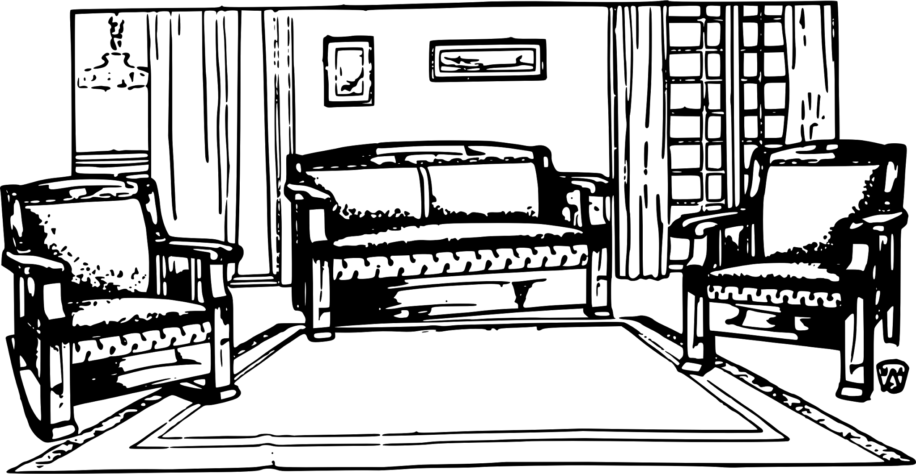 | I maximized the square footage inside the living space. In other words, I made as much space available inside my of building as possible and my building fits inside the tub.
Did I Use Science and Engineering Practices? |  | Not  Yet | Starting  to | Yes!
 | I asked thoughtful questions and defined more than one problem.
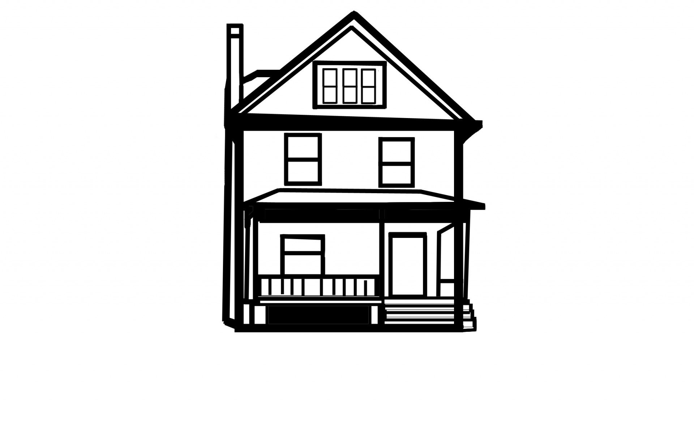 | I developed and used models that met all of the criteria.
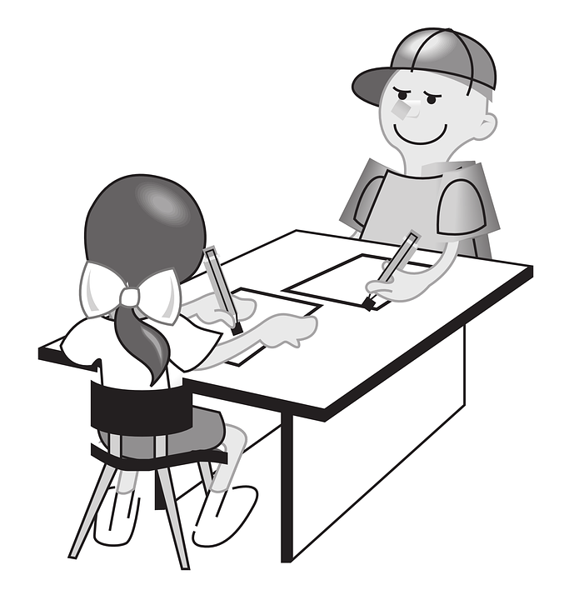 | I planned the design carefully and carried out the construction in the time given.
How did I work with my group members? |  | Not  Yet | Starting  to | Yes!
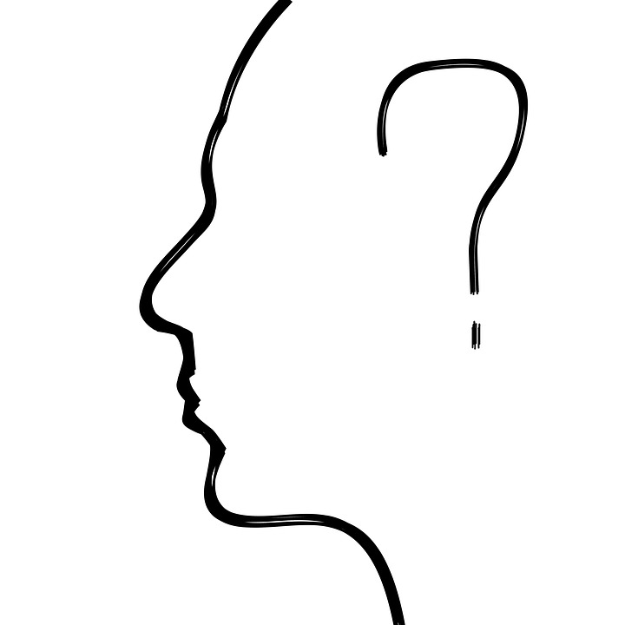 | I listened carefully to others’ ideas, asking their opinions. I took turns and made sure everyone was sharing.
 | I told others my ideas and I made sure I didn’t do all the talking.
 | I helped solve problems that came up in our group and was willing to compromise when things didn’t go my way.

Grade
Time to think about what I learned.
How did you use the exploration with materials to help you make your design? Think about the properties of the materials you used.

What would you do differently next time? How would you make your design even better?

What questions do you have about the process of planning, designing, testing, and redesigning?

What did you learn about being a design engineer?

