Protect My House: Flood Barrier Challenge 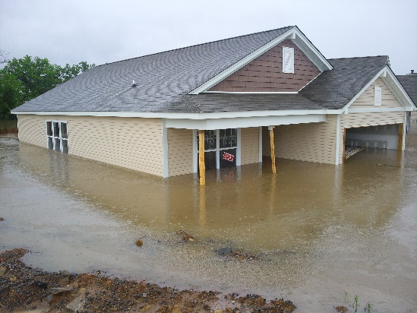
Challenge Prep: You will use the cardstock cube template to represent your house. Once you have created your model house then place it in the plastic tub. When the rain begins (Watering can will be used to dispense water as rainfall), your house could be in jeopardy of becoming flooded.
Flood Barrier Challenge: Devise a solution for how to protect your house from being consumed or damaged by flood waters. Brainstorm with your partners on what materials would be best utilized to protect and secure the house. Devise a plan of action to solve this challenge. What materials will you need? What type of materials would work best for this challenge? Prepare a material list of items each member is responsible. How will your flood barrier be constructed? How will your flood barrier be placed around the house?

3-ESS3-1 Make a claim about the merit of a design solution that reduces the impacts of a weather-related hazard.

*Elementary safety precautions were addressed with students at the beginning of the school year. Students sign Science Safety Contracts and are frequently reminded of appropriate science investigation protocol. See NSTA’s Safety Resources: http://static.nsta.org/pdfs/SafetyAcknowledgmentForm-ElementarySchool.pdf

Protect My House: Flood Barrier Challenge

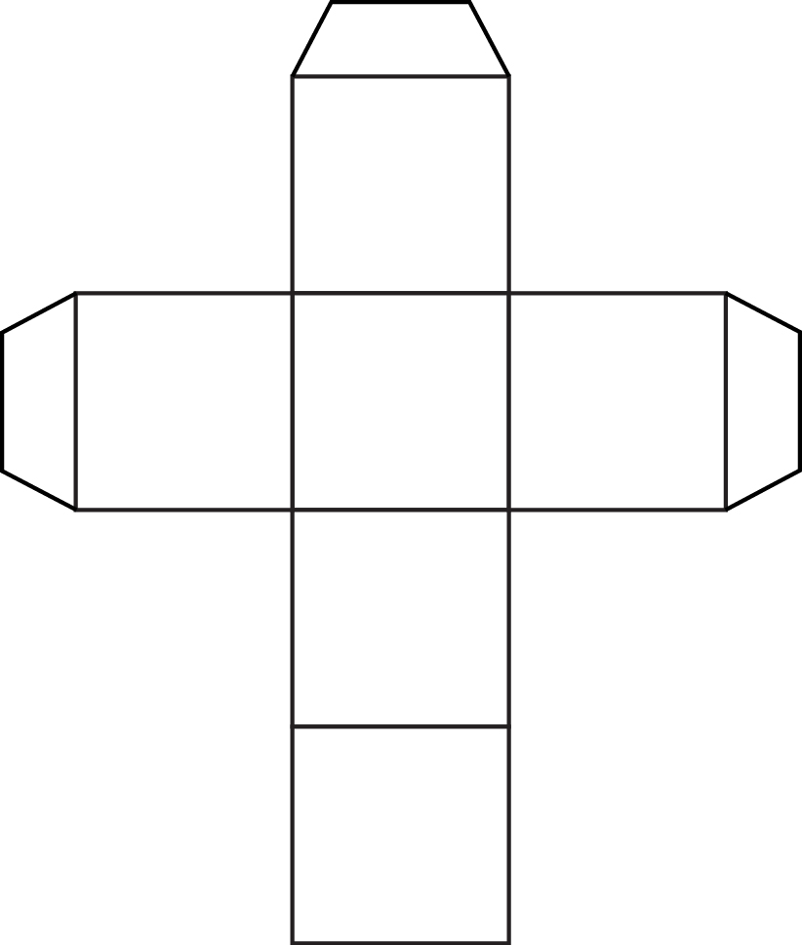

Earthquake Resistant Building Challenge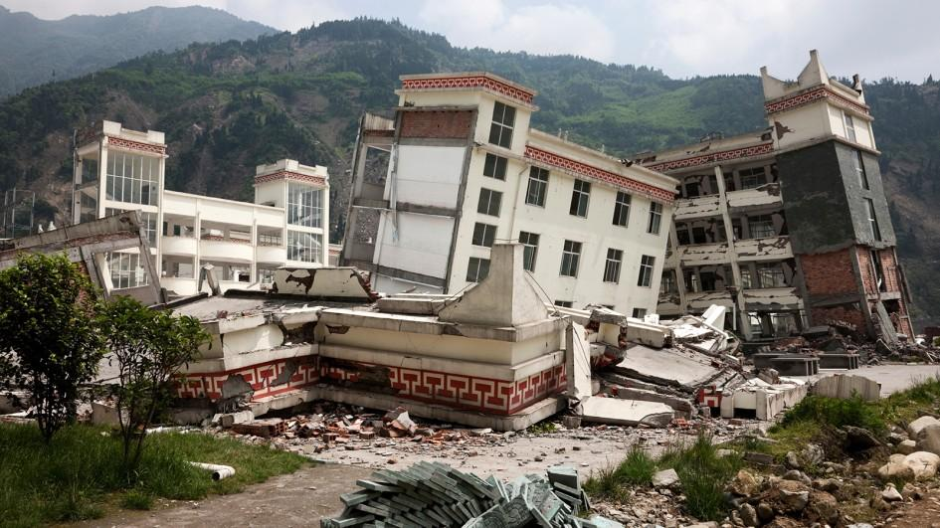
Challenge Prep: The teacher has a prepared “earthquake shake table” set up in the classroom (see below). Understanding that earthquakes register on the Richter scale at different intensity levels, design a building structure under the following requirements that may withstand various intensities of earthquake movement.
Earthquake Resistant Building Challenge: Considering the building requirements below and what you know about structure and stability, brainstorm what materials you will use to construct your building and in what structural design. You may use any recyclables and/or consumables available to you and/or brought from home. Consider the following materials: Index cards, straws, recycled Styrofoam meat trays, cardboard tubes, paper towel rolls, rubber bands, paper, toothpicks, etc
Building requirements:
Height: The structure may be any height up to 40 cm tall.
Number of Floors: Your building may have multiple floors, a minimum of 2 to no more than 6.
The top floor will be an open parking garage that will hold at least one car (Ziploc bag of sand -200 grams), during an earthquake.
DIY Shake Table: This shake table was made from recyclables and inexpensive consumables. Corrugated Cardboard from recycled boxes was used as the base and platform of the shake table. Two recycled plastic cylinder shaped tubes of similar length were used between the cardboard structures to allow for the movement of the simulated quake. Rubber bands were used to keep the platform together, but still allowed for the back and forth shaking movement.
4-ESS3-2. Generate and compare multiple solutions to reduce the impacts of natural Earth processes on humans.

*Elementary safety precautions were addressed with students at the beginning of the school year. Students sign Science Safety Contracts and are frequently reminded of appropriate science investigation protocol. See NSTA’s Safety Resources: http://static.nsta.org/pdfs/SafetyAcknowledgmentForm-ElementarySchool.pdf
Windmill Design Challenge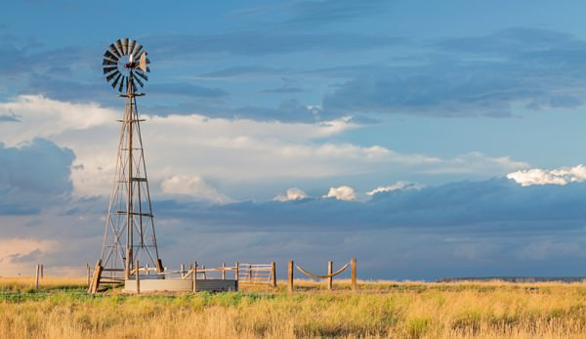
Challenge Prep: Research and discuss with peers what materials you believe would provide the best blades for your windmill. Does the number of blades make a difference? Would the blades need to be light in weight? How durable should the blade material be? What shapes of blades would capture the wind best? Does the blade shape impact the speed of the windmill and how well it performs or produces energy?
Windmill Blade Design Challenge: Brainstorm the shape and structure of 2 different windmill designs. Design and construct each windmill to determine which will harness wind and produce the greatest amount of energy (most number of turns in a set amount of time. Color one blade a different color from the rest so complete blade rotations can be counted as it spins in the allotted time. Design, test, and record data. Compare results and draw a conclusion about which of the blade designs performed best.

K-2-ETS1-2 Develop a simple sketch, drawing, or physical model to illustrate how the shape of an object helps it function as needed to solve a given problem.
4-ESS3-1 Obtain and combine information to describe that energy and fuels are derived from natural resources and their uses affect the environment.
*Elementary safety precautions were addressed with students at the beginning of the school year. Students sign Science Safety Contracts and are frequently reminded of appropriate science investigation protocol. See NSTA’s Safety Resources: http://static.nsta.org/pdfs/SafetyAcknowledgmentForm-ElementarySchool.pdf

The Greenhouse Challenge
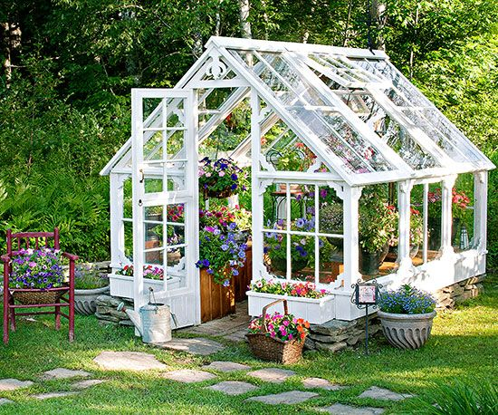
Challenge Prep: Research what temperatures are ideal for crops/edible plants to grow. How much sunlight do they need? What is an ideal growing environment for most edible plants that farmers would want to grow? Research solar energy.
Greenhouse Challenge: A local farmers’ market group is faced with the challenge of wanting to grow beneficial crops/plants for the community during the winter months. Considering the structure and surface covering of a Greenhouse, design a greenhouse that would help plants grow and thrive in when the temperatures outside are too cold. Materials: You may recycle your juice or milk cartons from the cafeteria. You may consider collecting other recyclables or inexpensive consumables such as straws, sandwich bags, cellophane, wax paper, foil, plastic bags, toothpicks, Q-tips, pencils, or paper. Plan your greenhouse design and select the greenhouse materials that you believe will provide the ultimate growing conditions for light and temperature. You may classroom thermometers and the “Grow Lamp” to set up your Greenhouse test on temperature. Use UV beads and a timer to record the rate at which the UV beads respond to the lighting in your greenhouse. Record your Greenhouse data on the chart at the station and compare to other groups’ Greenhouse data.

4-PS3-4 Apply scientific ideas to design, test, and refine a device that converts energy from one form to another.
*Elementary safety precautions were addressed with students at the beginning of the school year. Students sign Science Safety Contracts and are frequently reminded of appropriate science investigation protocol. See NSTA’s Safety Resources: http://static.nsta.org/pdfs/SafetyAcknowledgmentForm-ElementarySchool.pdf

