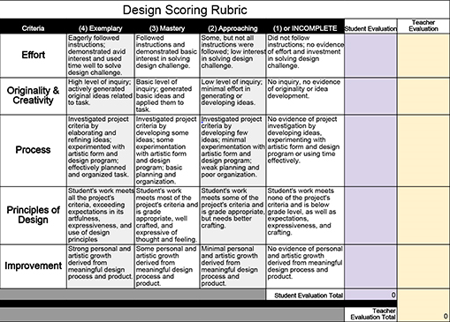
Rubric for Design Process Adapted from Meria Gottlieb at http://meiragottlieb.com/teach/design-project-graphic-book/

