Activity: Making and Documenting
Light & Shadows
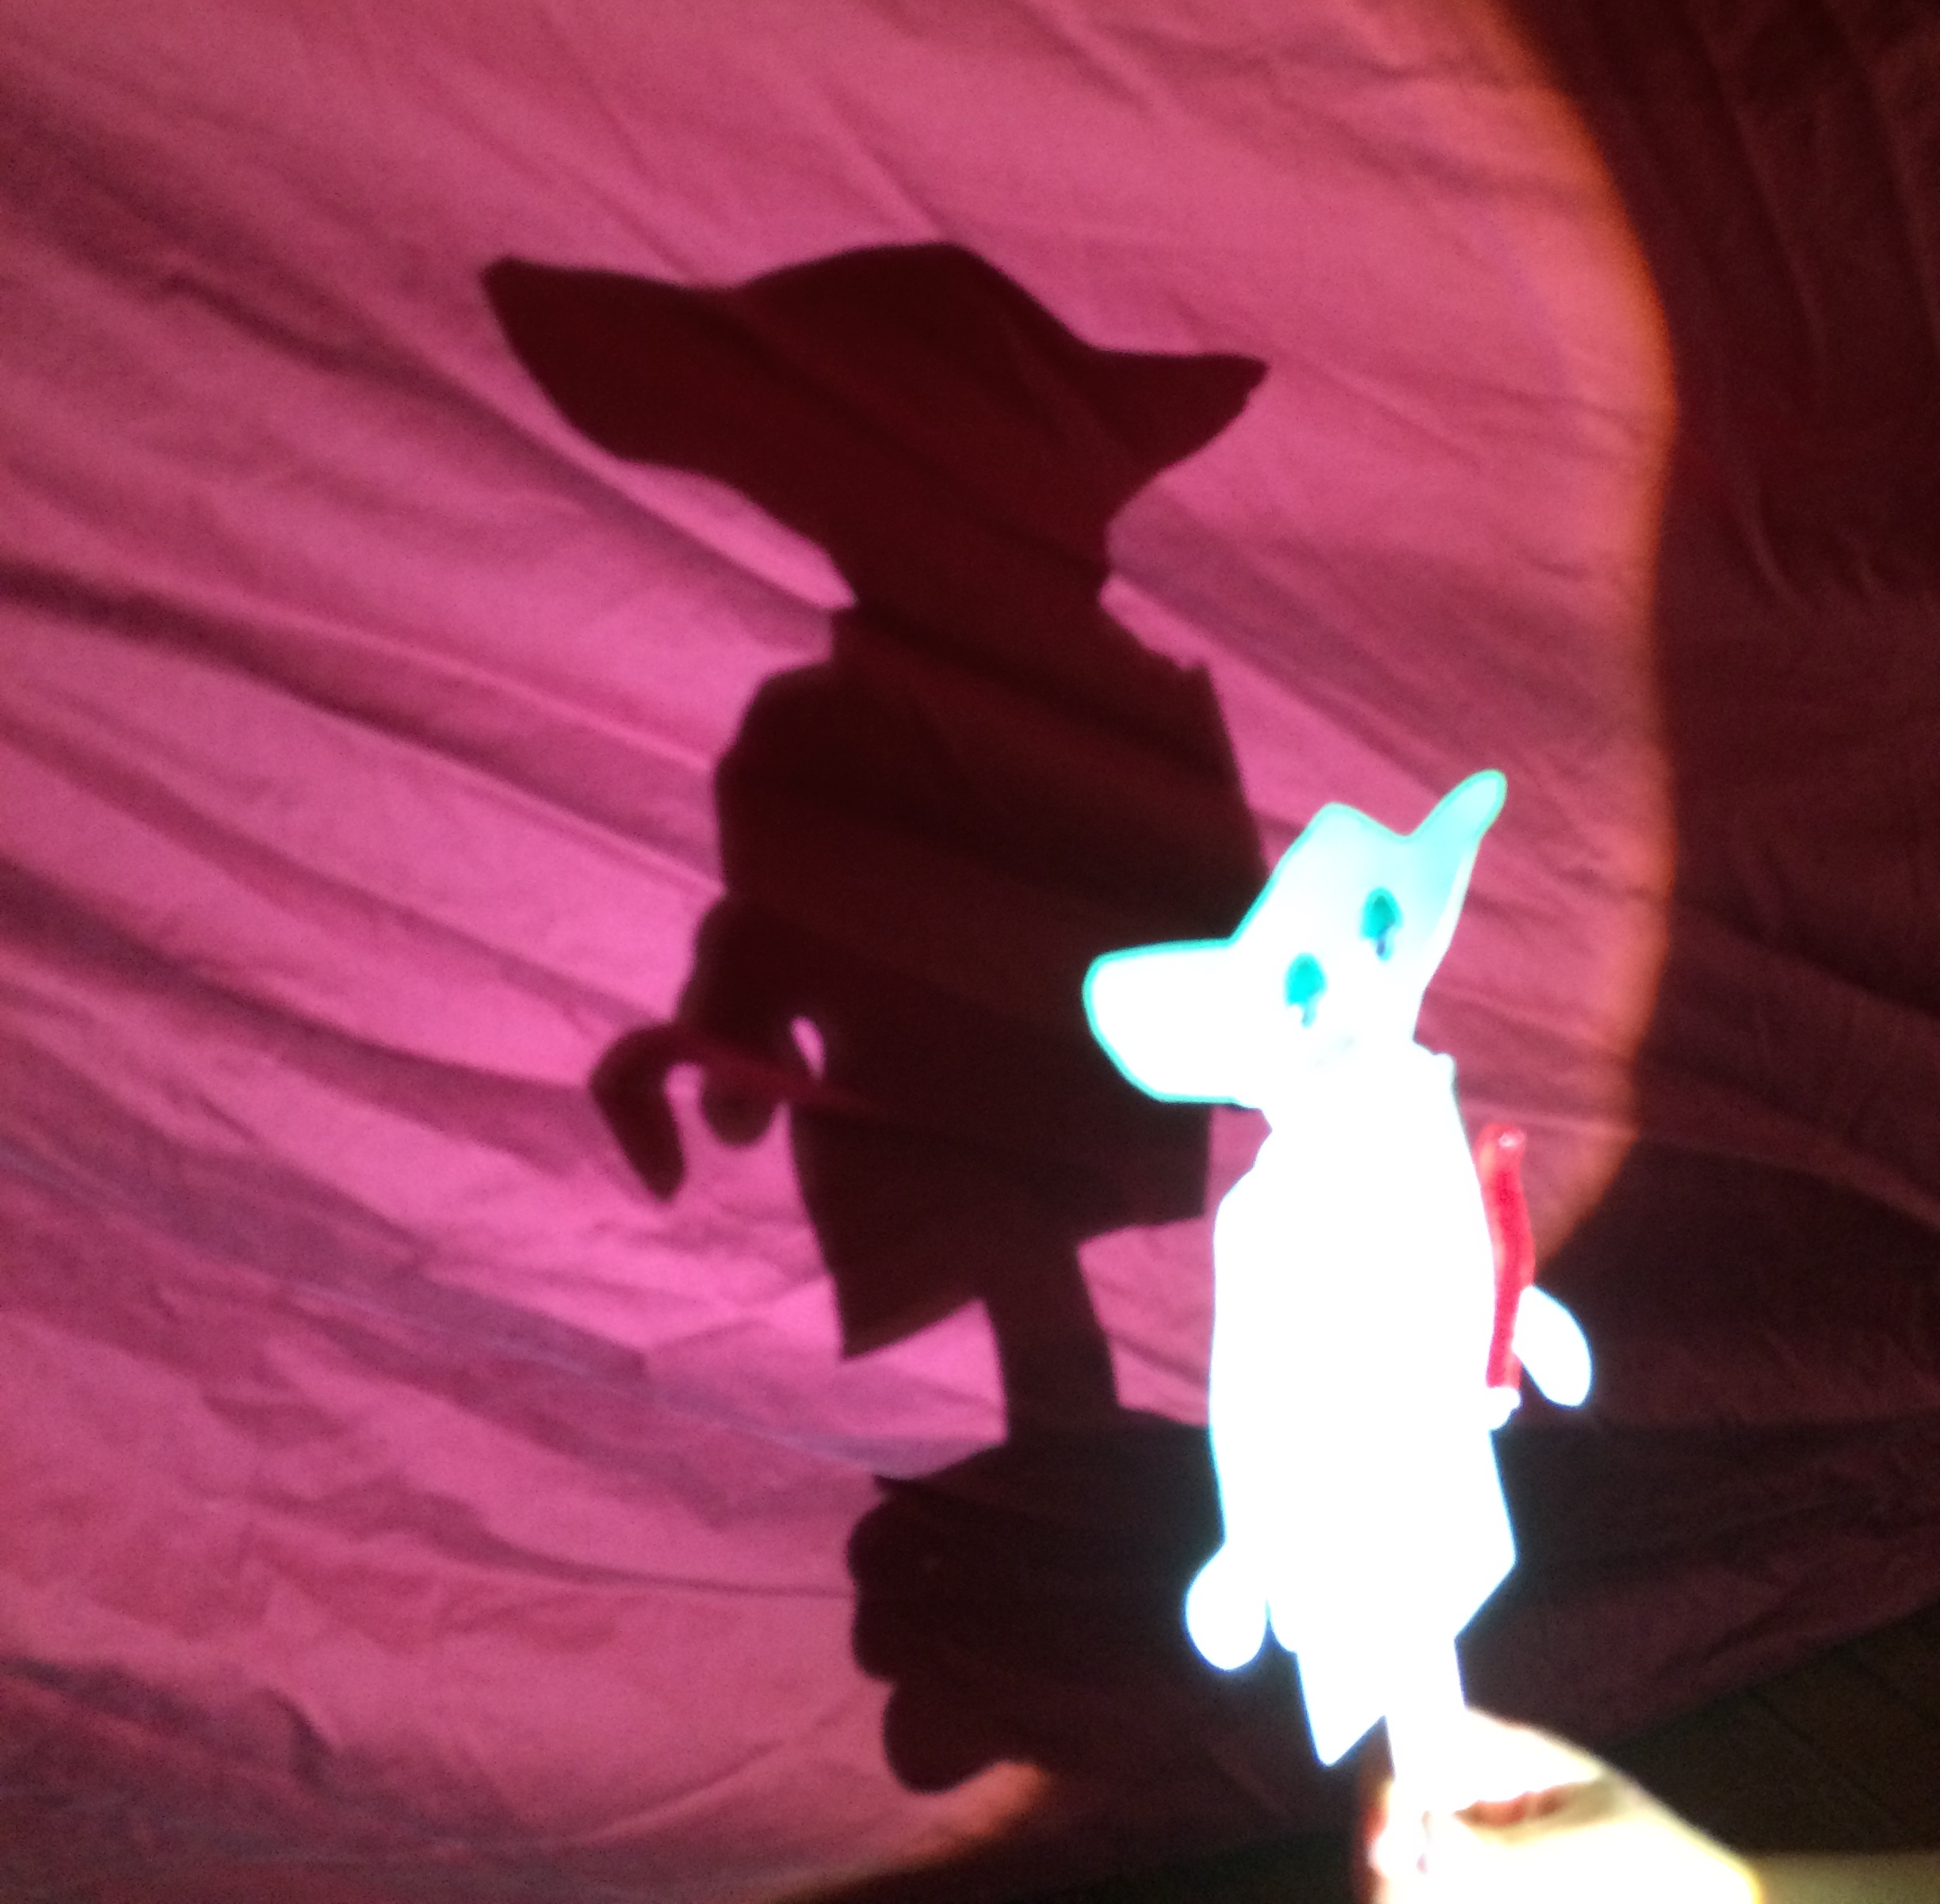
STEP 1: Make and Document a Shadow Puppet Movie

Overview: In this activity, you will do an activity and document your process. You will use this documentation to create a short video.

Making task: Shadow puppet video demonstrating a science concept.
Something must get bigger and smaller and something must appear to move only by changing the light source (puppet remains stationary). Keep track of the position of the light source, the motion of your puppets, and the image on the screen.

Some ideas: Life cycle of an insect, changing seasons, planetary motion, a volcano forming/erupting, etc…

Technology for creating videos: ShadowPuppetEDU , Adobe Voice, Youtube Capture

Document your process using SeeSaw.
Things to document:
  - Creating a story board of your movie plan
  - Sketching the puppets
  - How to move puppets or light source so that the shadow changes size.

Sketch out a story board. A story board is like a comic strip that shows the events or scenes in your movie. See template at http://get-puppet.co/wp-content/uploads/2014/07/5_Shadow-Puppet-Storyboard-Worksheet.pdf

An example of a student created story board for a digital story (programmed), not a shadow puppet story.

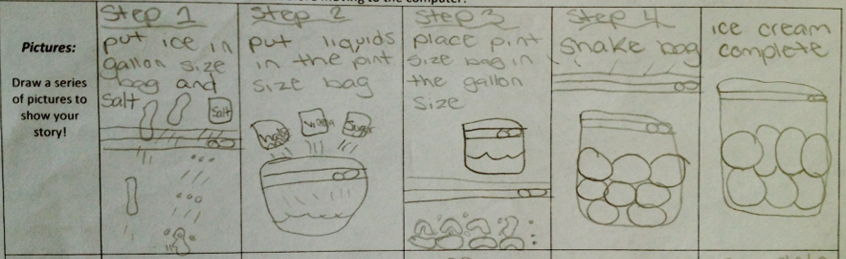

Related NGSS standards

1-PS4-3. | Plan and conduct investigations to determine the effect of placing objects made with different materials in the path of a beam of light.
4-PS4-2. | Develop a model to describe that light reflecting from objects and entering the eye allows objects to be seen.[Assessment Boundary: Assessment does not include knowledge of specific colors reflected and seen, the cellular mechanisms of vision, or how the retina works.]

K-2-ETS1-1. | Ask questions, make observations, and gather information about a situation people want to change to define a simple problem that can be solved through the development of a new or improved object or tool.
K-2-ETS1-2. | Develop a simple sketch, drawing, or physical model to illustrate how the shape of an object helps it function as needed to solve a given problem.
K-2-ETS1-3. | Analyze data from tests of two objects designed to solve the same problem to compare the strengths and weaknesses of how each performs.
3-5-ETS1-1. | Define a simple design problem reflecting a need or a want that includes specified criteria for success and constraints on materials, time, or cost.
3-5-ETS1-2. | Generate and compare multiple possible solutions to a problem based on how well each is likely to meet the criteria and constraints of the problem.
3-5-ETS1-3. | Plan and carry out fair tests in which variables are controlled and failure points are considered to identify aspects of a model or prototype that can be improved.

STEP 2. Design an assessment to assess a learning goal.

Select a DCI.
- K-2 PS4.B Objects can be seen only when light is available to illuminate them.
- 3-5 PS4.B Objects can be seen when light reflected from their surface enters our eyes.

Or a Performance Expectation
1-PS4-3. | Plan and conduct investigations to determine the effect of placing objects made with different materials in the path of a beam of light.
4-PS4-2. | Develop a model to describe that light reflecting from objects and entering the eye allows objects to be seen.[Assessment Boundary: Assessment does not include knowledge of specific colors reflected and seen, the cellular mechanisms of vision, or how the retina works.]

Design an assessment for the selected DCI or Performance Expectation.
Be prepared to share your idea with the class.

