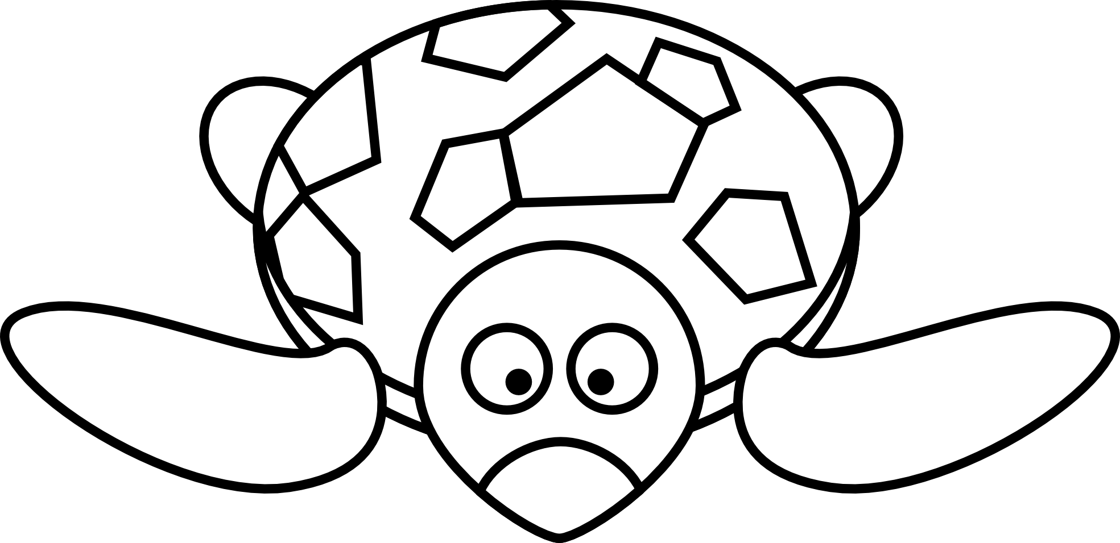
Plastic Pollution in the Ocean

Picture Walk #1

- What types of plastic pollution did you observe in these pictures? ________________________________________________________________

- Name some of the animals affected by plastic pollution in the ocean.
_____________________________ _____________________________
_____________________________ _____________________________

- How does plastic pollution affects these animals’ daily activities? Be specific.
________________________________________________________________

- How do these pictures make you feel? Why?
________________________________________________________________

- Have you ever observed plastic pollution in real life? Please explain. ________________________________________________________________

- Describe something that you learned about ocean plastic pollution.
________________________________________________________________

Picture Walk #2

- Name some of the items that you observed in these pictures.
_____________________________ _____________________________
_____________________________ _____________________________

- What do all of these items have in common?
________________________________________________________________

- Which item surprised you the most? Explain why.
_______________________________________________________________
_______________________________________________________________

- Do you think recycling plastic bottles would help ocean animals? How?
________________________________________________________________
________________________________________________________________

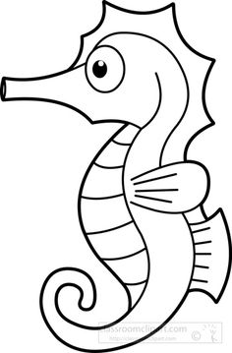
- Describe something that you learned about recycling plastic bottles.
______________________________________________ ______________________________________________
______________________________________________

