Pre-Reading Assignment
Rationale: These vocabulary terms are by no means exhaustive to the field of automotive engineering and may not even play an important role in this particular engineering lesson. These terms were chosen from this article and are meant to provide for students to learn some interesting STEM vocabulary and reading comprehension in the context of a web-based popular science articles.
Engineering vocabulary terms to define with students:
Aerodynamicist Wind turbine Torque Momentum

Guidance in reading assignment for teacher and/or language specialist for ELL students:
- Support the student in reading the previous web-based articles about a wind-powered car that is first, engineered to travel faster down-wind and then re-engineered to travel into the wind.
- Help students to look up the engineering vocabulary terms with classroom resources (dictionary or online CPU).
- Offer students space in their notebooks or create a hand-out where students may
  - Students draw an image of what they perceive best represents the above engineering vocabulary terms.
  - Write keywords and/or sentences that define/captures a correct understanding of the engineering vocabulary terms.
  - NOTE: English Language Learners (ELL) can write definitions using their own language and then debrief at the proper time with their language specialist or parent.
Sample Grading Rubric
Exemplary | Proficient | Needs Improvement
Student has correctly defined the engineering vocabulary term using both drawings and complete sentences. | Student has correctly defined the engineering vocabulary term using either a correct drawings or using keywords/concepts in incomplete sentences. | Student has attempted to define the engineering vocabulary term but drawing and/or sentence is incomplete or incorrect.

Wind-powered car goes down wind faster than the wind
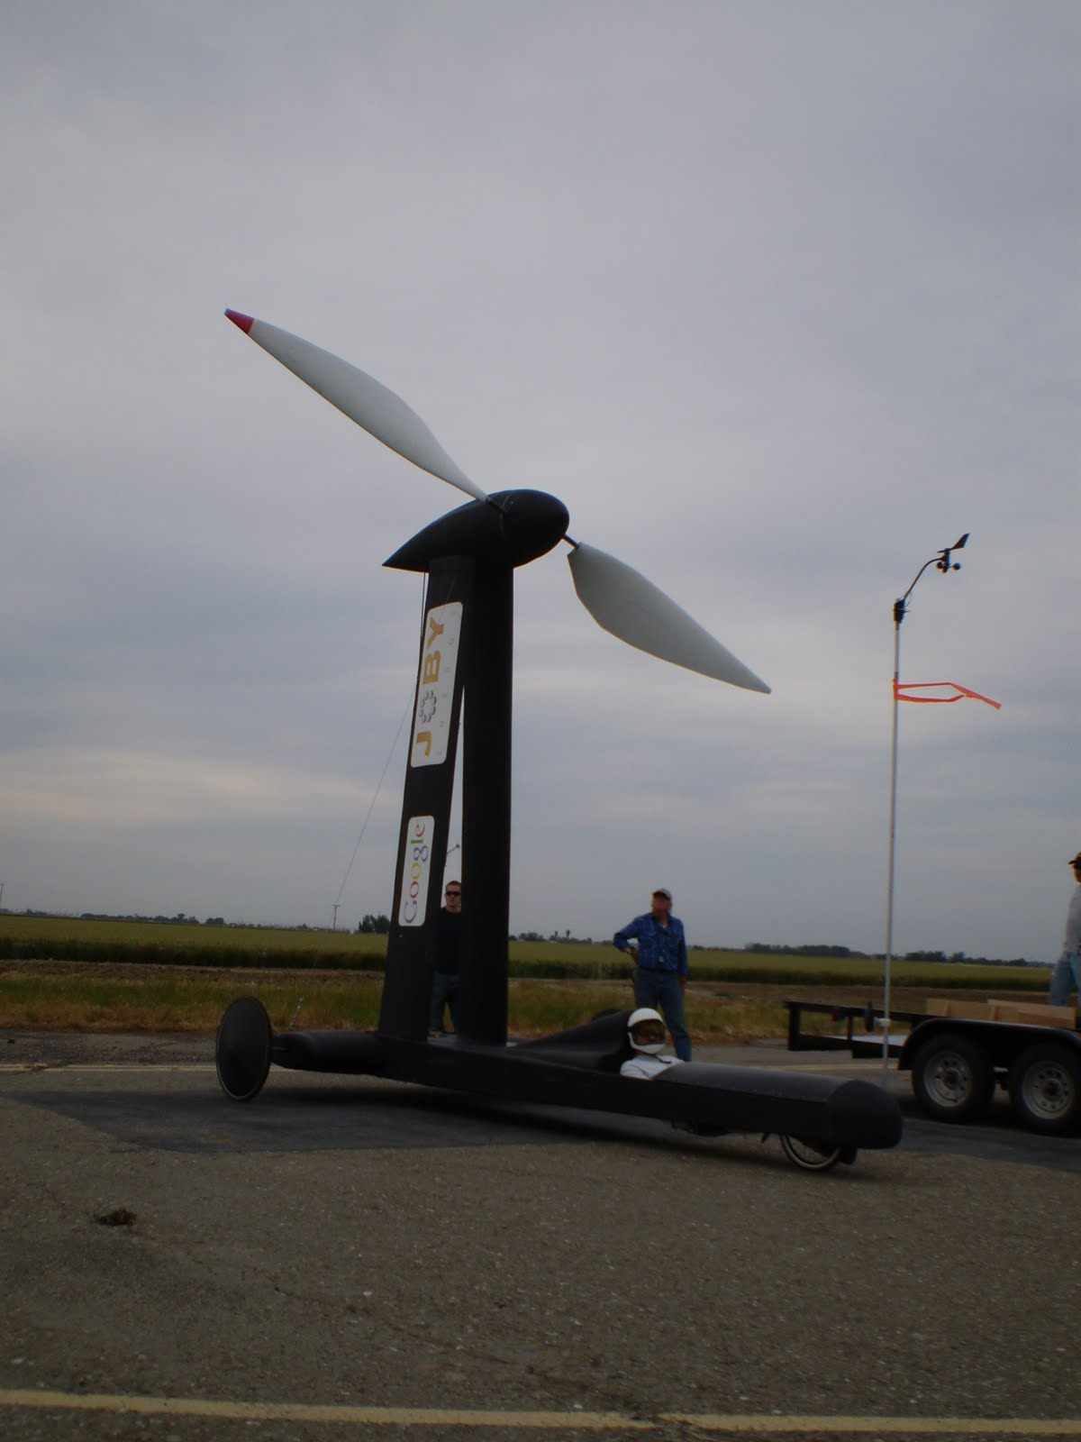
June 4, 2010 by Lin Edwards
Image credit: Thin Air Designs
(PhysOrg.com) -- A wind-powered car has been clocked in the US traveling down wind faster than the wind. In a recent run at New Jerusalem in Tracy, California, the car reached a top speed of more than 2.85 times faster than the wind blowing at the time (13.5 mph) powered by the wind itself. The run should now settle the DWFTTW (down wind faster than the wind) debate that has been raging for some time on the Internet about whether or not such a feat was possible.
The Thin Air Designs car, called the Blackbird, was built by Rick Cavallaro, an aerodynamicist, paraglider and kitesurfer, who was alerted to the DWFTTW debate by his employer at Sportvision Inc., Stan Honey, a world-class sailing navigator. Cavallaro is chief scientist with the company. He made some calculations that convinced him the feat was possible and then built a model to prove it. When skeptics remained unconvinced, Cavallaro and a friend decided to build a full-size version.
The “Faster than the Wind” team was able to attract sponsorship from wind turbine company Joby Energy and Google, and worked in collaboration with the aero department of the San Jose State University to build their ultra-light vehicle, which is made largely of foam. The car has a passing resemblance to a Formula 1 racing car, except for the five meter high propeller mounted on the back, and it is this propeller that holds the key to how it is possible for the car to travel down wind faster than the wind. An earlier version known as the BUC for Big Ugly Cart, also achieved speeds greater than the down wind speed at the North American Land Sailing Association (NALSA) meeting on a dry lakebed in Nevada in March.
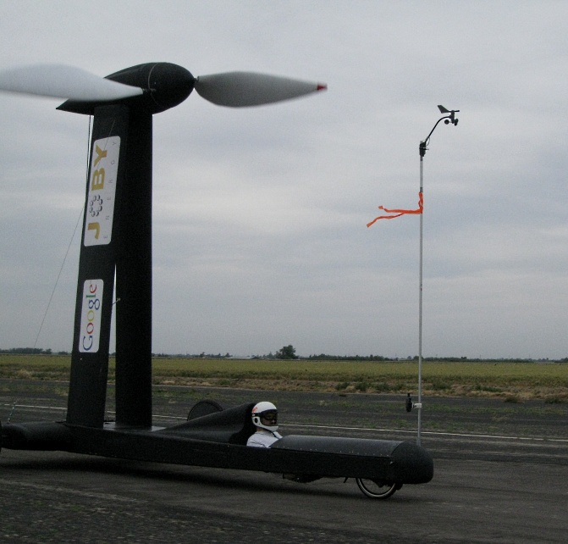
Cavallaro explained the car is able to move faster than the wind because the propeller is not turned by the wind. The wind pushes the vehicle forward, and once moving the wheels turn the propeller. The propeller spins in the opposite direction to that expected, pushing the wind backwards, which in turn pushes the car forwards, turning the wheels, and thus turning the propeller faster still.
The vehicle was built after over a year of trials. Building a transmission able to transfer power from the wheels to the propeller was the most difficult part of the design. The next stage in development will be to have trials confirmed by NALSA.

Last accessed on 9/29/2017 – https://phys.org/news/2010-06-wind-powered-car-faster.html
Blackbird cart runs with wind only twice as fast
July 12, 2012 by Nancy Owano

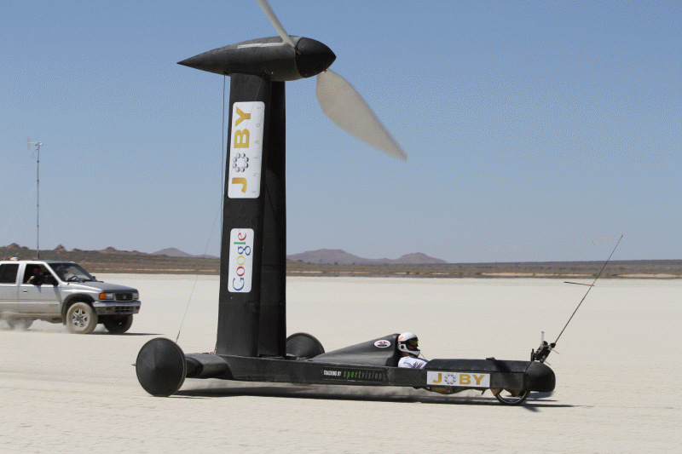Photograph of the land yacht Blackbird. Image: Stephen Morris
(Phys.org) -- This month’s news-making word in wind-powered vehicle experiments is “upwind.” Blackbird, a wind powered cart, has shown it can travel upwind at more than twice the speed of circulating air. Rick Cavallaro, an aerodynamicist focused on designing record-setting vehicles that challenge wind speed, first made news two years ago when his Blackbird vehicle raced downwind at 2.86 times the speed of the wind. This time, after modifying his cart, he and his Blackbird team went out to the New Jerusalem airport in Tracy, California, where the vehicle achieved a top speed 2.01 times faster than the wind speed when headed upwind.
Overall, the key modifications that made a downwind Blackbird ready to take on an upwind run included the substitution of the propeller with a turbine that rotates in the opposite direction and transmits power to the wheels.
“After a very long sabbatical, we're finally building some momentum on making our downwind cart go directly upwind faster than the wind,” Cavallaro had reported in the early days of his upwind project.
“We'll use the same vehicle,” he said, but the propeller will come off and will be replaced by a turbine. “The turbine will look very much like the propeller, only hopefully nicer, and with the opposite twist and camber.” He explained that the wind would turn the turbine and that would turn the wheels, “sending us upwind faster than the wind, steady-state. The turbine will also turn the opposite direction from the prop so we can again take advantage of the long left axle to keep us from overturning the Blackbird at speed.”
Cavallaro also had to work out a way to prevent the turbine’s torque from flipping the vehicle over. As a solution, he designed one of its axles as longer than the other, and the Blackbird’s chain drive was reconfigured to fit the asymmetrical axle setup.
The principle behind the upwind-configured Blackbird is similar to that of sailing. Blackbird’s version of two large sails are its turbine blades, spinning around a common axis, moving forward as the cart sails into the wind and cross-wind as the blades turn around the axis.
He said the combination of upwind and cross-wind motion is identical to that of a sail on a boat on an upwind tack. The sailboat makes use of its keel to constrain the motion of the sail in the correct direction, and in Blackbird’s case, the transmission and wheels perform the same function.
Cavallaro holds the title of Sportvision Chief Scientist and he holds 25 patents in computer enhancement of live sporting events. He received a B.S. in Aerospace Engineering from Georgia Tech and M.S.in Dynamics and Controls from UCLA and worked in aerospace for several years.

Last accessed on 9/29/2017 – file:///C:/Users/soreyt/Downloads/2012-07-blackbird-cart-fast.pdf

