School Maker Faire
Assignment Overview

What is a Maker Faire?
A Maker Faire is an event to celebrate “making.” Maker Faires are held all over the world, with the largest attracting hundreds of thousands visitors annually. They often include activities where people can participate in hands-on activities related to robotics, circuits, crafts, building, and other activities. They also include exhibits of people’s craftsmanship. For more information, see http://makerfaire.com/makerfairehistory/.

How will our School Maker Faire be different from other Maker Faires?
Our School Maker Faire will showcase how the Maker Movement exhibits the new move in Science Education to engage students of all ages in engineering and in the practices of science and engineering practices. We will provide a fun learning experience for local school children and provide inspiration and resources for local teachers.

What do I need to do?
Design. In small groups, you will design a hands-on “Maker Station” appropriate for K-6th grade students. You can select a target grade level and then make adjustments “up” and “down” for older and younger students.
Iterate. Before the MST School Maker Faire, you will test out your activity in your placement classroom. During this pilot, you should assess students’ ideas with a supplemental extension activity (described in next section). Following this pilot, you will revise your plan.
Share. Finally, you will implement the activity at the MST School Maker Faire. You should also invite children in your classroom and your cooperating teacher to attend. The event will be fun for everyone!

What do I need to turn in?
Throughout the course, you will turn in five primary assignments – waypoints to the creation of your two large final assignments: the Maker Activity and EdTPA. These are listed below. Details are provided on the following pages.

1. Maker Activity Facilitation Guide
2. Assessment activity
3. Description of Evidence of Learning
4. Rubric for Assessment

Description of Components

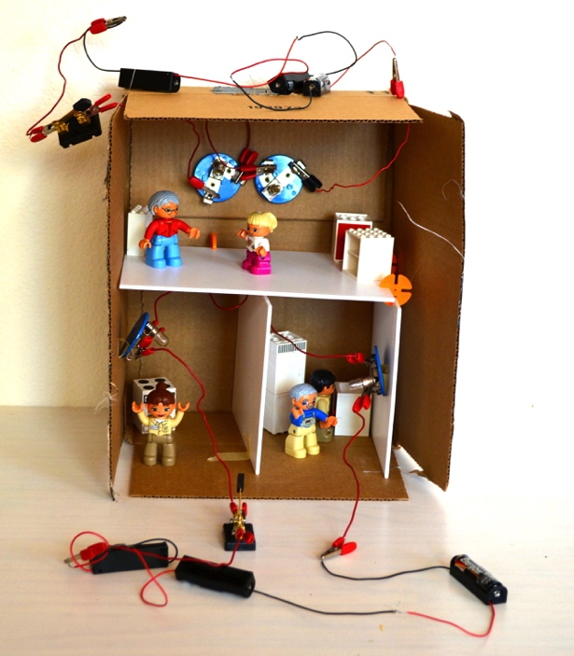
1. Maker Activity Facilitation Guide.

This is the description of how to run your activity and how it connects to the NGSS standards. This should include necessary materials, how to set up the task, handouts for students (if appropriate), expected student activities, and prompts for the teacher.

The facilitation guide alone should be sufficient for conducting the activity at the Maker Faire.

The Facilitation Guide should contain at least the following information

Overview
Duration: (estimate of time for completion)
Grade Level:
NGSS alignment: (DCIs, Science and Engineering Practices, Crosscutting Concepts)
Summary of activity (2-3 sentences)
Science for the Teacher: (a couple paragraphs explaining the science that the teachers need to know, links to useful references for teachers to access additional information).

Set Up
Materials: (Specify whether the materials are per group, per individual, or per class; specify required and optional materials)
Set Up: (How to arrange materials)

Facilitating
Invitation to engage: How to engage students in the activity (challenge posed, question asked)
Step-by-step instructions (if appropriate)
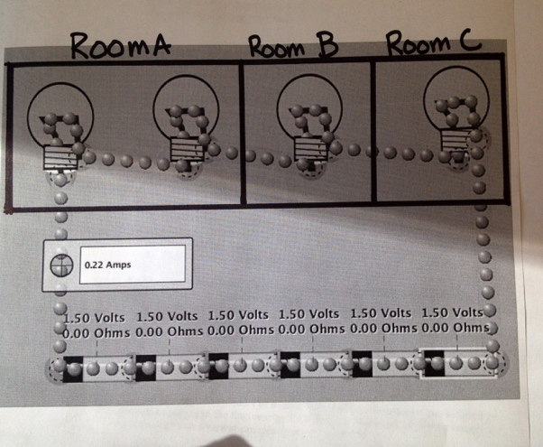
Challenging thinking: Questions to pose during activity
Safety concerns: (information about safe handling of chemicals, tools, etc.).

2. Assessment Activity

This activity is a supplement to the primary Maker Activity. Communicating Ideas is one of the eight practices of science and engineering described in the NGSS. Depending on the nature of your activity, you will provide informal ways for students to communicate ideas during the Maker Faire. This may be through asking questions, expressing insights and new ideas, or through the artifacts they construct.

While it is not necessary (and may be distracting) to formally collect information about students’ thinking during an event like a Maker Faire, in classroom settings it is sometimes necessary to do so.

For this part of the assignment, you will design or adapt an activity that will supplement the maker activity when used in a classroom. This part of the activity may occur before, after, or during the making activity, depending on the nature of the activity and the type of information you want to collect. Ideas can be communicated through drawing, writing, talking, programming, or in any number of other ways.

Some ideas: Students draw a diagram of their final design and describe how it meets goals and constraints of a task; Students write a paragraph in response to a prompt provided by the teacher; Students collect data as part of their activity and then use this data to support claims; Have students write a letter to a company (fictional or real) in support of an idea they developed; Students turn in a portfolio of work; Students create a video telling a story of their project or instructing someone else on how to do it.

3. Description of evidence of learning to be collected and how connected to goals.

The evidence of learning may include only the items collected as part of the assessment supplement. However, the artifacts completed by students also often provide evidence of learning. You may choose to photograph student’s creations or have them document them through photos or drawings to contribute to the evidence of learning. In this section you should describe your learning goals (which must include science content, practices and/or cross cutting concepts and may include academic language, literacy, math goals, and other content areas).

Here you should describe what your learning goals are, how you developed a rubric, and the type of data (student work in the form of writing, drawings, artifacts, etc) you collected and how this student work will demonstrate learning.

4. Rubric.

Rubric should demonstrate conceptual growth (disciplinary core ideas) or greater facility and understanding of scientific practices. This should be usable with multiple types of assessments. (e.g., it should not include statements like “answers 8 of 10 questions correctly”).

School Maker Faire
Useful Websites

The websites below are useful for understanding the expectations for students at your grade level, for understanding the maker movement and its relationship to schools, and for inspiration for activities.

Science and Engineering K-12 Standards
Next Generation Science Standards (NGSS): http://nextgenscience.org
National Science Teachers Association (NSTA): http://nsta.org

Making, Maker Faires, and Maker Education
Maker Faire website: http://makerfaire.com/
Maker Education: http://makered.org/

Engineering/Design/Maker Education Activities
Diy.org: http://diy.org
Design Squad Nation: http://pbskids.org/designsquad/parentseducators/
The Tinkering Studio: http://tinkering.exploratorium.edu/
Learn X Design: http://learnxdesign.org/
Maker Camp: http://makercamp.com/
Engineering is Elementary: http://EiE.org
Videos from Make: https://www.youtube.com/user/makemagazine
NySci MakerSpace: http://nysci.org/programs-main/maker-space-folio/
MakeShop Pittsburgh: http://makeshoppgh.com/resources/
National Academy of Engineering: http://LinkEngineering.org
Howtoons: http://www.howtoons.com

Innovative Schools
Lighthouse Charter Project Guides:http://lighthousecreativitylab.org/projects/project-guides/

Connect with other Educators
School MakerSpace GooglePlus community: https://plus.google.com/communities/108934196060301716128

