Jack and the Beanstalk Design Challenge

- Read Jack and the Beanstalk.

- Read Simple Machines OR Forces.

- Help Jack get down the beanstalk.
- Build a ramp 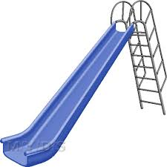

- Use a ball to test the ramp.

- Can you make the ball go faster?

- Can you make the ball go slower?

Note for the Teacher

Materials: recyclable paper of assorted types (handwriting, construction, computer paper), masking tape and scotch tape, marbles or small balls, shoe box, small Dixie cups, (to stack and make the beginning of the slide and, possibly, as a ball stopper).

Texts: Jack and The Beanstalk, Simple Machines by D.J. Ward (2015), Forces Make Things Move, by Kimberly Bradley, (2005)

8. Draw your design. Write a sentence about it.

