Name: _________________________ Date: ______________

Exploring Forces: Exploration One
Exploring Speed

Directions: Put one book under the ramp. With the stopwatch, measure how long it takes for each ball to roll from the top of the ramp to the bottom of the ramp. Then circle the ball that rolled the fastest.

Predict: Which ball (small, medium, or large) do you predict will roll the fastest? Why?
______________________________________________________________________________
______________________________________________________________________________

Ball Size | Time (s)

Small

Medium

Large

Directions: Put two books under the ramp. With the stopwatch, measure how long it takes for each ball to roll from the top of the ramp to the bottom of the ramp. Then circle the ball that rolled the fastest.
Ball Size | Time (s)

Small

Medium

Large

Did adding a book under the ramp change the time it took the balls to roll? Why or why not? ____________________________________________________________________________________________________________________________________________________________

Distance Traveled

Directions: Put one book under the ramp. With the meter stick, measure how far each ball rolls from the bottom of the ramp. Circle the ball that went the farthest.

Predict: Which ball (small, medium, or large) do you think will go the farthest? Why?
______________________________________________________________________________
______________________________________________________________________________

Data Collection
Ball Size | Distance Traveled (meters)

Small

Medium

Large

Directions: Put two books under the ramp. With the meter stick, measure how far each ball goes from the bottom of the ramp. Circle the ball that traveled the farthest.

Ball Size | Distance Traveled (meters)

Small

Medium

Large

Did the number of books under the ramp change how far the balls went? Why or why not? __________________________________________________________________________________________________________________________________________________________________________________________________________________________________________

Name: _________________________ Date: ______________

Bowling with Forces: Exploration Two

Directions: Put 6 water bottles in a triangle, 2 meters away from the bottom of the ramp. Put one book under the ramp. Write down how many pins are knocked down with each ball (small, medium, and large)

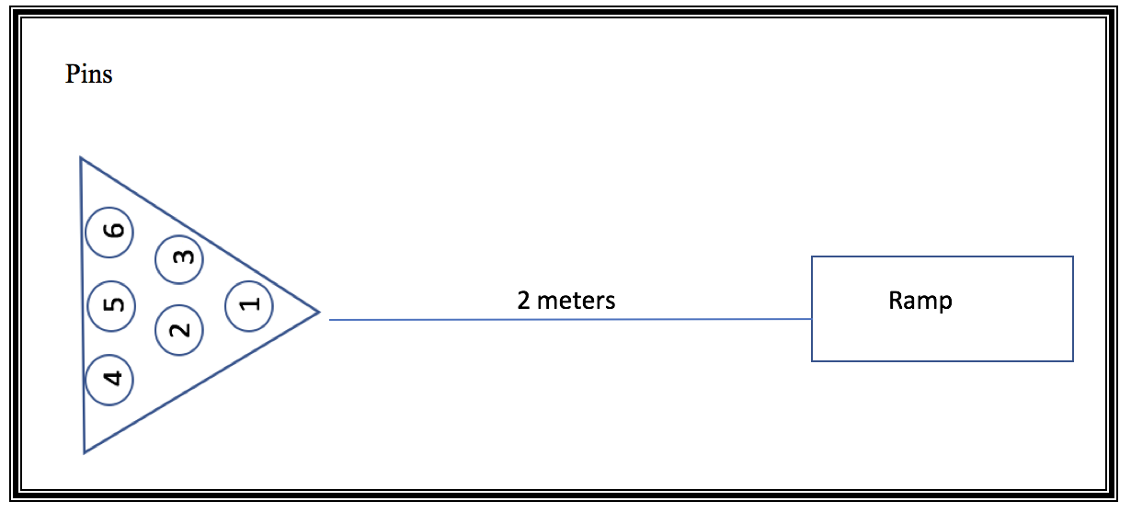

- Does a push or a pull force cause the pins to move? ___________________

- What object puts the force on the pins? ________________________________ ____________________________________________________________

- Which ball knocked down the most pins? Why do you think this happened? _____________________________________________________________
_____________________________________________________________

Data Collection:
Ball Size | Number of Pins Knocked Down: Roll 1 | Number of Pins Knocked Down: Roll 2
Small
Medium
Large

Directions: Place 6 water bottles in a triangle, 2 meters away from the bottom of the ramp. With two books under the ramp, write down how many pins are knocked down with each ball (small, medium, and large).
Ball Size | Number of Pins Knocked Down: Roll 1 | Number of Pins Knocked Down: Roll 2
Small
Medium
Large
Extend

Directions: Put 2 books underneath the ramp. Complete two rolls with each ball and write the data in the table. Next, put 3 books under the ramp and complete two rolls with each ball. Write down the data in the table.

Predict: Which ramp (1 book, 2 books, or 3 books) will make the ball hit the pins with more force? ______________________________________________________________________________
______________________________________________________________________________

Data Collection
Ball Size | Number of Pins Knocked Down: Two Books |  | Number of Pins Knocked Down: Three Books
 | Trail 1 | Trail 2 | Trial 1 | Trial 2
Small
Medium
Large

- Does the size of the ball change the amount of force the ball puts on the pins? Why or why not? ________________________________________________________________________________________________________________________________________________

- Does the number of books under the ramp affect the force of the ball hitting the pins? Why or why not? ________________________________________________________________________________________________________________________________________________

- Which ball (small, medium, or large) and ramp (1 book, 2 books, or 3 books) would you use to place the strongest push on the pins?
________________________________________________________________________________________________________________________________________________

