Name ________________________________________________ Date ____________________

Observable Silly Putty properties

Goal: Gather information with your senses to describe details of Silly Putty’s properties

List at least four properties of silly putty.
These can be properties like how it looks and feels, or properties like what it can do.
Your statements should start with “It is…”, “It can…” or “It has…” (If you think of another way to start a statement, ask me if it’s OK.)
Silly putty properties

________________________________________________________________________________________________________________

________________________________________________________________________________________________________________

________________________________________________________________________________________________________________

________________________________________________________________________________________________________________

________________________________________________________________________________________________________________

________________________________________________________________________________________________________________

________________________________________________________________________________________________________________

________________________________________________________________________________________________________________

________________________________________________________________________________________________________________

________________________________________________________________________________________________________________

________________________________________________________________________________________________________________

________________________________________________________________________________________________________________

________________________________________________________________________________________________________________

________________________________________________________________________________________________________________

________________________________________________________________________________________________________________

________________________________________________________________________________________________________________

________________________________________________________________________________________________________________

________________________________________________________________________________________________________________

Name _____________________________________________ Date _____________________

What’s your claim?

Goal: Get ready to talk about, ask questions and listen to others’ ideas about how to describe what happened to the snowman

Choose one. Circle the one you will answer:

1. “Melting” is the right word for what happened to the snowman because…

_________________________________________________________________________________________________

_________________________________________________________________________________________________

_________________________________________________________________________________________________

or

2. “Melting” is not the right word for what happened because…

_________________________________________________________________________________________________

_________________________________________________________________________________________________

_________________________________________________________________________________________________

This is what I think is really happening to the snowman…

_________________________________________________________________________________________________

_________________________________________________________________________________________________

_________________________________________________________________________________________________

_________________________________________________________________________________________________

_________________________________________________________________________________________________
Name ______________________________________ Date ____________________

Is Silly Putty a solid or a liquid?

Goal: Use observable properties to talk about, ask questions and listen to others’ ideas about how to classify what happened to the snowman

You may choose to complete only one of the following sections, or if you are not sure, you may choose to complete both of the following sections. You may use more than one sentence in each section, listing all the reasons you can think of to support your claim.

Silly putty is a liquid because _______________________________

_________________________________________________________

_________________________________________________________

_________________________________________________________

_________________________________________________________

_________________________________________________________

and/or

Silly putty is a solid because _______________________________

_________________________________________________________

_________________________________________________________

_________________________________________________________

_________________________________________________________

Name ______________________________________________ Date ______________________
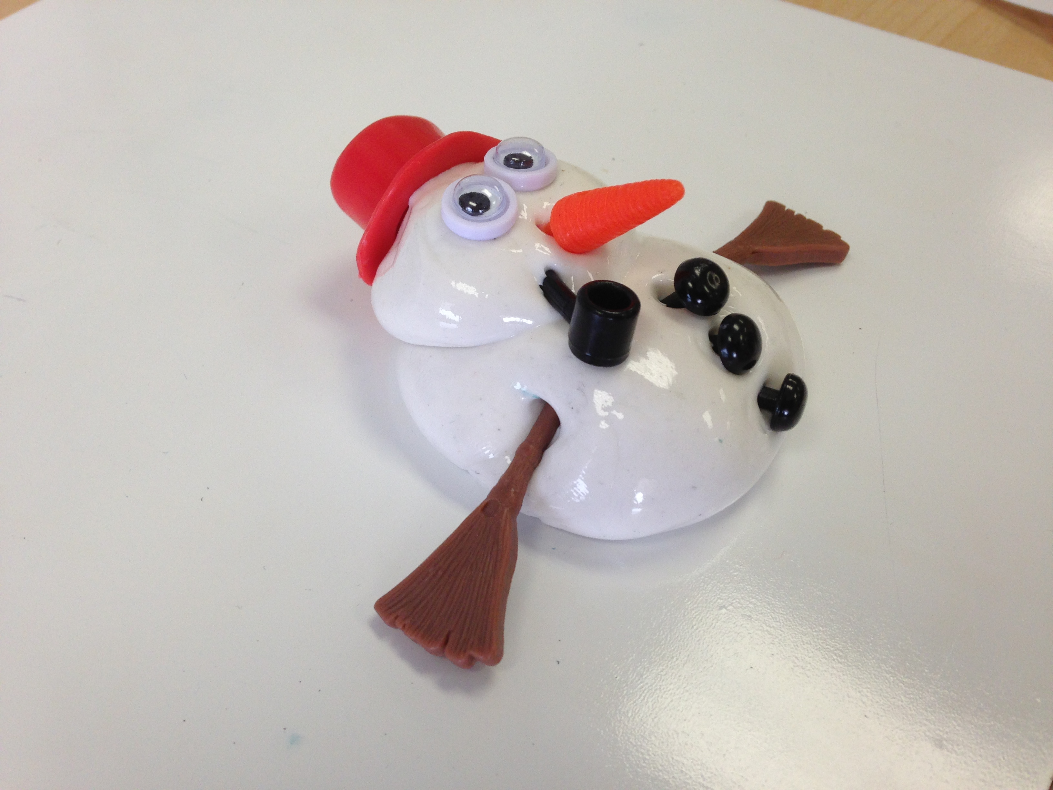
Final Snowman claims and evidence
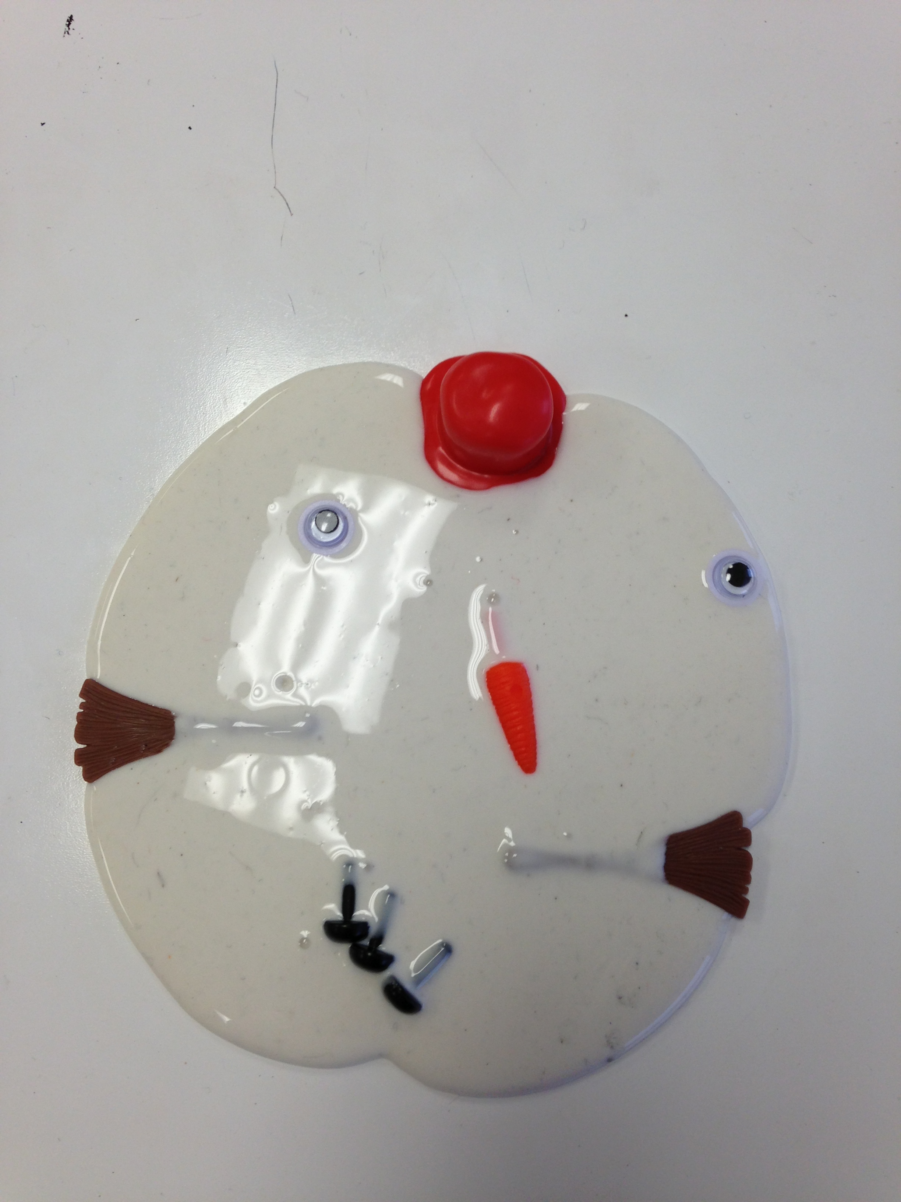

Goal: Remember key ideas and observations to explain what really happened to the snowman. Be ready to explain your claim to others and ask questions about their claims.

Use complete sentences to finish these phrases.

This is what happened to the snowman. The snowman…

_________________________________________________________________________________________________

_________________________________________________________________________________________________

_________________________________________________________________________________________________

I know this is true because…

_________________________________________________________________________________________________

_________________________________________________________________________________________________

_________________________________________________________________________________________________

_________________________________________________________________________________________________

_________________________________________________________________________________________________

_________________________________________________________________________________________________

_________________________________________________________________________________________________

_________________________________________________________________________________________________

_________________________________________________________________________________________________

Why Does Silly Putty Act So Strange?

Silly putty is a kind of “Non-Newtonian” fluid. This means that sometimes it acts like a solid, and sometimes it acts like a liquid. If you apply a quick, hard force to silly putty, it acts like a solid. If you apply a slow gentle force to silly putty, it acts like a liquid. So, if you hit it with a hammer, throw it at the floor, or pull it apart quickly, it acts like a solid, and it bounces or breaks. If you pull it apart slowly, or let gravity act on it over a period of time, it acts like a liquid and flows. It’s a very thick liquid, so it flows very slowly, and it takes hours for it to take the shape of it’s container, but it’s still acting like a liquid.

Other kinds of non-Newtonian fluids include Ooblek, which you can make from cornstarch and water, and ketchup. Ketchup acts in the opposite way as Silly Putty. If you apply a gentle force to ketchup, it acts like a solid, and if you apply a quick, hard force to it, it acts like a liquid. This is why ketchup often won’t come out of the bottle unless you hit the bottom of the bottle really hard.

Name ______________________________

Silly Putty Package

Your page includes…

An observation sentence about why silly putty acts like a liquid.

1 2 3

An observation sentence about why silly putty acts like a solid.

1 2 3

At least two other properties

1 2 3

A name for your putty

1 2 3

A picture showing your putty in action.

1 2 3

Total score _______/15

