Anatomy of a Flower
Comparative Question:
How is Flower 1 and Flower 2 alike and different?
Observations:
- Observe your flower’s scent.
Wafting the air above the flower, do you notice a smell? (yes or no)
Flower 1 _________________ Flower 2 _______________
- What is the primary color of your flower?
Flower 1 ________________ Flower 2 ________________
- Can see the stamen and the pistil on your flower without taking it apart?
Flower 1 ___________________ Flower 2 __________________
Flower Parts | Number on Flower 1 | Number on Flower 2
Sepals
Petals
Pistils
Stamen
Seeds
Carefully take each flower apart. Place all the parts on a black sheet of paper. Place similar parts together. Count each structure and enter the number.
Taking a Q tip, lightly brush over the pistil and stamen. Did you notice a powdery substance or pollen? What color is it?
Flower 1 _______________ Flower 2 __________________
Where was pollen located on Flower 1 and Flower 2?
Flower 1 ______________________________________
Flower 2 ______________________________________
Draw a Picture
Draw a picture of each flower and label the parts of the flower on your diagram.

Flower #1

Flower #2

Comparative Question:
How are the structures in flower 1 different than flower 2? Look at each flower sample and the data collected. Complete the Venn diagram for the two flowers comparing and contrasting their likenesses and differences.
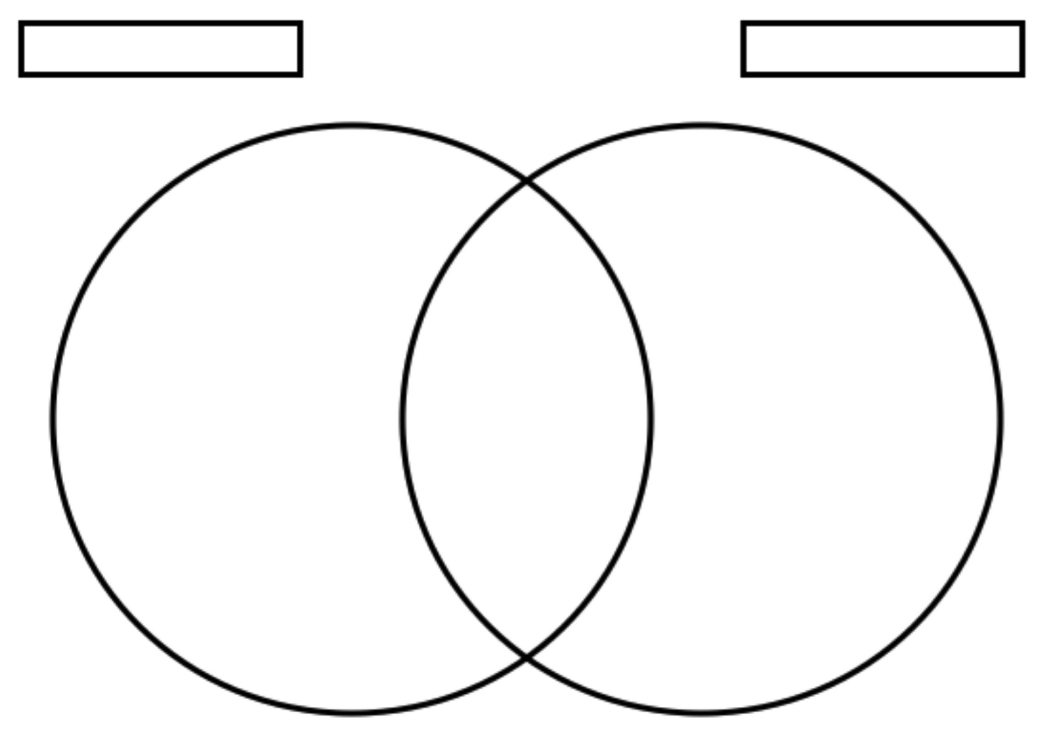

Write a paragraph describing how the two flowers are alike and different.
____________________________________________________________________________________________________________________________________________________________________________________________________________________________________________________________________________________________________________________________________________________________________________________________________________________________________________________________________________________________________________________________________________________________________________________________________________________________________________________________________________________________________________________________________________________________________________________________________________________________________

Sequencing of Events for Pollinating a Flower
Write in order the step in which pollen is transferred in the flower. Be sure to include the names of the parts of the flower.
- __________________________________________________________________________________________________________________________
- __________________________________________________________________________________________________________________________
- __________________________________________________________________________________________________________________________
- _________________________________________________________________________________________________________________________
- __________________________________________________________________________________________________________________________
- Practice teaching a classmate how pollen is transferred in a flower.

Engineering Design Process
Designing the Hand Bee Pollinator
- Define the Problem:
______________________________________________________________________________________________________________________________________________________________________________________________________
2. Background Research:
What anatomical structures and behaviors are important for pollinating flowers?
Anatomical parts: ____________________________________________________________________________________________________________________________________________________________________________________________________________________________________________________________________________
Behaviors: ____________________________________________________________________________________________________________________________________________________________________________________________________________________________________________________________________________

Specify Requirements:
Are there any anatomical parts and behaviors needed in the design of your hand bee pollinator?

__________________________________________________________________________________________
What size will your final product be? __________________________________________________________________
What special circumstances or conditions should be considered when developing your hand bee pollinator? Where is the flower located? What is the size of the flower? How will you remedy or fix this?

________________________________________________________________________________________________________________________________________________________________________________________________________________________________________________________________________________________________________________________________________________________________________

Brainstorm Solutions:
What do you think your hand bee pollinator should look like? Talk with a group of 3-4 other students about possible ideas. Draw a picture of your ideas:
Idea One
Materials needed: ______________________________________________________________________________________________________________________________________________________________________________________________________

Interview a different classmate on their design. Draw a picture of their design in the “Idea Two” box.
Idea Two
Materials needed:
______________________________________________________________________________________________________________________________________________________________________________________________________

Share with a partner Idea Two. Think: Is any part of their design I could use? Draw a third idea and include a list of materials.

Idea Three:

Materials needed:
_________________________________________________________________________________________________________________________________________________________________________________________________________
- Choose the Best Design:
Of the three designs which idea do you like the best and why?
______________________________________________________________________________________________________________________________________________________________________________________________________
- Development Work
Describe to a partner how you will build your model. Completed _________
- Build a Model
When building your model did you need to do something different than you originally thought? Explain
______________________________________________________________________________________________________________________________________________________________________________________________________________________________________________________________________________
Were there any materials difficult to use? Why were they difficult?
____________________________________________________________________________________________________________________________________
- Testing your hand bee pollinator
You will test your model on 6 different shaped flowers to see how effective it would be to pollinate each of the flowers. Record your findings on the table on the next page.
How effective is your hand bee pollinator in pollinating flowers?
Types of Flowers | Effective | Somewhat Effective | Not Effective
Flower 1
Flower 2
Flower 3
Flower 4
Flower 5
Flower 6

Effective= the hand pollinator is able to move the pollen from the stamen to the pistil.
Somewhat Effective = the hand pollinator is able to move pollen somewhat easily from the stamen to the pistil.
Not Effective= the hand pollinator does not move or has difficulty moving the pollen from the stamen to the pistil.

- What parts or behaviors of your hand bee pollinator are the most helpful for pollinating flowers?
______________________________________________________________________________________________________________________________________________________________________________________________________
- Talk with the other engineers at your table about what worked and why. Write one person’s ideas below. This may give you or other people some ideas on how to make their model better.
________________________________________________________________________________________________________________________________________________________________________________________________________________________________________________________________________
- Test and Redesign
After you have tested your hand bee pollinator, is there anything you need to redesign?
__________________________________________________________________________________________________________________________________________________________________________________________________________________________________________________________________________________________________________________________________________

Retest
After making adjustments to your hand bee pollinator bee, retest your hand bee pollinator using the flower table below.
Test your model on 6 different shaped flowers to see how effective it would be to pollinate each of the flowers. Record your findings on the table below.
How effective is your hand bee pollinator in pollinating flowers?
Types of Flowers | Effective | Somewhat Effective | Not Effective
Flower 1
Flower 2
Flower 3
Flower 4
Flower 5
Flower 6
Effective, Somewhat Effective and Not Effective as previously stated.

Was your hand bee pollinator more or less effective? Explain.
______________________________________________________________________________________________________________________________________________________________________________________________________
Overall how would you rate your tool’s effectiveness?
Circle the number that describes how effective your hand pollinator is

1 2 3 4 5
1= not very effective
5= very effective

Limitations of your hand bee pollinator

Describe some limitations of your hand bee pollinator. What things can a honeybee do that your hand bee pollinator would have difficulty doing?

______________________________________________________________________________________________________________________________________________________________________________________________________________________________________________________________________________

Bee Unit Assessment
1. Describe how a plant makes a seed? Include the parts of the flower in your description.
____________________________________________________________________________________________________________________________________________________________________________________________________________________________________________________________________________

2. Explain how a bee pollinates a flower. What structures or anatomical parts of the bee does she use?
_________________________________________________________________________________________________________________________________________________________________________________________________________

3. What are two ways that pollen is transferred?
_________________________________________________________________________________________________________________________________________________________________________________________________________

4. Describe the three terms; include what they look like and how they are formed.

  - Nectar
________________________________________________________________________________________________________________________________________________________________________________________________________
  - Honey
_________________________________________________________________________________________________________________________________________________________________________________________________________

  - Pollen
________________________________________________________________________________________________________________________________________________________________________________________________________.5. Describe or draw the lifecycle of a bee.

- Describe the Bee Colony Collapse. What is it and what are some possible causes.
________________________________________________________________________________________________________________________________________________________________________________________________
- Turn to the next page and label the parts of the bee. A list of the parts and their descriptions are provided.

Student’s Name ______________________________

Hand Pollinator Rubric Evaluation
Rating Scale | 3 | 2 | 1
Collaborating | Student stated at least two design ideas from their classmates and was open to other’s ideas. | Student stated at least one design idea from another classmate and was not open to other’s ideas . | Student was unable to state another classmate’s idea and was not open to other’s ideas.
Planning | Student has a very detailed plan and drawing including a list of materials needed. | Student has a somewhat detailed plan and drawing including some materials needed. | Student has an incomplete plan and materials list.
Building | Student was focused while building their pollinator. | Student was somewhat focused while building their pollinator. | Student was not focused while building their pollinator.
Implementing | Hand pollinator was effective with at least two types of flowers and was intact. | Hand pollinator was effective and able to pollinate one type of flower. Pollinator was intact or not falling apart. | Hand pollinator was ineffective or falling apart and unable to pollinate a flower.
Evaluating | Student was able to identify design ideas that were effective and ineffective and able to redesign their pollinators accordingly. | Student was able to identify designs that were effective and ineffective but did not redesign their pollinators to include these ideas. | Student was unable to identify designs that were effective and ineffective. He or she did not change their design to include effective ideas.

Total points score from student _______________

Total points score from teacher ________________

Additional Internet Resources
ABC News Australia Network. (2014, January 15). Sensors reveal secret life of bees [Video file]. Retrieved from https://youtu.be/oPt6AK-gn3QCole, J. (2002).
Bee Cloze Activity: EnchantedLearning.com. Retrieved from http://www.enchantedlearning.com/subjects/insects/bee/cloze/
Disney Productions. (2013, April 23). Phineas and Ferb - Waggle Dance. Retrieved from https://youtu.be/xe3LZBDcQvE
Elliot, M. (2006). Beehive webcam - bee web cam. Retrieved from http://www.wildwoodforesthoney.com/beehive_webcam.htm
Ertzberger, J. (n.d.). Microsoft Word Games - Board Game Templates by Dr. Jeff Ertzberger UNC Wilmington. Retrieved from http://people.uncw.edu/ertzbergerj/word_games.html
Explore Anneberg LLC. (2015). Honey Bees - hive - bees - explore. Retrieved from http://explore.org/live-cams/player/honey-bee-hive-cam
Sesno, F. (2013, July 2). Robobees to the rescue? [Video file]. Retrieved from https://youtu.be/5XE57FEhX0g
Ted Conferences, LLC. (2013, September 17). Marla Spivak: Why bees are disappearing. Retrieved from https://youtu.be/dY7iATJVCso
Zielinski, K. (2011, May 12). Pollinating Apple and Pear Orchards with Honeybees. Retrieved from https://youtu.be/Q8kYMrGp7Ng
*Internet links found at http://holttaylor3.weebly.com/all-about-plants-2.html

Book List for Read Aloud
Krebs, L., & Iwai, M. (2002). The beeman. Cambridge: Barefoot Books.
Markle, S. (2014). The case of the vanishing honeybees: A scientific mystery. Minneapolis: Millbrook Press.

Book List for Student Research on Bees
Chinery, M. (1997). How bees make honey. New York: Benchmark Books.
Cole, J., & Degen, B. (1987). The magic school bus: inside a beehive. New York: Scholastic.
Cutts, D., & Kinnealy, J. (1998). I can read about bees and wasps. Mahwah, N.J.: Troll.
Hartley, K., & Macro, C. (1998). Bee. Des Plaines, IL: Heinemann Library.
Hodge, D., Mulock, J., & Denver Museum of Nature and Science. (2004). Bees. Toronto: Kids Can Press.
Jango-Cohen, J. (2006). Bees. New York: Marshall Cavendish Benchmark.
Kalman, B. (2004). The life cycle of a honeybee. New York: Crabtree Publishing Company.
Micucci, C. (1995). The life and times of the honeybee. New York: Houghton Mifflin.
Winchester, E. (2005). Bees! New York, NY: HarperCollins Publishers.

