Name: ____________________________________________________ Date: ______________________________

**What Is Inside of a Light Bulb?**

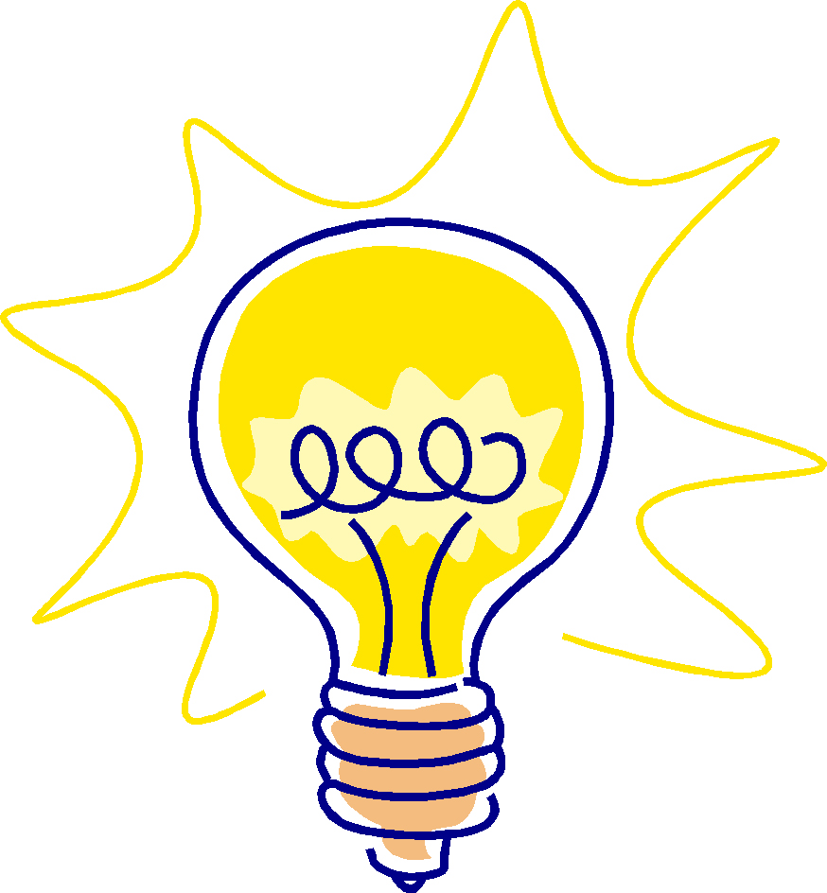

**Objective:**

Trace the path that the electric current must take in order to enter and exit a light bulb.

**Materials:**

Light bulb with glass removed

Magnifying glass

Diagram of light bulb

**Procedure:**

1. Carefully examine the broken light bulb using a magnifier to determine the position of the wires and how each one attaches to the outside of the light bulb.
2. Draw what you see in the space below.

|  |
| --- |
|  |

1. Turn your card from green to red and wait for your teacher.
2. Compare your drawing to the labeled drawing of a light bulb.
3. Discuss the drawings with your team.
4. What conclusions can you make about how electricity from a battery enters the light bulb, makes the light bulb light, and then exits the light bulb to return to the battery? ________________________________________________

___________________________________________________________

___________________________________________________________

___________________________________________________________

___________________________________________________________

T1a 1

T1a 2

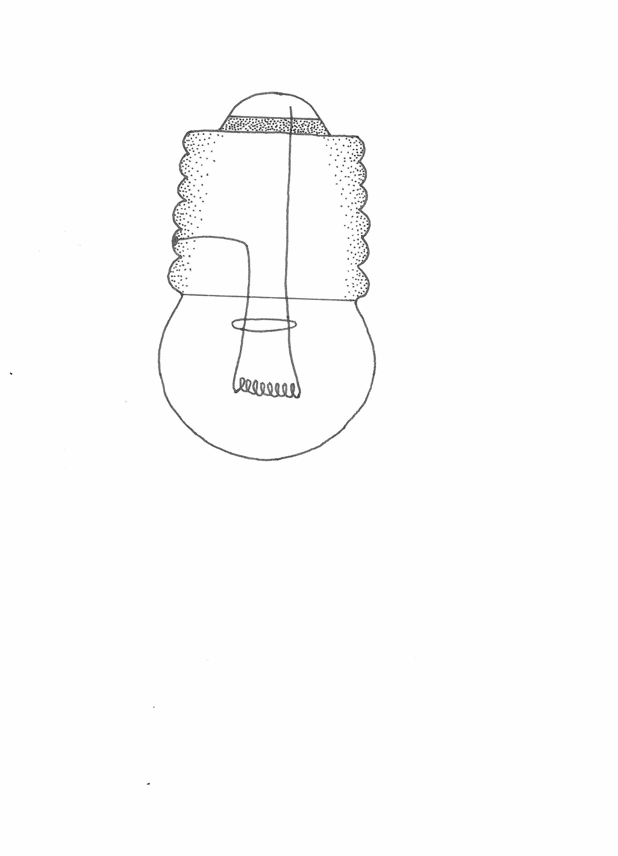

glass bulb

filament support wires

insulator

filament

base insulator

base

metal casing

casing wire

base wire

**Schematic Diagram of an Incandescent Light Bulb**

Name: ____________________________________________________ Date: ______________________________

**Will the light bulb light?**



1.

2.

3.

4.

5.

6.

7.

8.



T1b 1