Save Beady Kid From the Sun: Detailed Construction Instructions
By Melissa Demetrikopoulos, Wesley Thompson, and John Pecore

Items needed:
48 inches of cord (122cm)
20 UV sensitive pony beads for arms and legs
38 colored pony beads (allow students to select beads to create a unique beady dude: 2 black for shoes, 16 of their choice for head, and 20 of their choice for the body)
Scissors

Fold the cord in half to find the center and run the first three beads to this point. The two colored lines denote the two halves of the string.
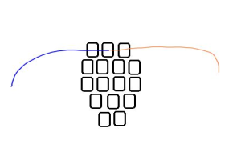
Line up the next four beads and run the two ends of the string through them from opposite ends and pull tight enough to remove slack.
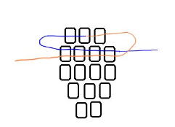
Continue the procedure for the next three rows of beads following the pattern shown.
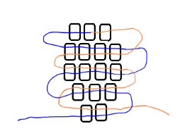
Line up the first four beads of the body and five UV beads for the arm. Run one line though the four body beads and the first four UV beads. Loop the line through the last UV bead as shown.
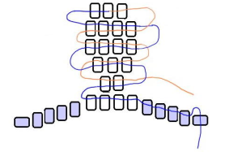
Run the line back through the remaining four UV beads and four body beads. The loop through the end bead should keep the remaining beads from sliding off the line.
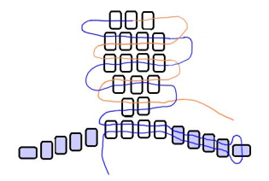

Repeat the procedure for the other arm. There should be four runs of line through the first four body beads. Remove slack from the lines that hold the arms at this time.
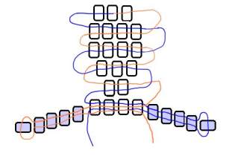

Prepare the next four rows of four body beads. Run the lines from opposite ends of each row like you did for the head and remove any slack.
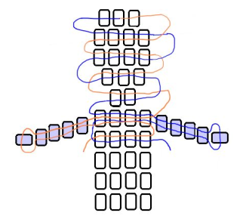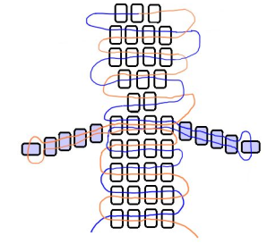

Prepare five UV beads for the leg and one additional bead for the foot. Run one line through the five UV beads and loop the end through the foot bead like you did for each arm. Run the line back through the five UV beads. The foot bead should keep the leg beads from sliding off. Run the line back through the last body bead where the line exited. Remove any slack at this time.
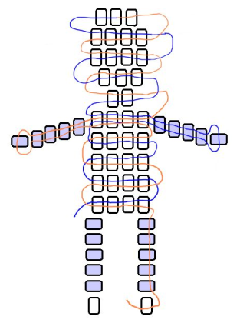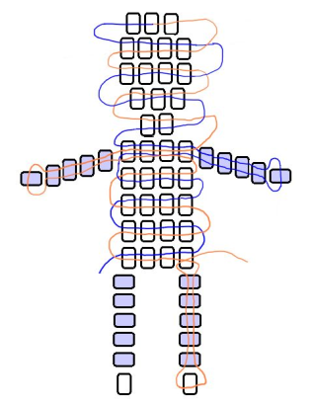

The leg should point down from the body and not out to the side. Tie two overhand knots around the line at the top of the leg to keep the leg from unraveling. Trim the remaining line with scissors.
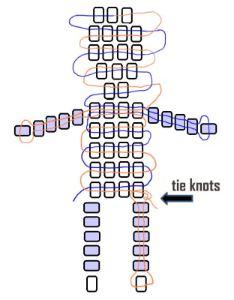

Repeat the procedure on the other leg, remove slack, tie knots and trim the line with scissors.
