Chemical Reaction Vehicle Self-Reflection
Rate your response for each statement to show how much you feel you learned during this engineering design challenge. Look through your science notebook for evidence. Add a comment after each statement with a specific example to support your claim.

- I am able to plan and carry out an investigation. This includes controlling the variables, recording data in a clear and organized manner (observations and accurate measurements), and writing my CER (claim, evidence, and reasoning).
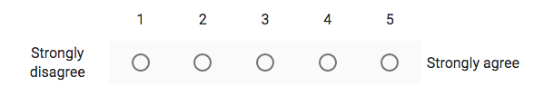
My evidence to support my response to question #1:

- I can create a basic chemical reaction and understand the changes in the properties of matter.

My evidence to support my response to question #2:

3. I consistenly demonstrate proper safety procedures.

My evidence to support my response to question #3:
- I am able to use the Engineering Design Process (Ask, Imagine, Plan, Create, Improve) to solve a problem.

My evidence to support my response to question #4:

- I demonstrate confidence and resiliency when working with difficult problems.

My evidence to support my response to question #5:

- I demonstrate the ability to communicate and work well with others to achieve a common goal (collaboration).

My evidence to support my response to question #6:

- Please share other comments about the project, your learning, and/or any suggestions to help your teachers make improvements to the Chemical Reaction Vehicle Engineering Design Challenge.

